NAME: BABATUNDE ANUOLUWAPO ORIYOMI
MATRIC NO: 19/MHS02/030
DEPT: NURSING SCIENCE
COURSE: CHEM102
LEVEL: 100L
ASSNGMNT TITLE: STEREOCHEMISTRY AND FUNTIONAL GROUP.
- Name the functional groups present in each of the following molecules
I.CH2=C(OH)HCHO
II. C6H5CH(NH2)COCH3
III. CH3C=CHCH(OH)CHO ANSWERS:
I.CH2=C(0H)HCHO
Functional group; i. alkanol
ii. aldehyde
iii. alkene
II. C6H5CH(NH2)COCH3
Functional group; i. amides
ii. ketones
III. CH3C=CHCH(OH)CHO
Functional group; i. Alkene
ii. Alkanol
iii. Aldehyde
- A 0.856g sample of pure (2R, 3R)-tatrtaric acid was diluted to 10cm3 with water placed in 1.0dm polarimeter tube the observed rotation at 20c was +1.0. Calculate the specific rotation of (2R, 3R)-tatrtatric acid.

SOLUTION;

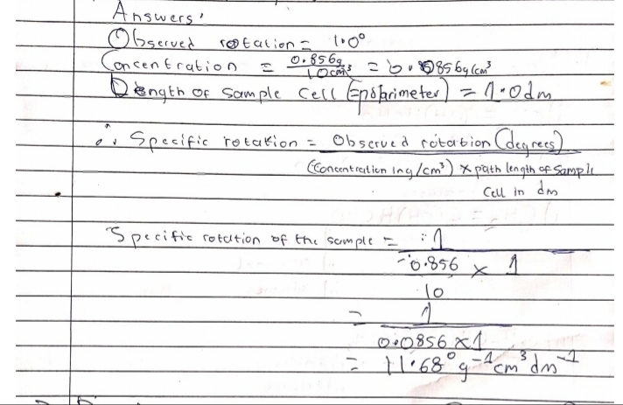

- Draw the possible geometric isomers (where possible) for each of the following compounds:
(i).Hexa-2,4-diene (ii)2,3-Dimethylbut-2-ene
ANSWERS;
