16/MHS06/030

PHYSICS OF LIGHT MICROSCOPE
As mentioned earlier, light microscopes visualize an image by using a glass lens and magnification is determined by, the lens’s ability to bend light and focus it on the specimen, which forms an image. When a ray of light passes through one medium into another, the ray bends at the interface causing refraction. The bending of light is determined by the refractive index, which is a measure of how great a substance slows the speed of light. The direction and magnitude of the bending of the light are determined by the refractive indexes of the two mediums that form the interface.
A medium with a lower refractive index such as glass to air, it normally speeds up the light penetration and making light bend away from the normal and when light is passed through a medium with a greater refractive index such as air to glass, it normally slows down and bends towards the normal, perpendicularly to the surface.
If an object is put between these two mediums i.e between water and air, in this case, a prism, the prism will bend the light at an angle. This is how the microscopic lenses work, they bend the light at an angle. The lens (convex) on receiving the light rays, it focuses the rays at a specific point known as the focal point (F-point). The measure of distance from the center of the lens and the focal point is known as the focal length.
A microscope uses lenses whose strength is predetermined, in that, the strength of a lens is directly related to the focal length i.e short focal length magnifies objects more than lenses with a long focal length.
Microscopy works strictly with a factor of resolution whereby resolution being the ability of a lens to be able to differentiate small objects that are closely packed together. The resolution of a light microscope is determined by a numerical aperture of its lens system and by the wavelength of the light it employs; a numerical aperture a definition of the light wavelengths produced when the specimen is illuminated.
A minimum distance (d) between two objects that distinguishes then to be two separate entities, determined by the wavelengths of the light can be calculated by an Abbe equation using the wavelength of the light that illuminated the specimen (Lambda, λ) and the numerical aperture (NA, n sin Ɵ) i.e. d=0.5 λ/n sin Ɵ
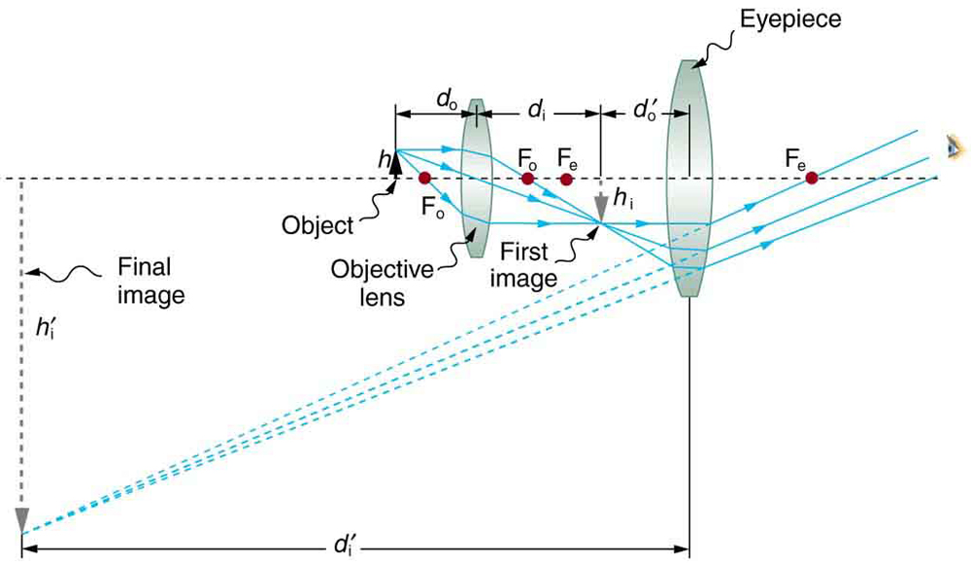

CENTRIFUGE
A centrifuge is a piece of equipment,generally driven by an electric motor, that puts an object in rotation around a fixed axis,applying a force perpendicular to the axis to separate substances of different relative densities.
WORKING PRINCIPLE OF CENTRIFUGE
The centrifuge works using the sedimentation principle, where the centrifugal acceleration causes denser substances and particles to move outward in the radial direction. At the same time, objects that are less dense are displaced and move to the center. The centrifuge rotates at a speed of 4000 revolution every 5 minutes.

Types of Centrifuges

1. Small Bench Centrifuges
They are used to collect small amount of material that rapidly sediment like yeast cells, erythrocytes etc. They have maximum relative centrifugal field of 3000-7000 g.

2. Large Capacity Refrigerated Centrifuges
They have refrigerated rotor chamber and have capacity to change rotor chambers for varying size. They can go up to maximum of 6500 g and use to sediment or collect the substances that sediment rapidly like erythrocytes, yeast cell, nuclei and chloroplast.

3. High Speed Refrigerated Centrifuges
They can generate speed of about 60000g and are used to collect micro-organism, cellular debris, larger cellular organelles and proteins precipitated by ammonium sulphate.

4. Ultra Centrifuges
(a) Preparative ultracentrifuge
It can produce relative centrifugal force of about 600000g and its chamber is refrigerated, sealed and evacuated. It is employed for separation of macromolecules binding kinetic studies, separation of various lipoprotein fractions from plasma and deprotonisation of physiological fluids for amino acid ananlysis.
(b) Analytical ultracentrifuge
It is capable of operating at 500000 g. Three kinds of optical systems are available in analytical ultracentrifuges: a light absorption system, and the alternative Schlieren system and Rayleigh interferometric system, both of which detect changes in the refractive index of the solution.
CARE AND MAINTENANCE OF CENTRIFUGE
- Clean the centrifuge daily, or at least weekly.
- Remove the rotor and any sample or container holders.
- Interior cleaning includes the interior bucket, specimen holder, rotor and supports.
- Use a sponge, warm water and a mild detergent such as dishwashing liquid.
- Spills should be wiped up immediately.
- Clean both the exterior and the interior.
- Motors, vacuum pumps, condensers and other expensive parts can also be damaged by exposure to water and cleaning products.
- Scrub tube cavities with a test tube brush with nonmetallic tip. Dry each part with an absorbent towel.

AUTOMATIC TISSUE PROCESSOR

A tissue processor is a device that prepares tissue samples for sectioning and microscopic examination in the diagnostic laboratory.

WORKING PRINCIPLE
The tissue basket oscillates up and down in each station at three-second intervals to ensure thorough and even mixing of the reagents and optimum tissue infiltration. Infiltration time is separately programmable for each station. Up to nine programs may be run with immediate or delayed starting times.
When it’s time for tissue to be transferred to the next beaker or jar, the cover of the machine is raised up, and the lifting mechanism carefully removes the tissue basket and gently transfers it to the next beaker. When the infiltration time for any particular station is exceeded, a warning message will display, indicating the station number and excess time. Controls are arranged by functionality with an LCD to indicate operational parameters. Reagent container lids have seals to minimize operator exposure to hazardous fumes. When power is restored, program will resume. In the event of long-term power failure, wax is liquefied. Capacity of tissue basket is 80 cassettes. Vacuum configurations hasten infiltration, allowing pressure to be applied to any station in either manual or automatic operation. Fume control configurations extract fumes with a fan and pass them through an internal carbon filter.
TYPES OF AUTOMATIC TISSUE PROCESSORS
1)Tissue transfer processors
These processors are characterized by the transfer of tissues, contained within a basket, through a series of stationary reagents arranged in-line or in a circular carousel plan. The rotary or carousel is the most common model of automatic tissue processor, and is provided with 9-10 reagent and 2-3 wax positions, with a capacity of 30-110 cassettes depending upon the model.
2)Fluid transfer processors
In fluid-transfer units, processing fluids are pumped to and from a retort in which the tissues remain stationary. There are 10-12 reagent stations with temperatures adjustable between 30-45°C, 3-4 paraffin wax stations with variable temperature settings between 48-68°C, and vacuum-pressure options for each station. Depending upon the model these machines can process 100-300 cassettes at any one time.
CARE AND MAINTENANCE
i) Change reagents regularly and when a yellow triangular alert appears on the screen of the machine
ii) Switch the machine off when it is not in usage
iii) Clean any spill on the machine immediately
iv) Cover the machine when not in use to avoid entry of dust particles
v) Machine must be operated by a skilled-personnel to avoid misuse of machine.
MICROTOME
Microtome use steel , glass and diamond blades depending upon the the specimen being sliced and the desired thickness of the section being cut . steel blades are used to prepare sections of animals or plant tissues for light microscopy histology. Glass knives are used to slice sections of light microscopy and to slice very thin sections for electron microscopy.

WORKING PRINCIPLE
Microtome is a sectioning instrument that allows the cutting of extremely thin slices of a material known as section . microtome are used in microscopy , allowing for the preparation of sample for observation under transmitted light or electrons radiation . it is a method for the preparation of thin section for materials such as bones, minerals, and teeth.

TYPES OF MICROTOME
i) Hand
ii) Rocking
iii) Freezing
iv) Rotary

CARE AND MAINTENANCE OF MICROTOME
A. Keep the edge of your knife clean at all times.
B. Spray or brush any household oil on your knife to prevent rust when not in use.
C. Store your knife in its case to prevent oxidation from occurring.
D. If you are using a lab sharpener, periodically send your knife out to be professionally reconditioned.
E. Before using your knife, take a lint-free facial tissue saturated in either xylene, benzene or acetone to remove the protective oil coating on the knife.

