NAME: YUSUF DEBORAH DAMILOLA
DEPARTMENT: PHARMACY
COURSE: CHM 102
COLLEGE: MHS

1.
1. CH₂=C(OH)HCHO
a. -OK (Alkanol)
b. -CHO (Alkanal)
c. = (Alkene)
2. C₆H₅CH(NH₂)COCH₃
a. -NH₂(Amine)
b. -C=O (Alkanone)
3. CH₃C=CHCH(OH)CHO
a. -CHO (Alkanal)
b. -OH (Alkanol)
c. =(Alkene)
2. Specific rotation= observed rotation (degrees)
(conc.g/cm³× path length of sample
Given: observed rotation=1.0°
Path length of sample=1dm
Conc.g/dm³=?
Conc g/dm³= size of sample (g)
Volume(cm³)
Conc g/cm³=0.856g
10cm
Conc g/cm³=0.0856g/cm³
Specific rotation=1.0°
0.0856g/cm³×1dm³
=11.68°g⁻¹cm⁻¹dm⁻¹

3.
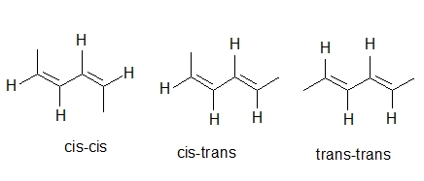
1. Hexa-2,4-diene

2. 2,3 Dimethylbut-2-ene
