NAME: ALADE EMMANUEL ADEMOLA
MATRIC NUMBER: 18/MHS07/006
DEPARTMENT: PHARMACOLOGY
COURSE CODE: PHA 206

Antimicrobial resistance is not a new phenomenon. In nature, microbes are constantly evolving in order to overcome the antimicrobial compounds produced by other microorganisms. Human development of antimicrobial drugs and their widespread clinical use has simply provided another selective pressure that promotes further evolution. Several important factors can accelerate the evolution of drug resistance. These include the overuse and misuse of antimicrobials, inappropriate use of antimicrobials, subtherapeutic dosing, and patient noncompliance with the recommended course of treatment.
Exposure of a pathogen to an antimicrobial compound can select for chromosomal mutations conferring resistance, which can be transferred vertically to subsequent microbial generations and eventually become predominant in a microbial population that is repeatedly exposed to the antimicrobial. Alternatively, many genes responsible for drug resistance are found on plasmids or in transposons that can be transferred easily between microbes through horizontal gene transfer (see How Asexual Prokaryotes Achieve Genetic Diversity). Transposons also have the ability to move resistance genes between plasmids and chromosomes to further promote the spread of resistance.

Mechanisms for Drug Resistance
There are several common mechanisms for drug resistance, which are summarized in Figure 1. These mechanisms include enzymatic modification of the drug, modification of the antimicrobial target, and prevention of drug penetration or accumulation.
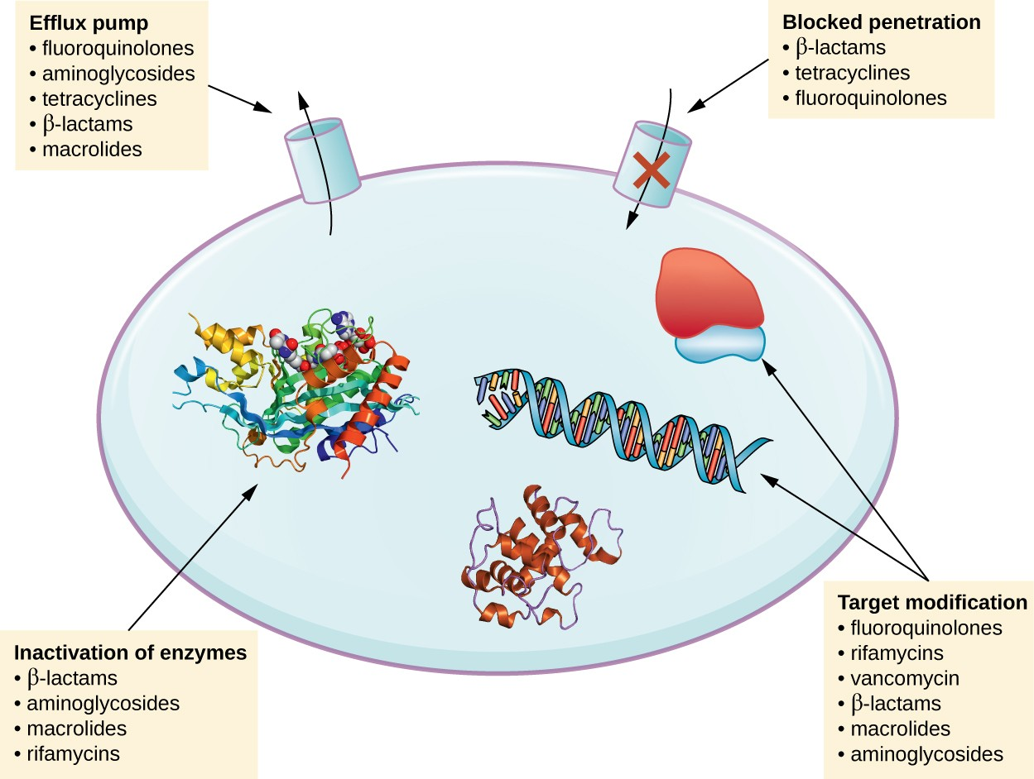

Drug Modification or Inactivation
Resistance genes may code for enzymes that chemically modify an antimicrobial, thereby inactivating it, or destroy an antimicrobial through hydrolysis. Resistance to many types of antimicrobials occurs through this mechanism. For example, aminoglycoside resistance can occur through enzymatic transfer of chemical groups to the drug molecule, impairing the binding of the drug to its bacterial target. For β-lactams, bacterial resistance can involve the enzymatic hydrolysis of the β-lactam bond within the β-lactam ring of the drug molecule. Once the β-lactam bond is broken, the drug loses its antibacterial activity. This mechanism of resistance is mediated by β-lactamases, which are the most common mechanism of β-lactam resistance. Inactivation of rifampin commonly occurs through glycosylation, phosphorylation, or adenosine diphosphate (ADP) ribosylation, and resistance to macrolides and lincosamides can also occur due to enzymatic inactivation of the drug or modification.

Prevention of Cellular Uptake or Efflux
Microbes may develop resistance mechanisms that involve inhibiting the accumulation of an antimicrobial drug, which then prevents the drug from reaching its cellular target. This strategy is common among gram-negative pathogens and can involve changes in outer membrane lipid composition, porin channel selectivity, and/or porin channel concentrations. For example, a common mechanism of carbapenem resistance among Pseudomonas aeruginosa is to decrease the amount of its OprD porin, which is the primary portal of entry for carbapenems through the outer membrane of this pathogen. Additionally, many gram-positive and gram-negative pathogenic bacteria produce efflux pumps that actively transport an antimicrobial drug out of the cell and prevent the accumulation of drug to a level that would be antibacterial. For example, resistance to β-lactams, tetracyclines, and fluoroquinolones commonly occurs through active efflux out of the cell, and it is rather common for a single efflux pump to have the ability to translocate multiple types of antimicrobials.

Target Modification
Because antimicrobial drugs have very specific targets, structural changes to those targets can prevent drug binding, rendering the drug ineffective. Through spontaneous mutations in the genes encoding antibacterial drug targets, bacteria have an evolutionary advantage that allows them to develop resistance to drugs. This mechanism of resistance development is quite common. Genetic changes impacting the active site of penicillin-binding proteins (PBPs) can inhibit the binding of β-lactam drugs and provide resistance to multiple drugs within this class. This mechanism is very common among strains of Streptococcus pneumoniae, which alter their own PBPs through genetic mechanisms. In contrast, strains of Staphylococcus aureus develop resistance to methicillin (MRSA) through the acquisition of a new low-affinity PBP, rather than structurally alter their existing PBPs. Not only does this new low-affinity PBP provide resistance to methicillin but it provides resistance to virtually all β-lactam drugs, with the exception of the newer fifth-generation cephalosporins designed specifically to kill MRSA. Other examples of this resistance strategy include alterations in
- ribosome subunits, providing resistance to macrolides, tetracyclines, and aminoglycosides;
- lipopolysaccharide (LPS) structure, providing resistance to polymyxins;
- RNA polymerase, providing resistance to rifampin;
- DNA gyrase, providing resistance to fluoroquinolones;
- metabolic enzymes, providing resistance to sulfa drugs, sulfones, and trimethoprim; and
- peptidoglycan subunit peptide chains, providing resistance to glycopeptides.

Target Overproduction or Enzymatic Bypass
When an antimicrobial drug functions as an antimetabolite, targeting a specific enzyme to inhibit its activity, there are additional ways that microbial resistance may occur. First, the microbe may overproduce the target enzyme such that there is a sufficient amount of antimicrobial-free enzyme to carry out the proper enzymatic reaction. Second, the bacterial cell may develop a bypass that circumvents the need for the functional target enzyme. Both of these strategies have been found as mechanisms of sulfonamide resistance. Vancomycin resistance among S. aureus has been shown to involve the decreased cross-linkage of peptide chains in the bacterial cell wall, which provides an increase in targets for vancomycin to bind to in the outer cell wall. Increased binding of vancomycin in the outer cell wall provides a blockage that prevents free drug molecules from penetrating to where they can block new cell wall synthesis.

Target Mimicry
A recently discovered mechanism of resistance called target mimicry involves the production of proteins that bind and sequester drugs, preventing the drugs from binding to their target. For example, Mycobacterium tuberculosis produces a protein with regular pentapeptide repeats that appears to mimic the structure of DNA. This protein binds fluoroquinolones, sequestering them and keeping them from binding to DNA, providing M. tuberculosis resistance to fluoroquinolones. Proteins that mimic the A-site of the bacterial ribosome have been found to contribute to aminoglycoside resistance as well.

Multidrug-Resistant Microbes and Cross Resistance
From a clinical perspective, our greatest concerns are multidrug-resistant microbes (MDRs) and cross resistance. MDRs are colloquially known as “superbugs” and carry one or more resistance mechanism(s), making them resistant to multiple antimicrobials. In cross-resistance, a single resistance mechanism confers resistance to multiple antimicrobial drugs. For example, having an efflux pump that can export multiple antimicrobial drugs is a common way for microbes to be resistant to multiple drugs by using a single resistance mechanism. In recent years, several clinically important superbugs have emerged, and the CDC reports that superbugs are responsible for more than 2 million infections in the US annually, resulting in at least 23,000 fatalities.^{[2]} Several of the superbugs discussed in the following sections have been dubbed the ESKAPE pathogens. This acronym refers to the names of the pathogens (Enterococcus faecium, Staphylococcus aureus, Klebsiella pneumoniae, Acinetobacter baumannii, Pseudomonas aeruginosa and Enterobacter spp.) but it is also fitting in that these pathogens are able to “escape” many conventional forms of antimicrobial therapy. As such, infections by ESKAPE pathogens can be difficult to treat and they cause a large number of nosocomial infections.

Methicillin-Resistant Staphylococcus aureus (MRSA)
Methicillin, a semisynthetic penicillin, was designed to resist inactivation by β-lactamases. Unfortunately, soon after the introduction of methicillin to clinical practice, methicillin-resistant strains of S. aureus appeared and started to spread. The mechanism of resistance, acquisition of a new low-affinity PBP, provided S. aureus with resistance to all available β-lactams. Strains of methicillin-resistant S. aureus (MRSA) are widespread opportunistic pathogens and a particular concern for skin and other wound infections, but may also cause pneumonia and septicemia. Although originally a problem in health-care settings (hospital-acquired MRSA [HA-MRSA]), MRSA infections are now also acquired through contact with contaminated members of the general public, called community-associated MRSA (CA-MRSA). Approximately one-third of the population carries S. aureus as a member of their normal nasal microbiota without illness, and about 6% of these strains are methicillin resistant.

