Ajayi Oluwafunto Jemima
19/MHS01/067
Biology assignment
1.
- Fungi acts as decomposers in the ecosystem
- They are agents of fermentation in the production of certain food and beverages
- They play a role in human nutrition In form of mushrooms

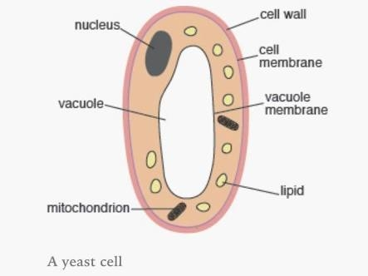
2. A yeast cell

3. A typical filamentous form of fungi is Rhizopus stolonifer
Sexual reproduction occurs when two mating types of hyphae grow in the same medium. Chemical interactions in the two mating types of hyphae induces growth in opposite directions. These growths are delimited by a wall such that many nuclei are isolated in what is called a gamentagium. The two gamentangia fuse (plasmogamy) and a zygote is formed which may undergo prolonged dormancy or resting stage. The nuclei in the zygote fuse in twos and undergo meiosis independently.
The zygote terminates under favourable conditions to produce a fruiting which at maturity liberates tabloid spores.

4. Ways in which Bryophytes adapt to their habitat
- They have definite structures for water and nutrient absorption from the soil; therefore the plant body is divided into two (an aerial portion and a subterranean portion). The subterranean portion is the rhizoid and is not a true root as the case of land plants that are advanced
- The aerial portion being exposed to the atmosphere demand some modifications that prevent loss of excess water through the body surface.
- Some other modifications that permit elimination of excess water from the plant body and not only exchange of gases between the internal parts of the plant and the atmosphere therefore opening are available on the aerial parts of the plant.

5.
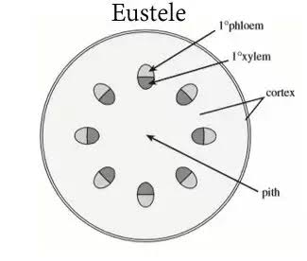
A. Eusteles
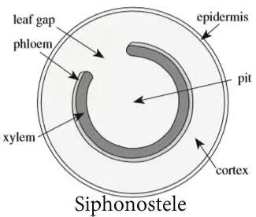
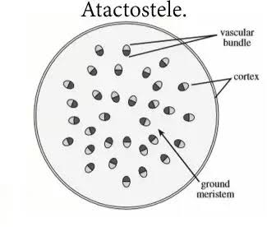
B. Atactostele
D. Dicotyostele

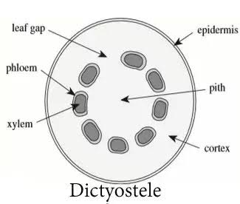

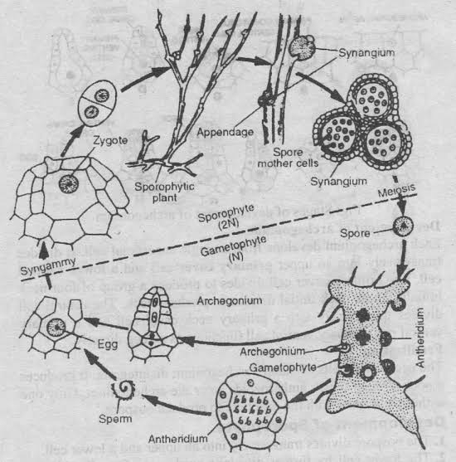
6.

