NAME: OKESOLA AIBOLA
COURSE: CSC302
MAT.NO: 17/SCI0/064

ANSWERS
- THE DIFFERENCE BETWEEN MODULAR AND OBJECT ORIENTED PROGRAMMING PARADIGM
  - 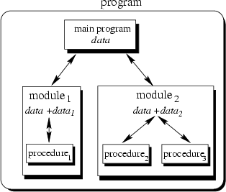
Figure 1: SCHEMA OF MODULAR PROGRAMMING PARADIGM
The modular programing is the process of breaking down a large program into small manageable tasks and design them independently. A modular programming language consists of a main module ( which is the program’s entry point and controlling section of the program which is located at the top level of the program), and sub-modules which are written under the main module as separate independent units
  - 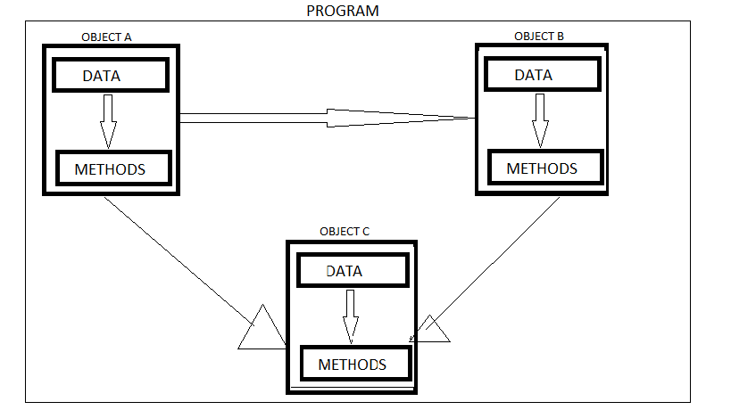
Figure 2: SCHEMA OF OBJECT ORIENTED PROGRAMMING PARADIGM\
Object oriented programming is a programming paradigm that capitalizes on data and classes. The program is group into entities and objects that are to be properly contained, protected and functioning and interact with each other. An object is composed of static attributes also referred to as data and dynamic attributes which is usually called Method in most OOP languages

- Using the above knowledge, the airline reservation system would already be in modular design meaning that the entire program flow would be divided into several modules, which contain a particular functionality that has been adapted into one or more procedures. The diagram below gives an example of what the program schema could possibly look like

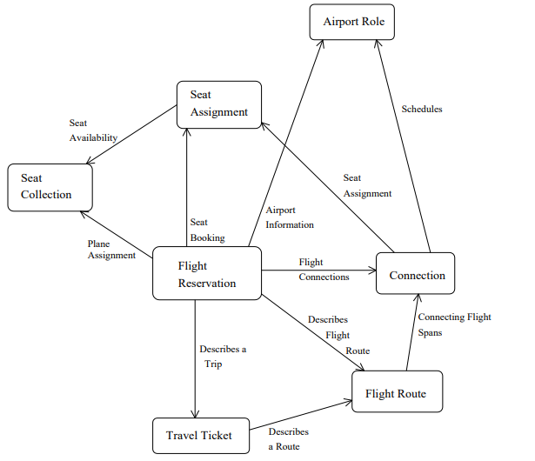

In other to transform this to an object oriented design, the elements or entities would have to be identified and fashioned into classes or objects where their main functionalities are fashioned into methods within said classes and these classes would be allowed to interact with each other for smooth running of the overall program. For example, some entities are the customer, the airline, the seats, the tickets, the route and much more. Each of these would have to become classes (objects) which contain modules to perform the actions needed like ticket collection, etc.
An example is shown in the diagram below

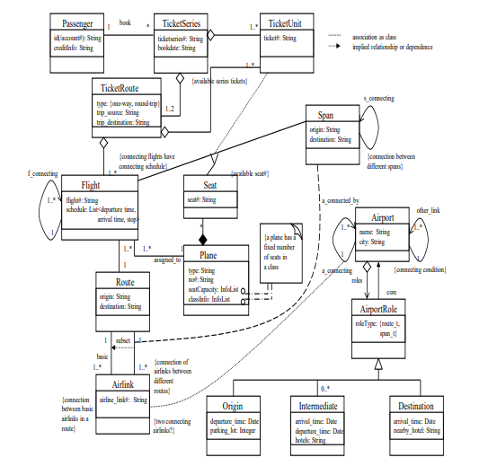

REFERENCES:
- “Modular Programming in Q basic” obtained 2020/05/17 from https://www.kullabs.com/classes/subjects/units/lessons/notes/note-detail/10043
- “Concept of Object Oriented Programming (OOP)”, obtained 2020/0/17 from https://www.kullabs.com/classes/subjects/units/lessons/notes/note-detail/10043
- Zhen Jiang and Eduardo B. Fernandez, “Composing analysis patterns to build complex models: -Flight Reservation”, obtained 2020/05/17 from https://www.cs.wcupa.edu/zjiang/Flight.pdf

