NAME: Chukwuma Blessing Chioma
DEPARTMENT: Nursing
MATRIC NUMBER: 19/MHS02/038
COURSE CODE: CHM 102
Answers to the assignment on stereochenistry and functional group.
1 . Functional groups present in:
a . CH2=C(OH)HCHO- Aldehyde, alkanols and alkene.
b . C6H5CH(NH2)COCH3- Amine and alkanone.
c . CH3C=CHCH(OH)CHO- Alkanol, aldehyde and alkene.

2 . Calculation of the specific rotation of (2R,3R)-tartaric acid.
Answers:
Parameters given:
Mass of sample of pure(2R,3R)-tartaric acid= 0.856g
Volume of diluted sample of pure(2R,3R)-tartaric acid=10cm3
Density of polarimeter tube= 1.0dm
Observed rotation= +1.0°
Specific rotation= ?
Specific rotation=
Observed rotation (degrees)
—————————————————————
(concentration g/cm3)×(path length of sample cell in dm)
Specific rotation= 1.0°
——————————
(0.0856g/cm3)×(1dm)
.:. Specific rotation= 11.68g-1 cm3 dm-1

3 . Possible geometric isomers of:
a . Hexa-2,4-diene
b . 2,3-dimethylbut-2-ene
Answers:
a . Molecular formula of hexa-2,4-diene is C6H10
Geometric isomers of hexa-2,4-diene:
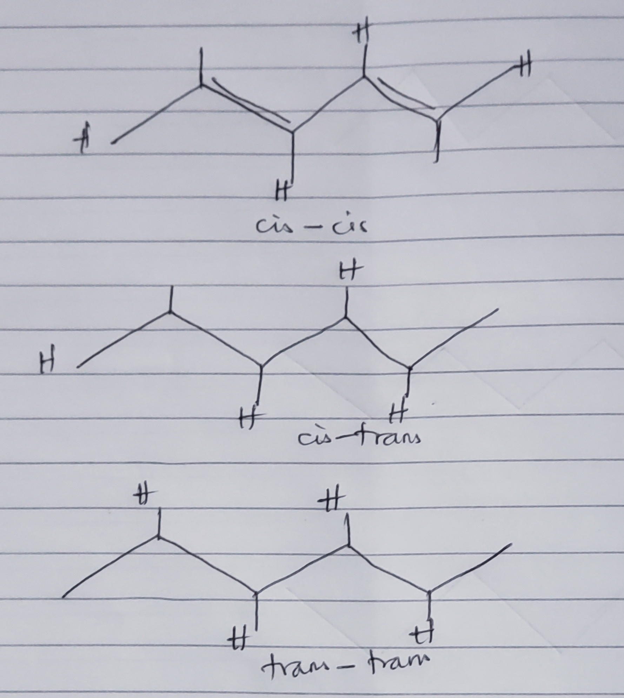

b . Molecular rd of 2,,3-dimethylbut-2-ene is C6H12
Geometric isomers of 2,,3-dimethylbut-2-ene:
