NAME: Aibangbee Efeosa Anthonia
DEPARTMENT: Pharmacy
MATRIC NO.: 19/MHS11/021
COURSE: CHEMISTRY (CHM 102)Assignment
1. Name the functional groups present in each of the following molecules
(i) CH₂=C(OH)HCHO = alkene, alkanol and aldehyde
(ii) C₆H₅CH(NH₂)COCH₃ = ketone and amine
(iii) CH₃C=CHCH(OH)CHO = alkene, aldehyde and alkanol
2. A 0.856 g sample of pure (2R, 3R)-tartaric acid was diluted to 10cm3 with water and placed in a 1.0 dm polarimeter tube. the observed rotation at 20⁰ C was +1.0⁰. Calculate the specific rotation of (2R, 3R)-tartaric acid.
Specific rotation= observed rotation/ [concentration]*[pathlength]
Observed rotation= +1.0, concentration= 0.0856g/cm³, pathlength= 1dm
Specific rotation= 1/[0.0856*1]
= 11.682cm³g⁻¹dm⁻¹
3. Draw the possible geometric isomers (where possible) for each of the following compounds:
(i) Hexa-2,4-diene – there are 3 possible geometric isomers
Cis-cishexan-2,4-diene, trans-transhexan-2,4-diene, cis-transhexan-2,4-diene
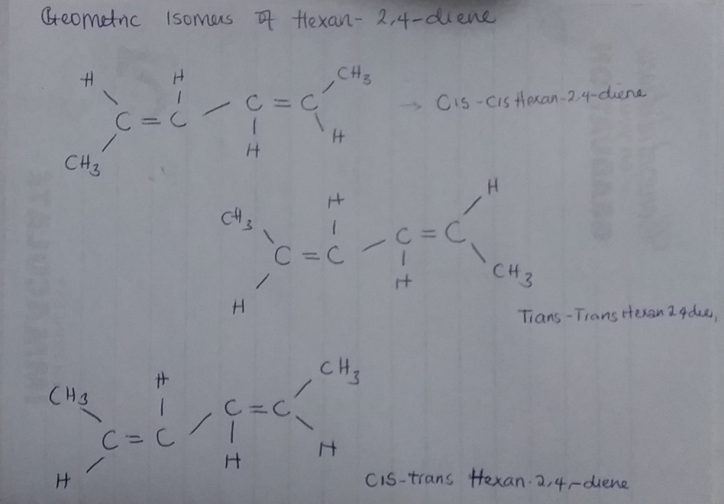
(ii) 2,3-Dimethylbut-2-ene- there are no possible isomers because all the alkyl groups attached are equal

