NAME: OKAM EDNA ACHI CHINMA
MATRIC NUMBER: 19/MHS03/015
DEPARTMENT: HUMAN ANATOMY
COURSE CODE: ANA 212

THE ANAL CANAL
The anal canal is the final segment of the gastrointestinal tract. It is about 3 to 4 cm long and lies completely extraperitoneally. It begins at the anorectal junction distally from the perineal flexure and ends at the anus. It has an important role in defecation and maintaining faecal continence.

Anatomical Position
The anal canal is located within the anal triangle of the perineum between the right and left ischioanal fossae. It is the final segment of the gastrointestinal tract, around 4cm in length.
The canal begins as a continuation of the rectum, and passes infer posteriorly to terminate at the anus.
Function
The anal canal is an important part of the continence organ. It is surrounded by a muscular sphincter system which tightly closes the lumen. The internal anal sphincter is permanently contracted through the sympathetic tonus and relaxes under parasympathetic influence. The external anal sphincter surrounds the anal canal like a clamp. It is in close relationship to the puborectalis muscle (part of levator ani muscle) which encircles the rectum from behind (puborectal sling) and thus forms a bending closure. Both the external anal sphincter and the puborectalis muscle are voluntarily controlled.
The anal cushions play an important role in the fine control. Physiologically they are filled with arterial blood. During defecation, the internal anal sphincter relaxes so that the blood in the cushions drains away, allowing a smooth passage of the stool through the anal canal. A pathological enlargement of the anal cushions leads to hemorrhoids.
The human anal glands are rudimentary. Their secreted scent does not a play role for humans anymore. For many animals the scent still fulfils important functions, e.g. territory marking or sexual stimulation.

Anatomical Structure
Except during defecation, the anal canal is collapsed by the internal and external anal sphincters to prevent the passage of faecal material.

Anal Sphincters
The anal canal is surrounded by internal and external anal sphincters, which play a crucial role in the maintenance of faecal continence:
- Internal anal sphincter – surrounds the upper 2/3 of the anal canal. It is formed from a thickening of the involuntary circular smooth muscle in the bowel wall.
- External anal sphincter – voluntary muscle that surrounds the lower 2/3 of the anal canal (and so overlaps with the internal sphincter). It blends superiorly with the puborectalis muscle of the pelvic floor.
At the junction of the rectum and the anal canal, there is a muscular ring – known as the anorectal ring. It is formed by the fusion of the internal anal sphincter, external anal sphincter and puborectalis muscle, and is palpable on digital rectal examination.
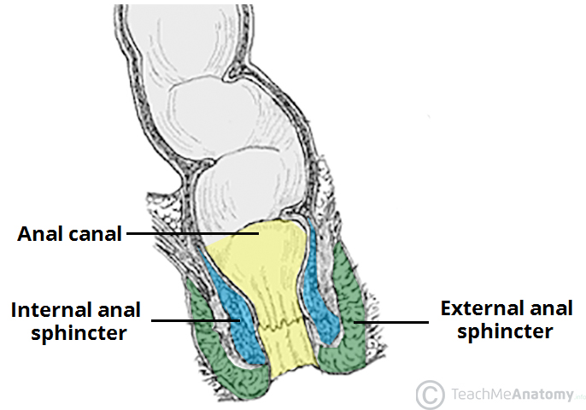
The Internal and external anal sphincters.

Internal Structure
The superior aspect of the anal canal has the same epithelial lining as the rectum (columnar epithelium). However, in the anal canal, the mucosa is organised into longitudinal folds, known as anal columns. These are joined together at their inferior ends by anal valves. Above the anal valves are small pouches which are referred to as anal sinuses – these contain glands that secrete mucus.
The anal valves collectively form an irregular circle – known as the pectinate line (or dentate line). This line divides the anal canal into upper and lower parts, which differ in both structure and neurovascular supply. This is a result of their different embryological origins:
- Above the pectinate line – derived from the embryonic hindgut.
- Below the pectinate line – derived from the ectoderm of the proctodeum.
Inferior to the pectinate line, the anal canal is lined by non-keratinised stratified squamous epithelium (known as the anal pecten). It is a pale and smooth surface, which transitions at the level of the inter-sphinteric groove to true skin (keratinised stratified squamous).
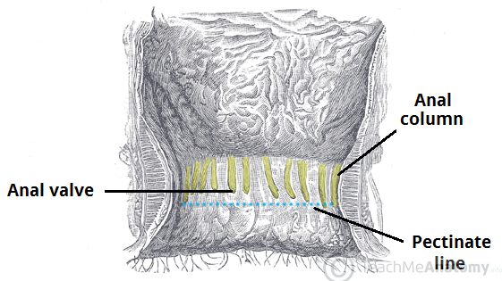
The anal columns, anal valves and pectinate line.

Anatomical Relations
It lies in close proximity to several other important structures in the pelvis and perineum:
Anteriorly |  | Posteriorly | Laterally
Male | Female | Anococcygeal ligament  Coccyx and sacrum | Ischioanal fossae
Perineal body  Urogenital diaphragm  Urethra  Bulb of the penis | Perineal body  Urogenital diaphragm  Vagina

Neurovascular Supply and Lymphatics
The pectinate line divides the anal canal into two parts – which have a different arterial supply, venous drainage, innervation and lymphatic drainage.
Modality | Above Pectinate line | Below Pectinate line
Arterial Supply | Superior rectal artery (branch of inferior mesenteric artery)  Anastomosing branches from the middle rectal artery. | Inferior rectal artery (branch of the internal pudendal artery)  Anastomosing branches from the middle rectal artery.
Venous Drainage | Superior rectal vein, which empties into the inferior mesenteric vein (portal venous system). | Inferior rectal vein, which empties into the internal pudendal vein (systemic venous system).
Nerve Supply | Visceral innervation via the inferior hypogastric plexus.  Sensitive to stretch. | Somatic innervation via the inferior anal nerves (branches of the pudendal nerve)  Sensitive to pain, temperature, touch and pressure.
Lymphatics | Internal iliac lymph nodes | Superficial inguinal lymph nodes

Clinical Relevance - Haemorrhoids
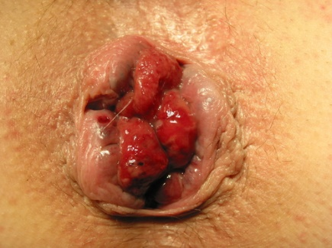
Haemorrhoids located in the 3, 7, and 11 o’clock positions
Haemorrhoids are vascular cushions found within the anal canal of healthy individuals, which help with the maintenance faecal continence. If they become swollen and distended, they are referred to as pathological haemorrhoids.
Pathological haemorrhoids are observed in people who suffer from constipation, prolonged straining when defecating, or raised intra-abdominal pressure (e.g pregnancy, ascites). Upon examination of the anal canal (with the patient in the lithotomy position), the haemorrhoids are typically located at the 3, 7 and 11 o’clock positions.
They can cause bleeding and itchiness, and depending on the severity, can be managed conservatively or surgically.

