AHIOME DANIELLA ADERONKE
19/mhs02/009
NURSING
CHM ASSIGNMENT

1. Name the functional groups present in each of the following molecules

- CH2=C(OH)HCHO
- (ii) C6H5CH(NH2)COCH3
- (iii) CH3C=CHCH(OH)CHO
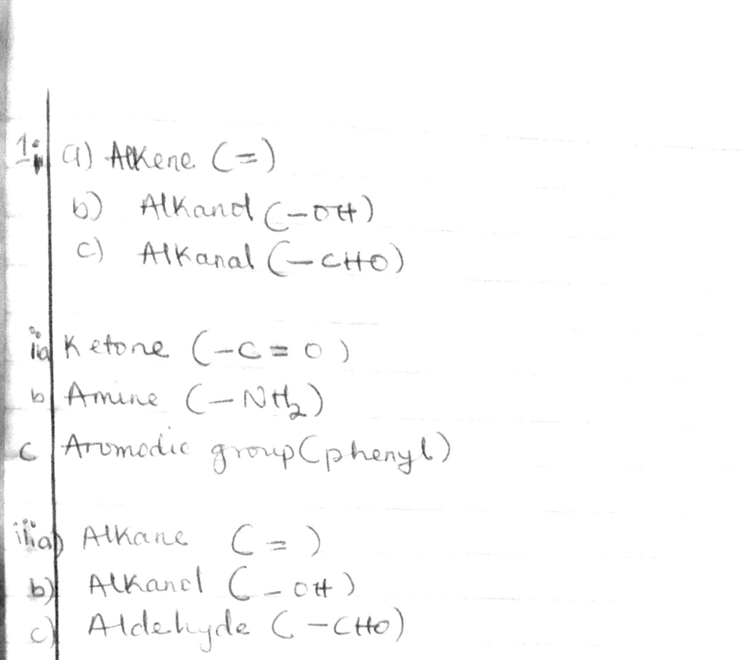

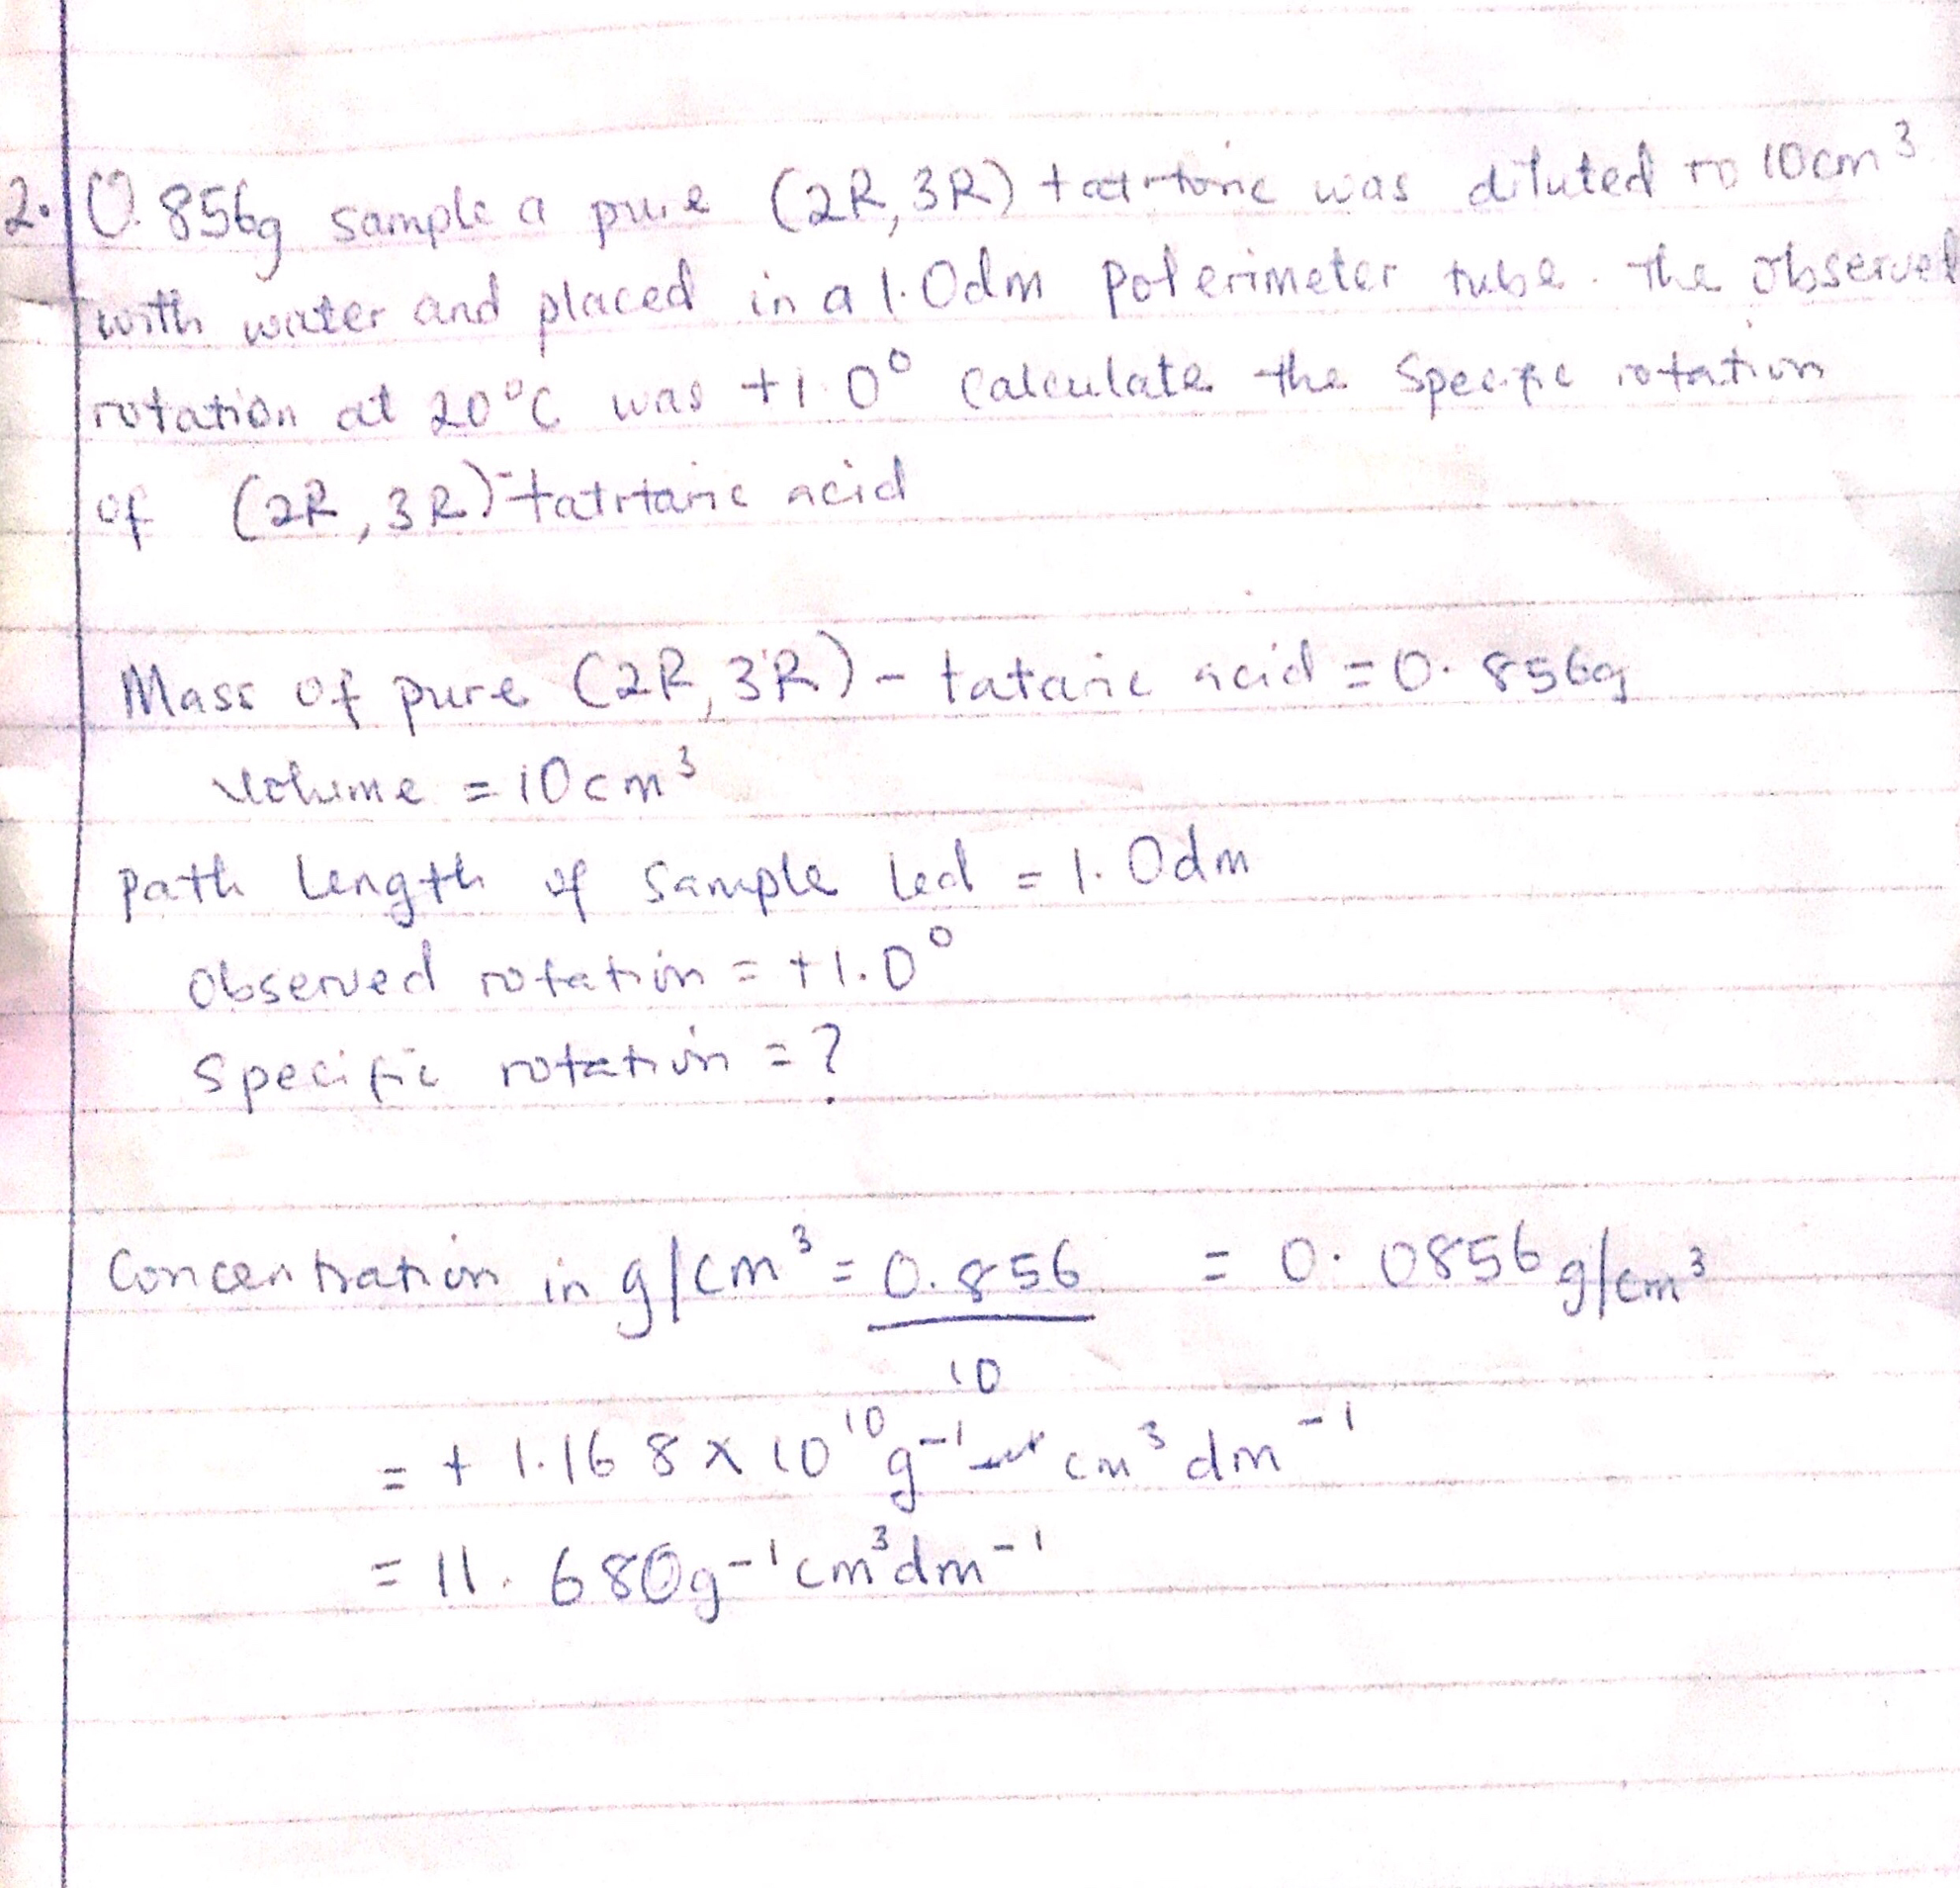

3. Draw the possible geometric isomers (where possible) for each of the following compounds:

- Hexa-2,4-diene (ii) 2,3-Dimethylbut-2-ene
