NAME: ADETOKUNBO PRECIOUS ADEMIDE
MATRIC NO: 19/MHS11/015
PHARMACY
CHM102
STEREOCHEMISTRY AND FUNCTIONAL GROUPS
- Name the functional group present in each of the following molwcules
- CH₂=C(OH)HCHO - Aldehyde/Carbonyl group-COH
- Alkene =
- Alcohol-OH
- C₆H₅CH(NH₂)COCH₃ - Amines
- CH₃C=CHCH(OH)CHO - Alkene
- Alcohol
- Aldehyde
- A 0.856 g sample of pure (2R, 3R)- tatrtaric acid was diluted to 10cm³ with water and placed in a 1.0 dm polarimeter tube. The observation at 20⁰c was +1.0⁰. Calculate the specific rotation of (2R, 3R)-tatrtaric acid.
WHERE ꙋ = SPECIFIC ROTATION
[ꙋ] = ꙋ observed
------------------
C*I
ꙋobserved = +1.0º
c = 0.856g/10cm³
= 0.856g/10ml
I = 1.0dm
[ꙋ] = +1.0º
---------------
0.856g/10ml*1.0dm
= +11.68º
- Draw the possible geometric isomers (where possible) for each of the following compounds
- Hexa-2-4-diene
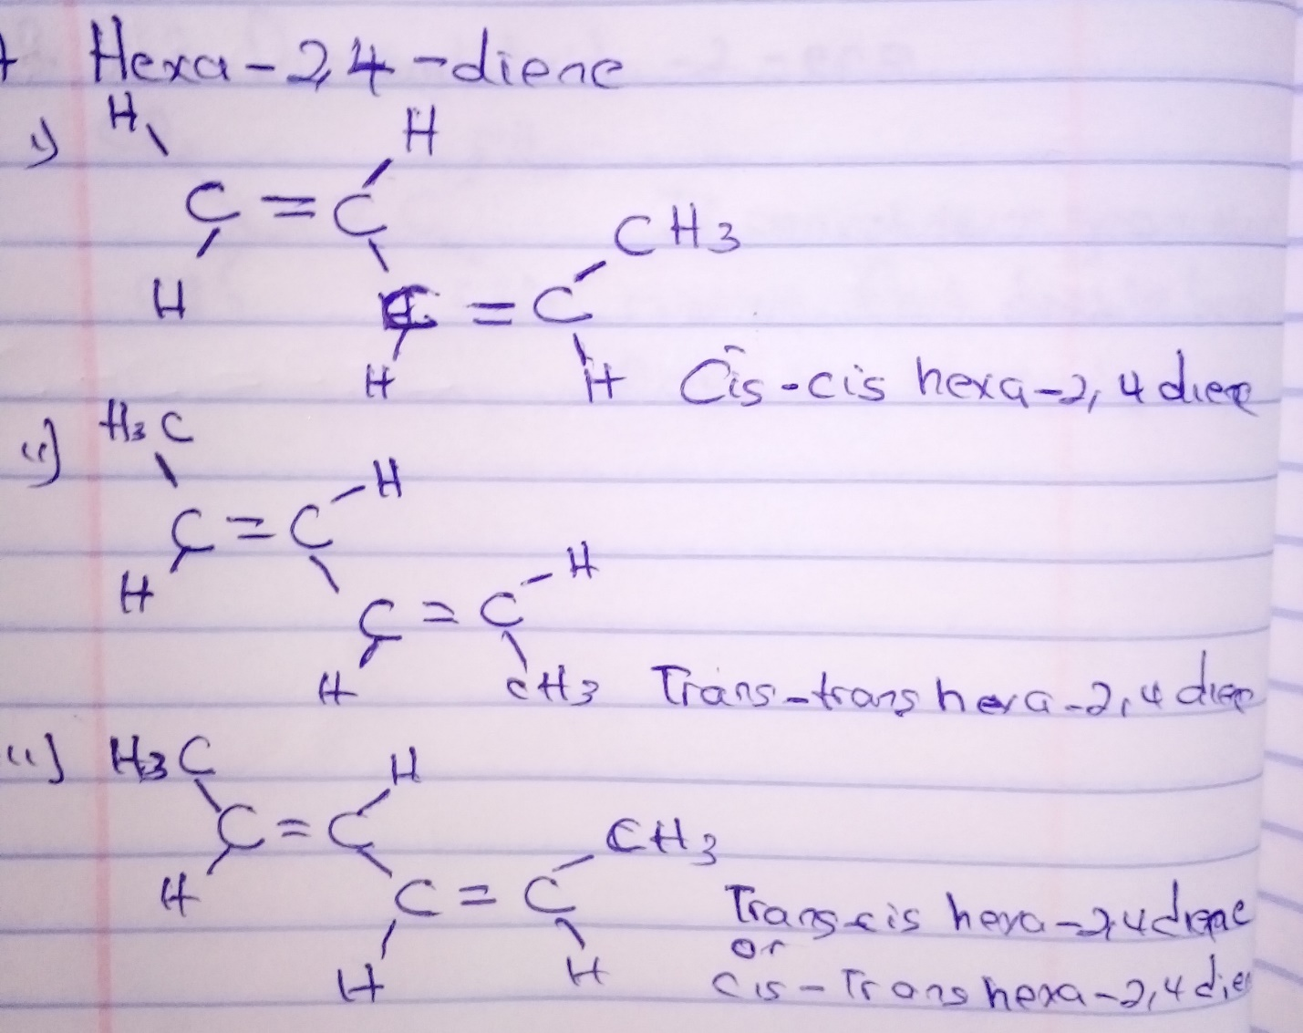
- 2,3 Dimethyl but-2-ene
