NAME: AJAYI TOLUWANIMI HANNAH
COURSE: EMBRYOLOGY
MATRIC NUMBER: 18/MHS01/045
DEPARTMENT: MEDICINE AND SURGERY
LEVEL: 200
ASSIGNMENT: DISCUSS THE SECOND WEEK OF EMBRYONIC DEVELOPMENT

INTRODUCTION
Key events of human development occur during the second week (week 2) following fertilization.
Week 2 is about the implantation process and blastocyst differentiation. All cells produced from the initial fertilization event are defined as the "conceptus" and will include cells with both embryonic and extra-embryonic futures. In the conceptus, this is a period of the blastocyst undergoing rapid blastocyst differentiation into extra-embryonic and embryonic tissues. In placental animals, this is the first physical interaction between the conceptus and the maternal uterine wall with the commencement of implantation.
The implanting conceptus releases a hormone (human Chorionic Gonadotropin or HCG) that initiates maternal hormonal changes, stopping the menstrual cycle. Detection of HCG in maternal urine or blood is also the basis of many modern pregnancy tests.
During the second week of embryonic development, 3 major events take place;
- Implantation process is completed
- Formation of a bilaminar germ disc
- Development of extra-embryonic structures

DAY 8
On this day the blastocyst begins to erode the endometrium and thus implantation begins. The embryoblast (the mass of cells inside the primordial embryo that will eventually give rise to the definitive structures of the fetus), begins to differentiate into two types of cells.
- The coboidal shaped cells called the hypoblast
- The columnar shaped cells called the epiblast
These two cells give rise to what is called the bilaminar germ disc.
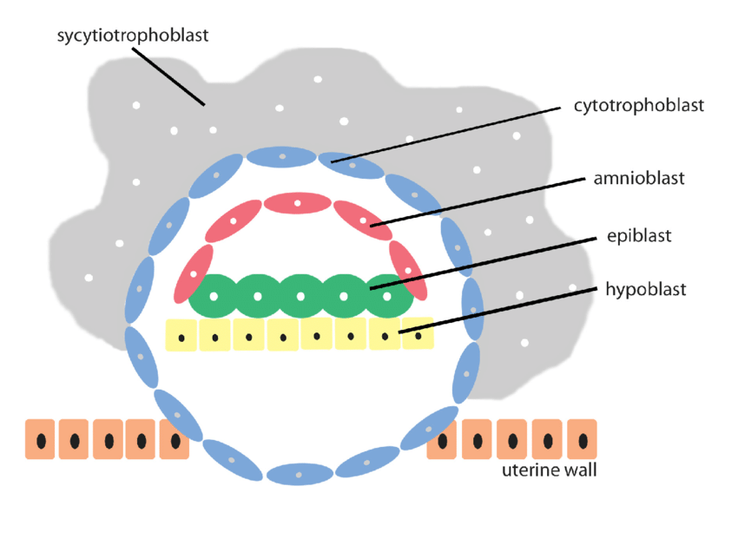

DAY 9
The blastocyst erodes the endometrium and is now deeply embedded. The surface epithelium is closed by a substance called the fibrin coagulum (which is a semi solidified mass, as of blood or lymph). Adjacent to the cytiotrophoblast is the exocoelomic membrane. There is a formation of vacuoles called trophoblastic lacunae in the syncytiotrophoblast.
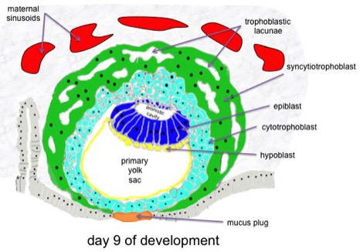

DAY 10-12
At this stage the blastocyst is deeply embedded in the endometrium. Some capillaries rupture to form sinusoids, which communicate with the lacunae to transfer oxygen and blood between the mother and conceptus, this can also be referred to as the formation of a primordial utero-placental circulation.
A space is formed between the amnioblast and cytiotrophoblast, and also between the exocoelomic membrane and the cytiotrophoblast. This space is called the extra-embryonic mesoderm. Cavities develop in this mesoderm, they are called extra-embryonic coelum. This coelum divides the mesoderm into 2 parts. The part of the mesoderm that lines the region of the cytiotrophoblast is referred to as the extra-embryonic somatic mesoderm.
In this stage, there is an accumulation of glycogen and lipid in the cytoplasm, which causes a decidual reaction to occur. The cells are then called decidual cells. These cells provide nutrition for the early embryo and immunologically privileged site for the conceptus.
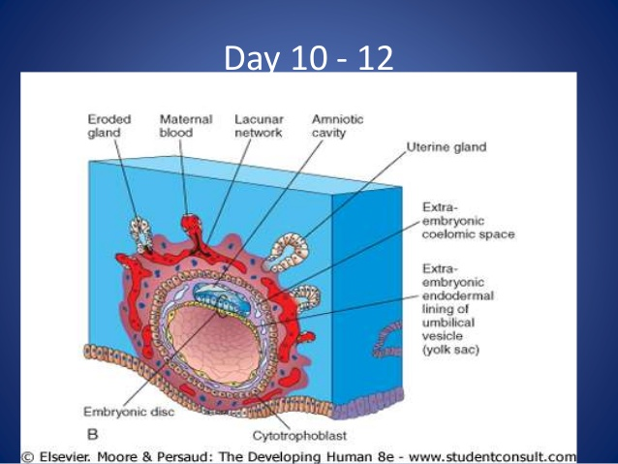

DAY 13
The cytiotrophoblasts of the conceptus acquire syncytium on their cells to form what is known as the primary villi. The extra-embryonic cavity also enlarges to form the chorionic cavity. A portion of the primary yolk sac is removed to form the secondary yolk sac. The removed portion is thus known as the exocoelomatic cyst.

