Aderinola Deborah Ademidun
19/MHS11/010
Pharmacy
CHM 102 ass

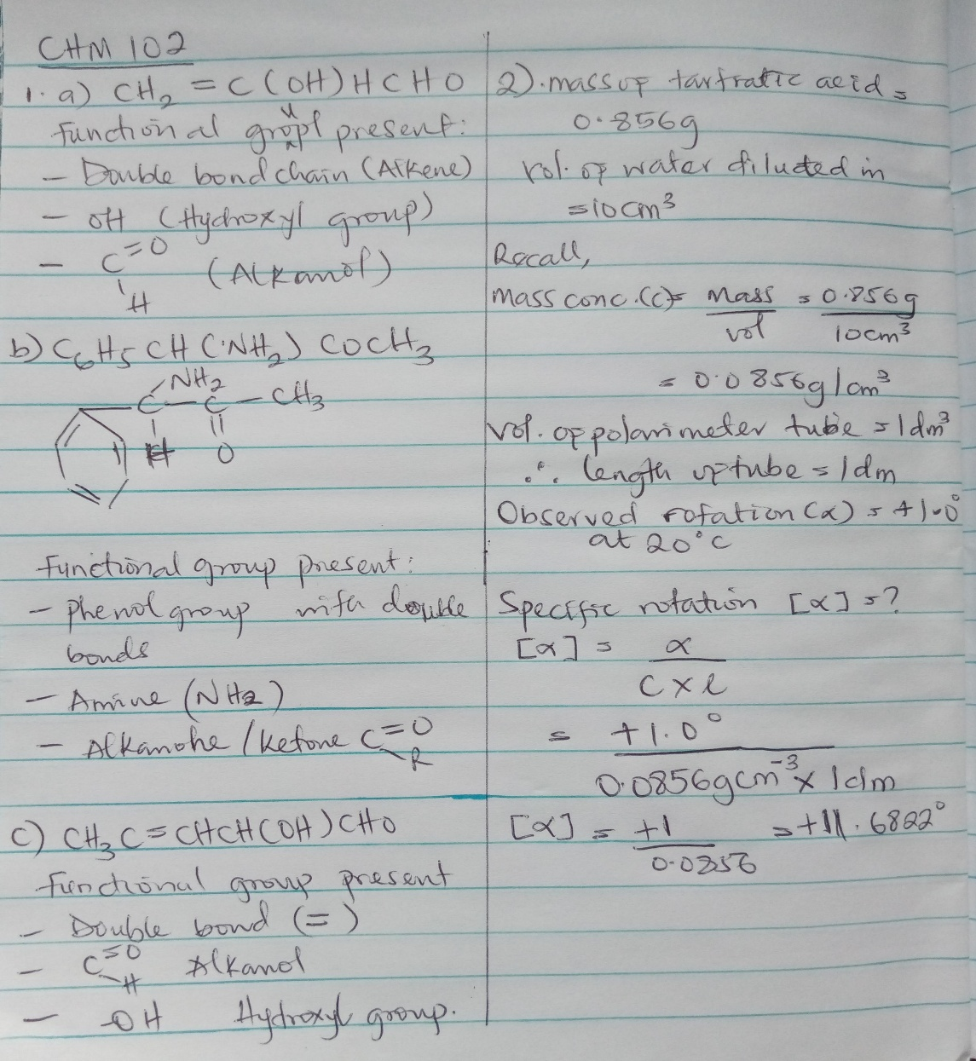
1&2.

3. Hexa-2,4-diene – has only 3 isomers
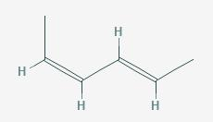
Isomers
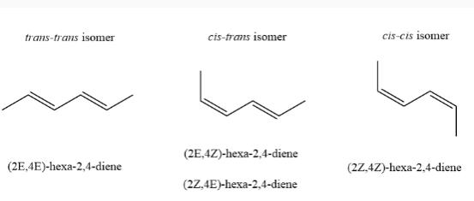

B. 2,3 dimethy but-2-ene. - does not have geometric isomers because there are two identical groups attached to the same carbon of the double bond.
