NAME: Molokwu Valerie Odirachukwumma R.C
MATRIC NO.: 19/ENG05/038
DEPT./COLLEGE: Mechatronics Engineering.
COURSE: CHM 102
ASSIGNMENT.
1. Name the functional groups present in each of the following molecules
(i) CH₂=C(OH)HCHO. ANS= Functional group – Alkene (double bond)
-OH (hydroxyl group)
- CHO (Aldehydes)
(ii) C₆H₅CH(NH₂) COCH₃ ANS= Functional group – Ketone
(iii) CH₃C=CHCH(OH)CHO. ANS= Functional group – Alkene
- Aldehyde (CHO)

2. A 0.856 g sample of pure (2R, 3R)-tatrtaric acid was diluted to 10cm3 with water and placed in a 1.0 dm polarimeter tube. the observed rotation at 20⁰ C was +1.0⁰. Calculate the specific rotation of (2R, 3R)-tatrtaric acid.
Recall,${\left[α\right]}_{A}^{T}$ = $\frac{α}{IxC}$
Where, l = length
C= $mass÷volume\frac{g}{mol}$
S₁ = $\frac{1⋅0}{10}x\left(\frac{0⋅8}{1⋅0}\right)$
= 11.68

3. Draw the possible geometric isomers (where possible) for each of the following compounds:
(i) $Hexa-2,4-diene$ ANS= 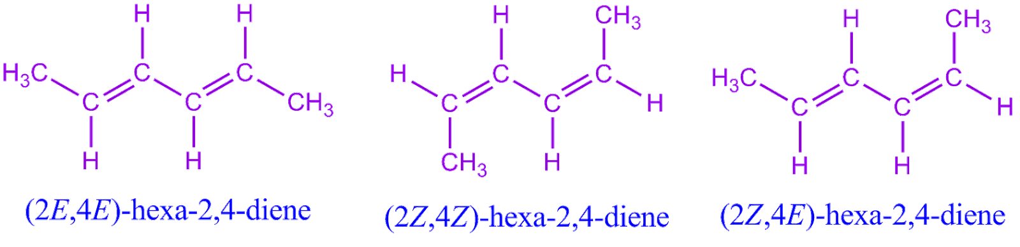
(ii) 2,3-Dimethylbut-2-ene ANS=
