NAME: OSATIMEHIN VICTOR AYOTOMIDE
DEPARTMENT: DENTISTRY
MATRIC NUMBER: 19/MHS09/109
COURSE CODE: CHM 102
- Alcohols are very important organic compounds. Discuss briefly their classification and give one example each.
ANSWER = CLASSIFICATION OF ALKANOLS
- The first classification is based on the number of atoms attached to the carbon atom containing the hydroxyl group.
For instance: if the number of hydrogen atom attached to the carbon atom bearing the hydroxyl group are 3 or 2, then it is called a primary alcohol, if it is one hydrogen atom it is called secondary alcohol and if no hydrogen atom is attached to the carbon atom bearing the hydroxyl group, it is called a tertiary alcohol.
Example: CH3CH2OH Ethanol (Primary alcohol)
CH3CH(OH)CH3 Propanol-2-ol (Secondary alcohol)
- The second classification is based on the number of hydroxyl groups they possess;
Monohydric alcohol have one hydroxyl group present in the structure, Dihydric alcohol have two hydroxyl groups present in the alcohol structure, Trihydric alcohol have three hydroxyl group present in the alcohol structure while polyhydric alcohol have more than three hydroxyl groups.
Example: CH3CH2OH ------> Ethanol (Monohydric alcolol)
CH3CH(OH)CH(OH)CH(OH)CH(OH)CH(OH)CH3 -----> Heptane-2,3,4,5,6-pentanol (Polyhydric alcohol)
- Discuss the solubility of alcohols in water, organic solvents
-WATER
Lower alcohols with up to three carbon atoms in their molecule are solubility in water because these lower alcohols can form hydrogen bond with water molecules. The water solubility of alcohols decreases with increasing relative molecular mass
-ORGANIC SOLVENT
All monohydric alcohols are soluble in organic solvents. The solubility of simple alcohols and polyhydric alcohols is largely due to their ability to form hydrogen bonds with water molecules.
- Show the three steps in the industrial manufacture of ethanol. Equations of reaction are mandatory
Carbohydrate is broken down into maltose on addition of diastase contained in malt at 60°C
2(C6H10O5)n + nH20 ---------------------------------------> nC12H22O11
carbohydrate 60°/diastase Maltose
Maltose is then broken down into glucose on addition of yeast which contains the enzyme maltase and at a temperature of 15°C
C12H22O11 + H20 --------------------------------------> 2C6H12O6
Maltose 15°C/maltose Glucose
The glucose at constant temperature of 15°C is then converted into alcohol by the enzyme Zymase contained also in yeast
C6H12O --------------------------------------> 2CH3CH2OH + 2CO2
Glucose 15°C/Zymase Ethanol

- Show the reaction between 2-methylpropanal and butylmagnesiumchloride Grignard synthesis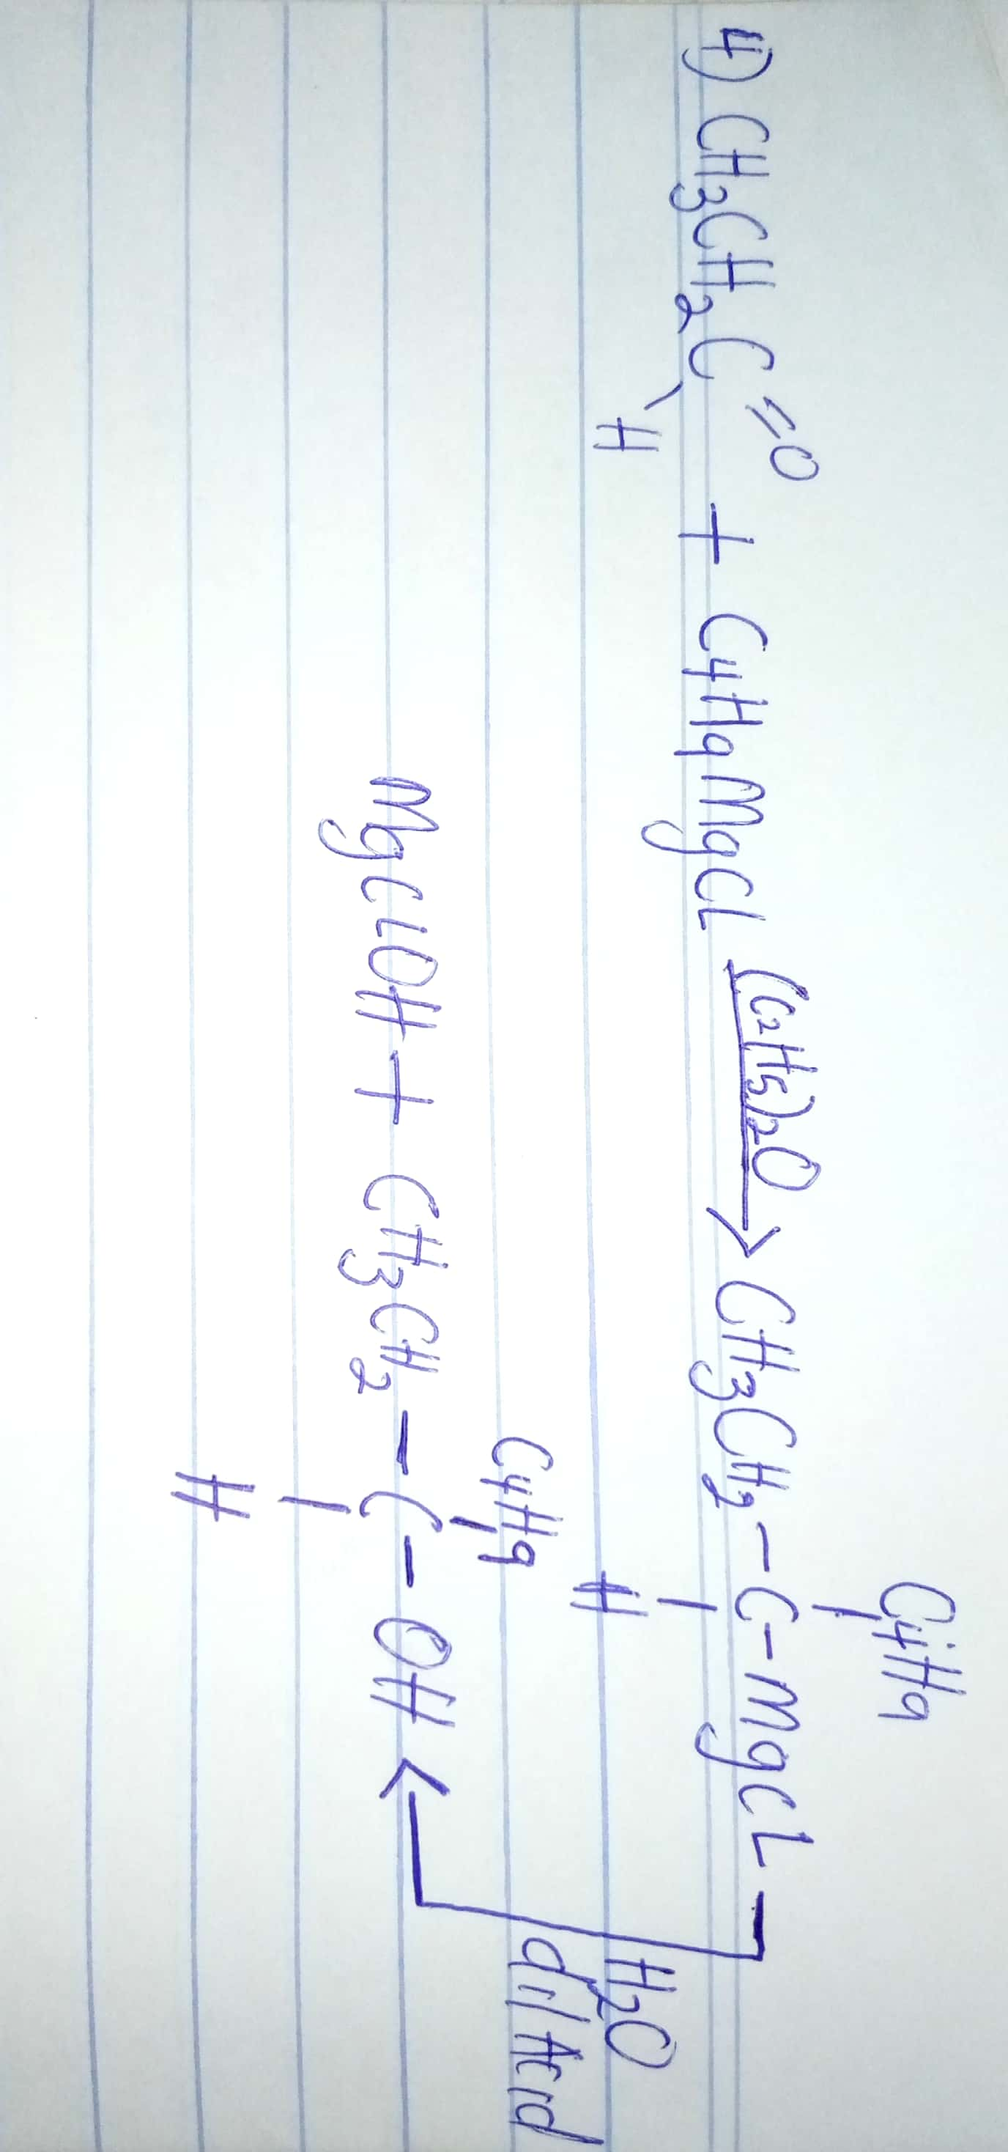

- Show the reduction reaction of 2-methylpropanal
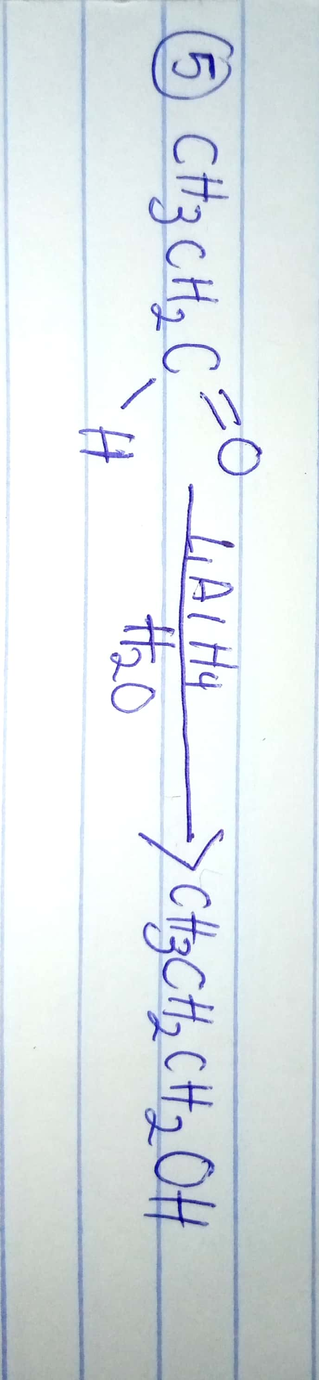
- Propose a scheme for the conversion of propan-1-ol to propan-2-ol.
