NAME: ABUDU, PRECIOUS ESTHER
MATRIC NO: 17/MHS01/008
LEVEL: 300
DEPARTMENT: MEDICINE AND SURGERY
COURSE CODE: PHS 303
COURSE TITLE: RENAL PHYSIOLOGY BODY FLUID AND TEMPERATURE REGULATION
RENAL PHYSIOLOGY FOR MBBS STUDENTS
Question
Assignment
Q1. Discuss the role of kidney in glucose homeostasis?
Q2. Discuss the process of micturition?
Q3. Explain juxtaglomerular apparatus?
Q4 Discuss the role of kidney in regulation of blood pressure?
Q5. Discuss the role of Kidney in Calcium homeostasis?

Answer
Q1. Role of kidney in glucose homeostasis
The maintenance of normal glucose homeostasis requires a complex, highly integrated interaction among the liver, muscle, adipocytes, pancreas and neuroendocrine system. Recent studies have showed that the kidneys also play a central role in glucose homeostasis by reabsorbing all the filtered glucose, an adaptive mechanism that ensures sufficient energy is available during fasting periods.

Renal release of glucose into the circulation is the result of glycogenolysis and gluconeogenesis, respectively involving the breaking down and formation of glucose-6-phosphate from precursors (e.g., lactate, glycerol, amino acids). With regard to renal reabsorption of glucose, the kidneys normally retrieve as much glucose as possible, rendering the urine virtually glucose free. The glomeruli filter from plasma approximately 180 grams of D-glucose per day, all of which is reabsorbed through glucose transporter proteins that are present in cell membranes within the proximal tubules. If the capacity of these transporters is exceeded, glucose appears in the urine.

The process of renal glucose reabsorption is mediated by active (sodium-coupled glucose cotransporters) and passive (glucose transporters) transporters. In hyperglycemia, the kidneys may play an exacerbating role by reabsorbing excess glucose, ultimately contributing to chronic hyperglycemia, which in turn contributes to chronic glycemic burden and the risk of microvascular consequences. This article provides an extensive review of the kidneys’ role in normal human physiology, the mechanisms by which they contribute to glucose regulation, and the potential impact of glucose imbalance on the kidneys.

The kidneys are essentially designed to filter large quantities of plasma, reabsorb substances that the body must conserve, and secrete substances that must be eliminated. These basic functions are critical to regulation of fluid and electrolyte balance, body fluid osmolality, acid-based balance, excretion of metabolic waste and foreign chemicals, arterial pressure, hormone secretion, and, most relevant to this discussion, glucose balance. The 2 kidneys produce a total of approximately 120 mL/min of ultrafiltrate, yet only 1 mL/min of urine is produced.

The basic urine-forming unit of the kidney is the nephron, which serves to filter water and small solutes from plasma and reabsorb electrolytes, amino acids, glucose, and protein. The nephron, of which there are approximately 1 million in each kidney, consists of a filtering apparatus (the glomerulus) that is connected to a long tubular portion that reabsorbs and conditions the glomerular ultrafiltrate. Fluid filtered from the glomerular capillaries flows into the tubular portion, which is made up of a proximal tubule, the Loop of Henle, and the distal tubule, all of which assist in reabsorbing essential substances and converting filtered fluid into urine.

Under normal conditions, the kidneys retrieve as much glucose as possible, rendering the urine virtually glucose free. The glomeruli filter from plasma approximately 180 grams of D-glucose per day, all of which is reabsorbed through glucose transporter proteins that are present in cell membranes within the proximal tubules.4 If the capacity of these transporters is exceeded, glucose appears in the urine. This maximum capacity, known as the tubular maximum for glucose (TmG), ranges from 260 to 350 mg/min/1.73 m2 in healthy adults and children, and corresponds to a plasma glucose level of approximately 200 mg/dL. Once the TmG (the threshold) is reached and transporters are unable to reabsorb all the glucose (as in T2DM), glucosuria occurs.

Q2. Process of Micturition
Micturition or urination is the process of expelling urine from the bladder. This act is also known as voiding of the bladder. The excretory system in humans includes a pair of kidneys, two ureters, a urinary bladder and a urethra. The kidneys filter the urine and it is transported to the urinary bladder via the ureters where it is stored till its expulsion. The process of micturition is regulated by the nervous system and the muscles of the bladder and urethra. The urinary bladder can store around 350-400ml of urine before it expels it out.

Stages of Micturition

The urinary bladder has two distinct stages or phases:
- Resting or filling stage
- Voiding or emptying stage

- Resting or Filling Stage
It is in this phase of the bladder that the urine is transported from the kidneys via the ureters into the bladder. The ureters are thin muscular tubes that arise from each of the kidneys and extend downwards where they enter the bladder obliquely.
The oblique placement of the ureters in the bladder wall serves a very important function. The opening of the ureter into the urinary bladder is not guarded by any sphincter or muscle. Therefore, this oblique nature of opening prevents the urine from re-entering the ureters. At the same time, the main muscle of the urinary bladder, the detrusor muscle, is relaxing allowing the bladder to distend and accommodate more urine.

The filling phase is characterized by voluntary contraction of the external urethral sphincter, with sympathetic contraction of the inner urethral sphincter. The sympathetic nervous system also enables the detrusor to distend without reflex contractions, unlike that which happens in most voluntary muscles.
Urethral reflexes, called ‘the guarding reflex,’ also play a part in inhibiting involuntary bladder emptying during this process. The afferents are all conveyed through the pelvic nerves to initiate a spinal reflex.

- Voiding or Emptying Stage
During this stage, both the urinary bladder and the urethra come into play together. The detrusor muscle of the urinary bladder which was relaxing so far starts to contract once the bladder’s storage capacity is reached.
The urethra is controlled by two sets of muscles: The internal and external urethral sphincters. The internal sphincter is a smooth muscle whereas the external one is skeletal. Both these sphincters are in a contracted state during the filling stage.

The micturition or emptying phase displays a coordinated relaxation of the inner and outer urethral sphincters, under sympathetic and somatic regulation respectively, with strong contractions of the detrusor muscle due to parasympathetic impulses.
Micturition is thus characterized by:
- relaxation of the striated sphincter (somatic innervation)
- relaxation of the smooth muscle sphincter and opening of the bladder neck (sympathetic innervation)
- detrusor contraction (parasympathetic innervation)
The distension of the urinary bladder wall causes wall tension to rise very slightly. However, when the bladder is almost full, at about 300-400 ml, the inherent contractility of the detrusor causes reflex contractions to occur, which are less powerful than the voiding contraction. Afferent firing frequency increases with filling, but cortical control still overrides the micturition reflex until voluntary voiding is determined upon.

During micturition, urinary flow is assisted by additional detrusor contractions and external sphincter relaxation which further lowers resistance to the passage of urine. The abdominal wall and pelvic floor musculature also participates by increasing the force on the bladder to help achieve complete emptying.

Spinal Reflex Arcs
The act of micturition is an autonomic reflex at the level of the spinal cord. This reflex also helps to complete micturition when the act is voluntarily initiated, or when it follows a period of inhibition by the brain, by relaxing the external sphincter.

The control of this process is mediated via afferent signals from stretch and volume receptors in the bladder, as well as from the muscles of the pelvic floor, the vagina/penis, and the rectum, which informs the brain about the extent of filling, initiating several spinal reflexes. These serve to inhibit micturition until filling is complete, while activating the voluntary external urethral sphincter via the pudendal nerve. At the same time, detrusor activity is inhibited and the internal urethral sphincter is stimulated via sympathetic activity. Impulses from the filling bladder are carried to the spinal cord via the pelvic and hypogastric nerves, whereas the pudendal and hypogastric nerves carry impulses from the neck of the bladder and the urethra.

Pontine Micturition Center
The pontine micturition center (PMC) in the brainstem is activated via afferent signals from the urinary bladder as it is filling. This center sends inhibitory impulses to the spinal reflex arcs to enable bladder voiding.

In the absence of any other regulation, the afferents from the bladder and urethra to the midbrain and pons and the efferents to the spinal cord would act as an on-off switch, to cause either reflex voiding or storage depending only on the urine volume stored in the bladder. This means that during the filling or storage phase, the voiding reflex is off, but it is switched on to the highest level when the bladder is distended beyond a critical point, activating the tension receptors in the wall.

Central Nervous System Regulation
As the bladder fills, the conscious sensation is perceived and the cortical signals are triggered. This inhibits the purely involuntary firing of the voiding reflex and instead helps the individual to control voiding until the time and place are appropriate. This includes social, sensory, and emotional states, including the degree to which bladder stretching is sensed to be safe and tolerable.

The cell group in the periaqueductal gray (PAG) plays a role in detecting the bladder distension, as well as in relaying bladder afferents to higher centers in the brain and enabling the person to feel the sensation. It also regulates the feed to the pontine center, while receiving afferents from higher brain centers such as the anterior cingulate and the prefrontal cortex. These help to inhibit the voiding reflex via suppression of PMC excitation.

The PMC neurons are released from inhibition and fire maximally once the voluntary signal for voiding is produced. This causes excitation of the sacral neurons which stimulate detrusor contractions and induce a sudden increase in turn of intravesical pressure, as well as relaxing the external or voluntary urethral sphincter. Once the intravesical pressure overcomes the urethral resistance, urine flows out through the urethra.

Micturition is thus under cortical control as well as mediated by the spinal reflex arc, which inhibits the pontine center until it is deemed appropriate to void. In addition, the motor cortex controls the voluntary muscle of the external urethral sphincter. The decision to void implies that the prefrontal cortex suppresses the tonic inhibition of the afferents from the PAG to the PMC.

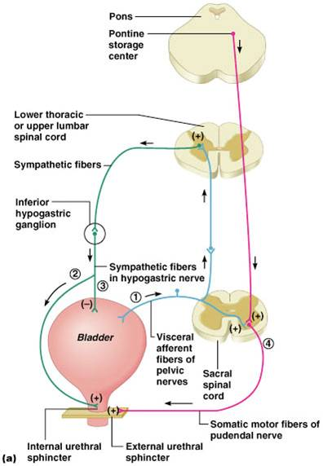

Q3. Juxtaglomerular apparatus
The juxtaglomerular apparatus is a specialized structure formed by the distal convoluted tubule and the glomerular afferent arteriole. It is located near the vascular pole of the glomerulus and its main function is to regulate blood pressure and the filtration rate of the glomerulus. The macula densa is a collection of specialized epithelial cells in the distal convoluted tubule that detect sodium concentration of the fluid in the tubule. In response to elevated sodium, the macula densa cells trigger contraction of the afferent arteriole, reducing flow of blood to the glomerulus and the glomerular filtration rate.

The juxtaglomerular cells, derived from smooth muscle cells, of the afferent arteriole secrete renin when blood pressure in the arteriole falls. Renin increases blood pressure via the renin-angiotensin-aldosterone system. Lacis cells, also called extraglomerular mesangial cells, are flat and elongated cells located near the macula densa. Their function is unknown.

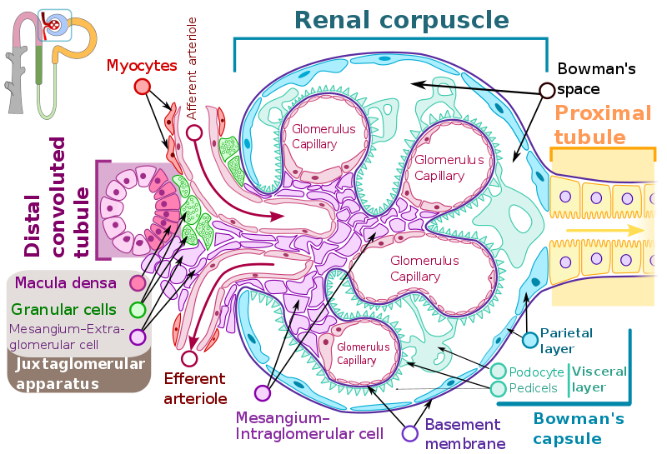

Q4. Role of kidney in regulation of blood pressure
The kidneys play a central role in the regulation of arterial blood pressure. A large body of experimental and physiological evidence indicates that renal control of extracellular volume and renal perfusion pressure are closely involved in maintaining the arterial circulation and blood pressure. Renal artery perfusion pressure directly regulates sodium excretion; a process known as pressure natriuresis, and influences the activity of various vasoactive systems such as the renin–angiotensin–aldosterone (RAS) system.

Along with vessel morphology, blood viscosity is one of the key factors influencing resistance and hence blood pressure. A key modulator of blood viscosity is the renin-angiotensin system (RAS) or the renin-angiotensin-aldosterone system (RAAS), a hormone system that regulates blood pressure and water balance.

The blood pressure in the body depends upon:
- The force by which the heart pumps out blood from the ventricles of the heart - and this is dependent on how much the heart muscle gets stretched by the inflowing blood into the ventricles.
- The degree to which the arteries and arterioles constrict-- increases the resistance to blood flow, thus requiring a higher blood pressure.
- The volume of blood circulating round the body; if the volume is high, the ventricles get more filled, and the heart muscle gets more stretched.

The kidney influences blood pressure by:
- Causing the arteries and veins to constrict
- Increasing the circulating blood volume

Specialized cells called macula densa are located in a portion of the distal tubule located near and in the wall of the afferent arteriole. These cells sense the Na in the filtrate, while the arterial cells (juxtaglomerular cells) sense the blood pressure. When the blood pressure drops, the amount of filtered Na also drops. The arterial cells sense the drop in blood pressure, and the decrease in Na concentration is relayed to them by the macula densa cells. The juxtaglomerular cells then release an enzyme called renin.

Renin converts angiotensinogen (a peptide, or amino acid derivative) into angiotensin-1. Angiotensin-1 is thereafter converted to angiotensin-2 by an angiotensin-converting enzyme (ACE), found in the lungs. Angiotensin-2 causes blood vessels to contract -- the increased blood vessel constrictions elevate the blood pressure. When the volume of blood is low, arterial cells in the kidneys secrete renin directly into circulation.

Plasma renin then carries out the conversion of angiotensinogen released by the liver to angiotensin-1. Angiotensin-1 is subsequently converted to angiotensin-2 by the enzyme angiotensin converting enzyme found in the lungs. Angiotensin-2m a potent vasoactive peptide causes blood vessels to constrict, resulting in increased blood pressure. Angiotensin-2 also stimulates the secretion of the hormone aldosterone from the adrenal cortex.

Aldosterone causes the tubules of the kidneys to increase the reabsorption of sodium and water into the blood. This increases the volume of fluid in the body, which also increases blood pressure. If the renin-angiotensin-aldosterone system is too active, blood pressure will be too high.

Many drugs interrupt different steps in this system to lower blood pressure. These drugs are one of the main ways to control high blood pressure (hypertension), heart failure, kidney failure, and harmful effects of diabetes. It is believed that angiotensin-1 may have some minor activity, but angiotensin-2 is the major bioactive product. Angiotensin-2 has a variety of effects on the body: throughout the body, it is a potent vasoconstrictor of arterioles

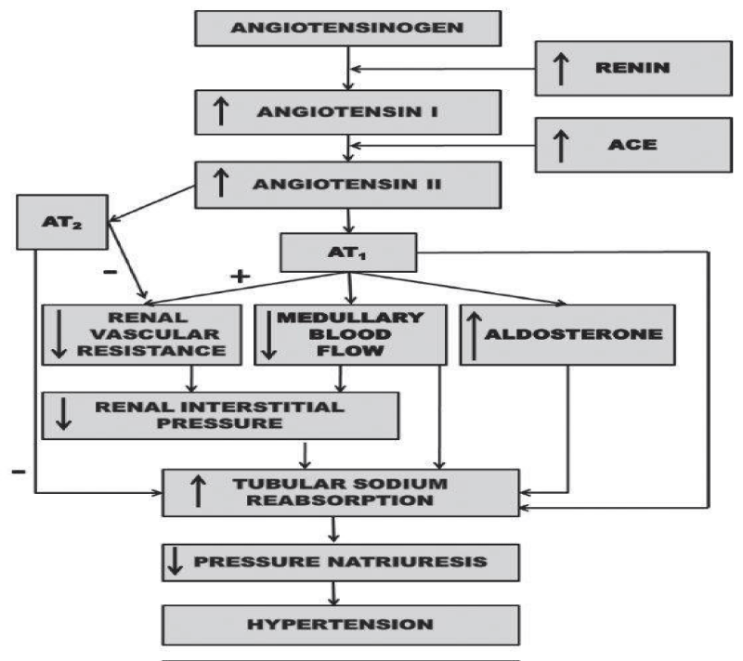
Fig: Renal mechanism whereby activation of the renin-angiotensin system reduces pressure natriuresis relationship and leads to hypertension

Q5. Role of kidney in calcium homeostasis
The maintenance of calcium homeostasis is very important because calcium is the main component of bony skeleton and serves as the intracellular and extracellular messenger in numerous essential cellular events such as neuronal network, immune response, muscle contraction, and hormone secretion. Total body calcium in the adult human is about 1-2 kg and 99% of total calcium exists in bone.

Even though only less than 1% of body calcium is in the extracellular space, maintaining the extracellular calcium concentration within a narrow range (8.5-10.5 mg/dL) is very important for calcium homeostasis. Approximately 40% of plasma calcium is protein-bound and 10% of calcium is in a complex with anions like phosphate, citrate, and sulfate etc. Only half of plasma calcium is in its free form (ionized form, iCa²⁺) and physiologically important. The ionized calcium is tightly regulated by hormones like parathyroid hormone (PTH), 1,25-dihydroxyvitamin D₃ (1,25(OH)₂D₃), calcitonin, and calcium itself. The kidney, intestine, and bone are the main target organs of these regulators, and the kidney plays a key role in the fine regulation of calcium excretion.

About 50% of plasma calcium (ionized and complexed form; ultrafilterable fraction, excluding the protein bound form) is freely filtered through the renal glomerulus, and 99% of the filtered calcium is actually reabsorbed along renal tubules. The excreted calcium in the final urine is about 200 mg per day in an adult person with an average diet. Several factors are involved in the regulation of calcium in renal tubules. PTH and activated vitamin D enhance calcium reabsorption in the thick ascending limb (TAL), distal convoluted tubule (DCT) and/or connecting tubule (CNT), and estrogen promotes calcium absorption in the DCT/CNT.

Acidosis contributes to hypercalciuria by reducing calcium reabsorption in the proximal tubule (PT) and DCT, and alkalosis vice versa. Diuretics like thiazide and furosemide also alter calcium absorption in the renal tubules; thiazide promotes calcium reabsorption and furosemide inhibits it. Plasma calcium itself also controls renal calcium absorption through altered PTH secretion as well as via binding to the calcium sensing receptor (CaSR) in the TAL.

To facilitate Ca²⁺ reabsorption along renal tubules;
- voltage difference between the lumen and blood compartment should be favorable for Ca²⁺ passage, i.e., a positive voltage in the lumen;
- concentration difference should be favorable for Ca²⁺ passage with a higher Ca²⁺ concentration in the lumen;
- An active transporter should exist if the voltage or concentration difference is not favorable for Ca²⁺ reabsorption. Each renal tubular segment has a different Ca²⁺ concentration difference or voltage environment for its unique mechanism for calcium reabsorption.

The kidney is critically important in calcium homeostasis. Under normal blood calcium concentrations, almost all of the calcium that enters glomerular filtrate is reabsorbed from the tubular system back into blood, which preserves blood calcium levels. If tubular reabsorption of calcium decreases, calcium is lost by excretion into urine. Healthy kidneys turn vitamin D into an active hormone (calcitriol), which helps increase calcium absorption from the intestines into the blood.

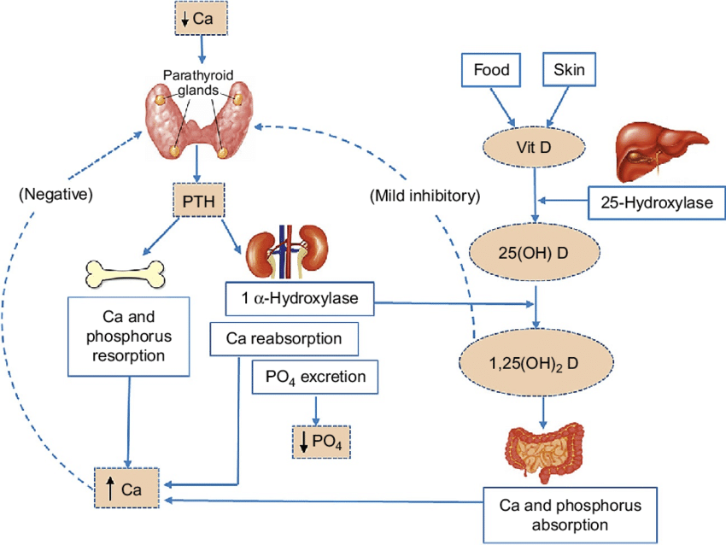
Schematic of calcium homeostasis. Solid line represents stimulatory interaction, dashed line indicates negative feedback.

The kidney has been known as the central organ for calcium homeostasis through fine regulation of renal calcium excretion. For the past decade, there has been big progress in the understanding of the roles of the kidney in calcium homeostasis. The identification of calcium transport proteins and the molecular approach to the regulatory mechanisms achieved a major contribution to this progress. TRPV5, TRPV6, calbindin-D28K, NCX1, and PMCA1b have been identified as the main calcium transport proteins in the distal nephron. PTH, vitamin D, i[Ca2+], CaSR, and other various conditions control renal calcium excretion through the regulation of these transport proteins. Klotho and FGF23 emerged as new players in calcium metabolism in the kidney.

