NAME:Mubarak Abdullahi Gwaram
MATRIC NUMBER: 19/MHS01/249
DEPARTMENT: MBBS
COLLEGE: MHS.
COURSE CODE: CHEMISTRY 102.
1.Name the functional groups present in each of the following molecules.
a.CH2=C(OH)HCHO – aldehyde group(-CHO), Hydroxyl group(-OH) and double bond.
b.C6H5CH(NH2)COCH3 – phenyl group, carbonyl group (-C=O) and amine group (NH2).
c.CH3C=CHCH(OH)CHO – hydroxyl group(-OH), aldehyde group(-CHO), and double bound.
2. A 0.856g sample of pure (2R,3R)- tatrtaric acid was diluted to 10cm3 with water and placed in a 1.0dm polarimeter tube, the observed rotation at 20^0 was +1.0^0. Calculate the specific rotation of (2R,3R)- tatrtaric acid.
Solution.
0.856g to cm3= 0.856g/10cm3 = 0.0856g/cm3.
To find specific rotation= observed rotation (degrees) /conc.* path length of sample cells in dm
=1.0/0.0856*1 = 1.0/0.0856 = 11.68= 11.7^0g^_1cm^3dm^-1.
3.Draw the possible geometric isomers (where possible) for each of the following compounds;
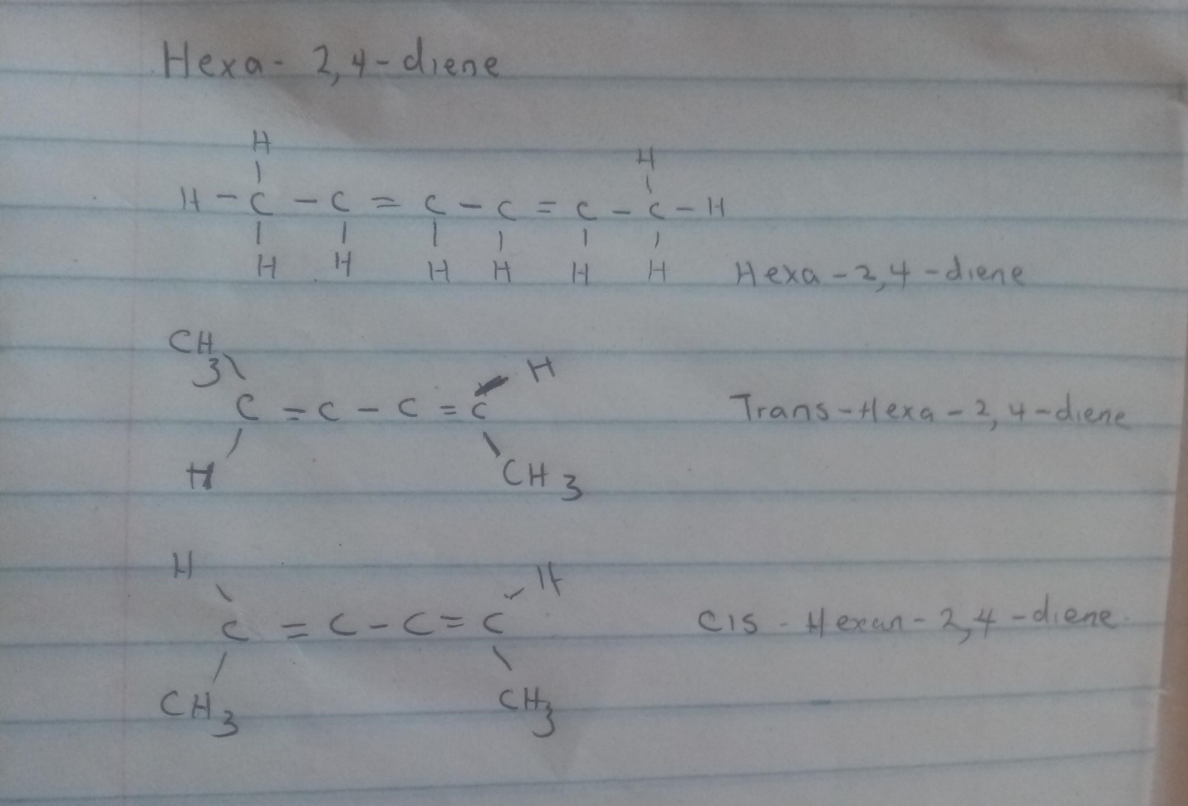
A.Hexa-2,4-diene .

2,3-dimethylbut-2-ene.
Ans: this does not have a geometric isomers because they are two identical groups attached to the same carbon of the double bond.

