NAME – ONYEMAOBI IFEANYICHUKWU OSCAR
COLLEGE- MHS
DEPARTMENT – PHARMACY
MATRIC NO- 19/MHS11/117
COURSE CODE- CHM 102

QUESTION 1-Name the functional groups present in each of the following molecules
- CH₂=C(OH)HCHO –Carbonyl group
- (ii) C₆H₅CH(NH₂)COCH₃ –carbonyl group
- (iii) CH₃C=CHCH(OH)CHO –carbonyl group
QUESTION 2- A 0.856 g sample of pure (2R, 3R)-tatrtaric acid was diluted to 10cm3 with water and placed in a 1.0 dm polarimeter tube. the observed rotation at 20⁰ C was +1.0⁰. Calculate the specific rotation of (2R, 3R)-tatrtaric acid.
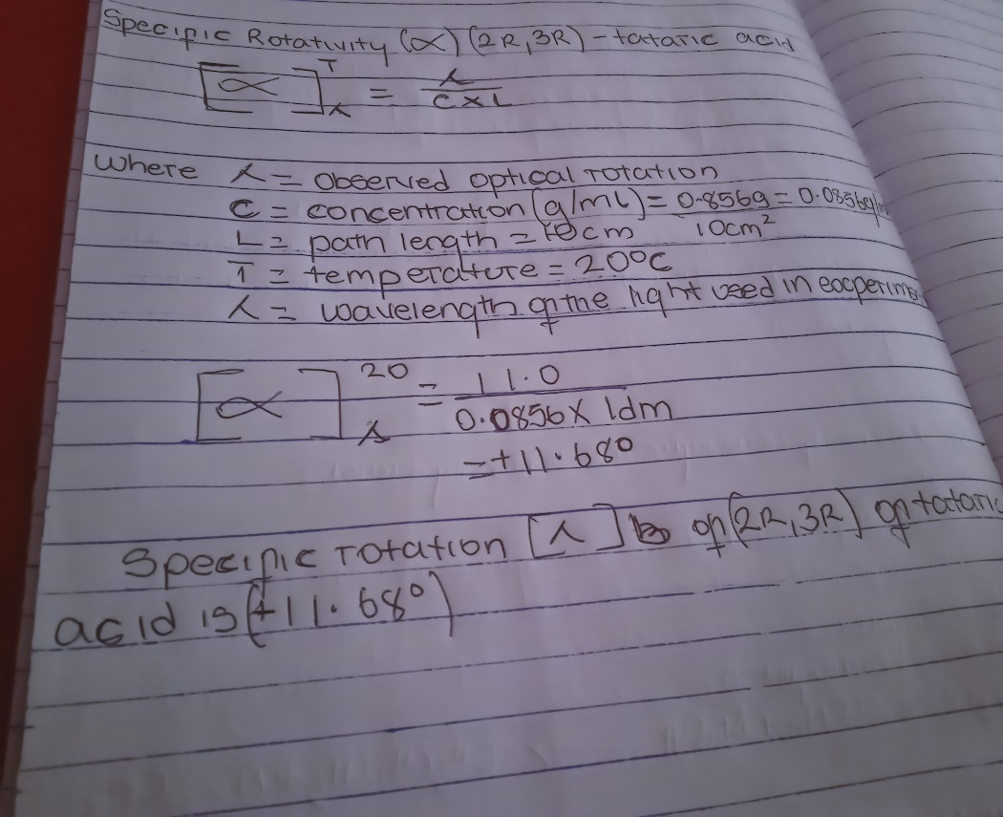

QUESTION 3-. Draw the possible geometric isomers (where possible) for each of the following compounds:

- Hexa-2,4-diene
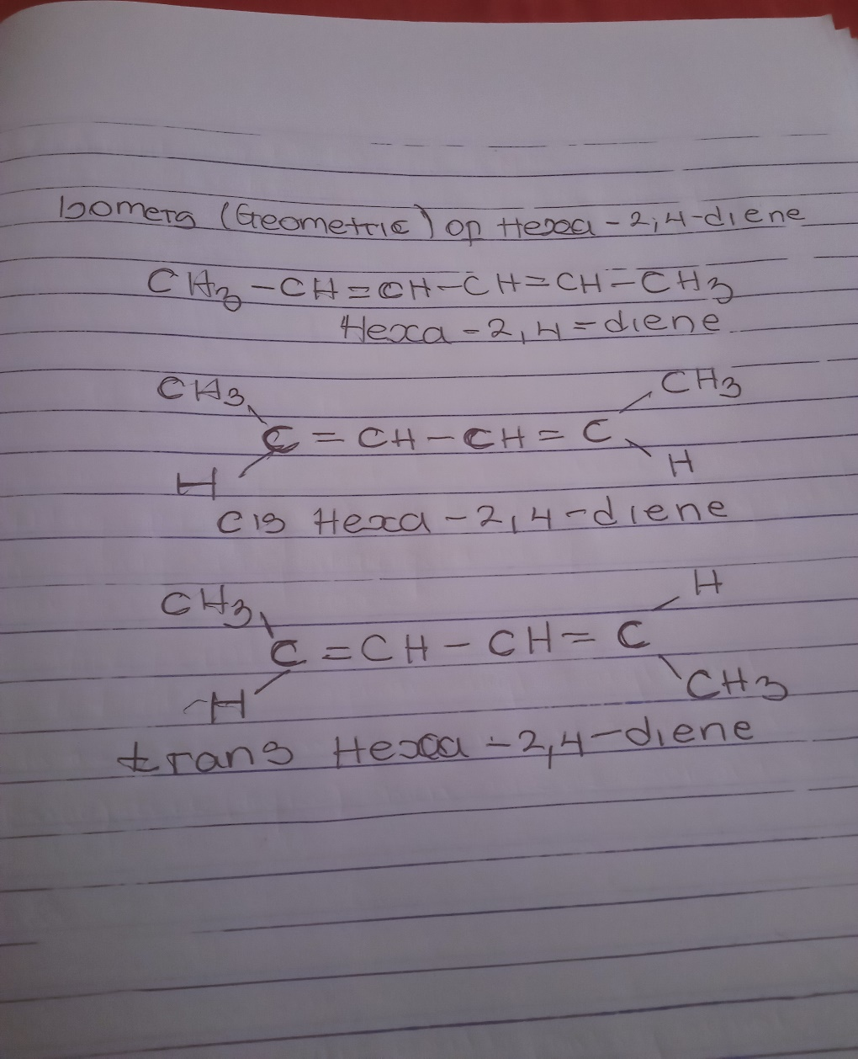
- (ii) 2,3-Dimethylbut-2-ene$∝$
