Name: Obiakor fredrick ifeanyi
College: MHS
Department: Dentistry
Matric No:19/mhs09/017
Subject: CHM 102
CHM 102 ASSIGNMENT
1&2.
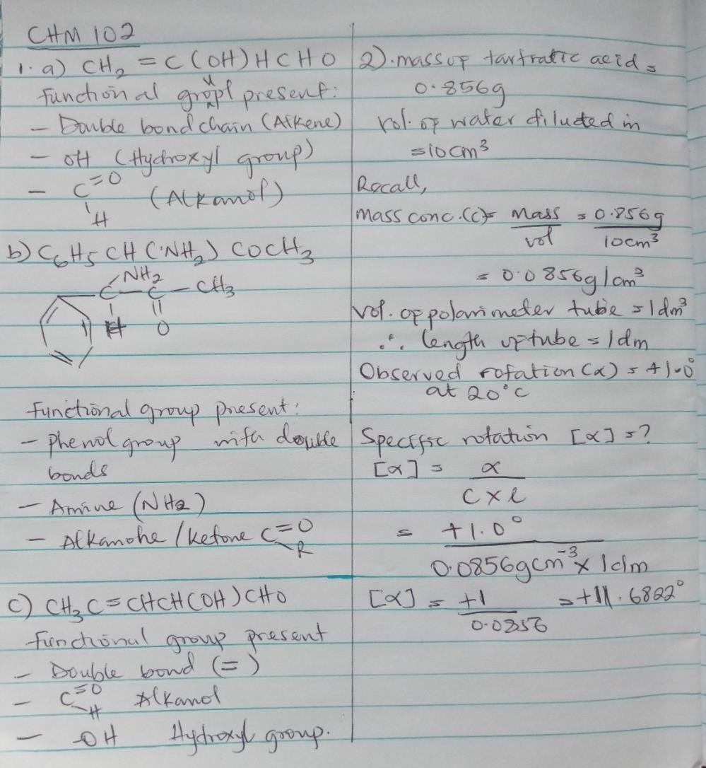

3A. Hexa-2,4-diene – has only 3 isomers
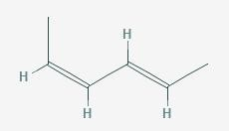

Isomers

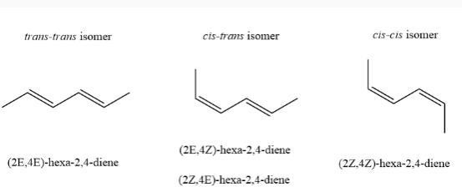

B. 2,3 dimethyl but-2-ene. - does not have geometric isomers because there are two identical groups attached to the same carbon of the double bond.

