Esien Eyo Oku
19/SCI14/014
Geology
Assignment
1a. aldehyde group, hydroxyl group, and double bond
b. phenyl group, carbonyl group, amine group
c. hydroxyl group, adhyde group and double bond
2. 0.856g to cm3=0.0856g/cm3
To specific rotation= observed rotation/conc. * path length of sample cell
=1.0*0.0856*1=11.68=11.7g^1cm^3dm^-1
3.a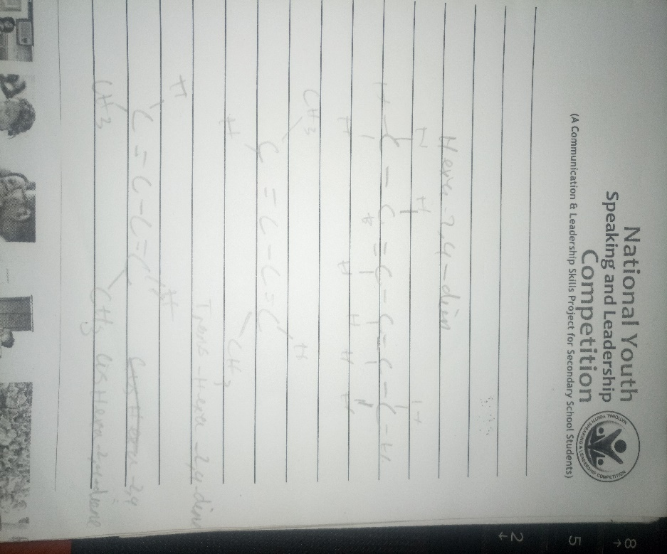
b.this does not have a geometric isomers because there are two identical groups attached to the same carbon of the double bond

