NAME- BARANGO OBELEM EMMANUELLA
COLLEGE- MHS
DEPARTMENT- PHARMACY
MATRIC NUMBER- 19/MHS11/039
COURSE CODE- CHM 102

1&2.
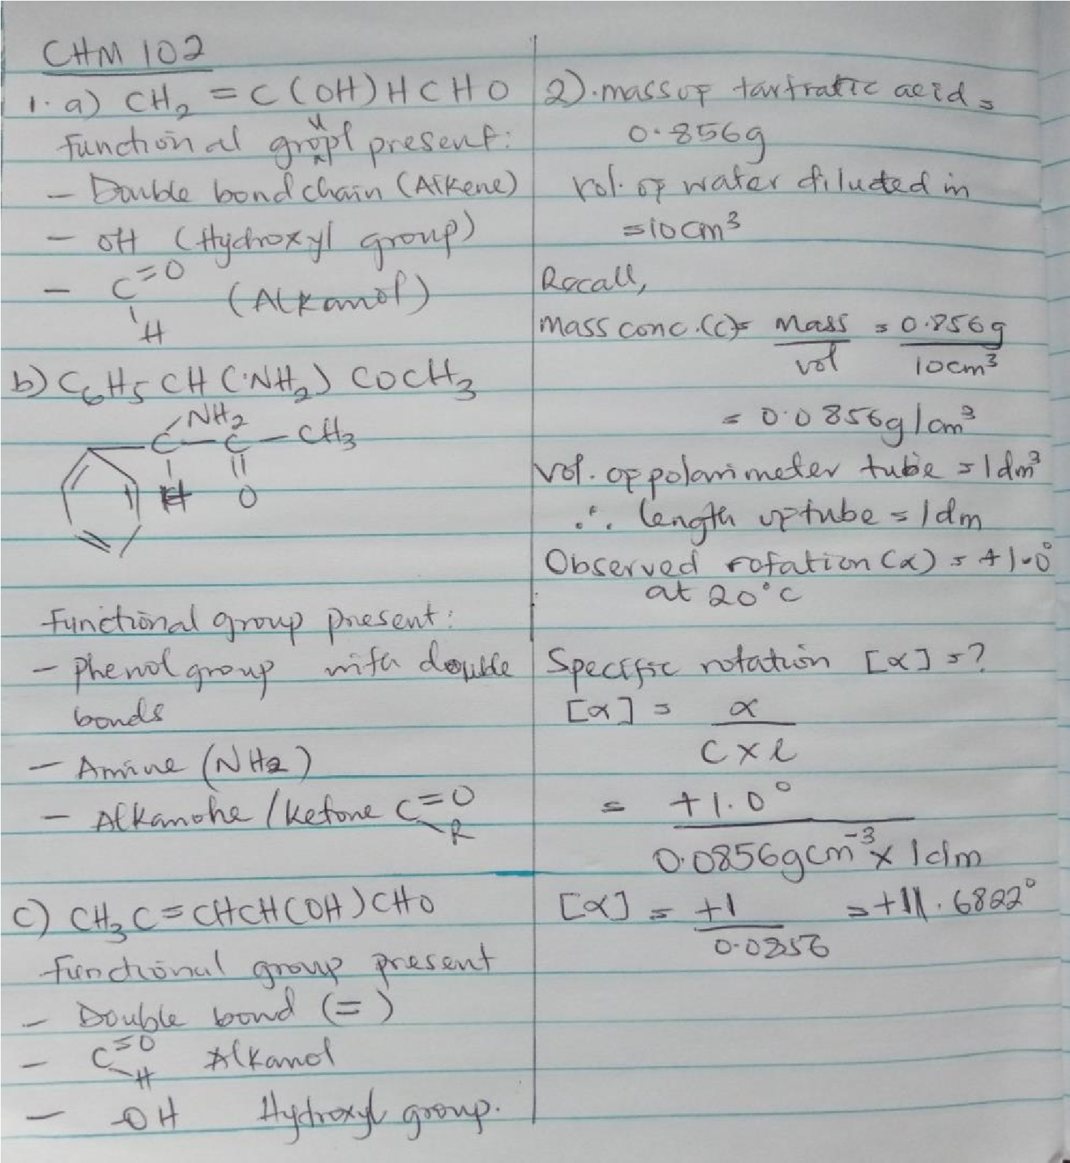

3. Hexa-2,4-diene – has only 3 isomers
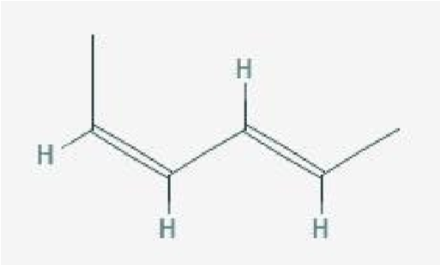

Isomers

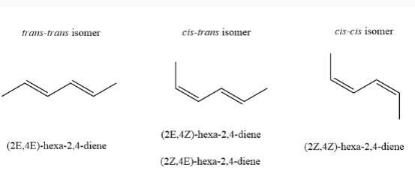

B. 2,3 dimethy but-2-ene. - does not have geometric isomers because there are two identical groups attached to the same carbon of the double bond.

