NAME: Fidelis Godfrey Mamza
DEPARTMENT: Elect/elect engineering
MATRIC NO: 18/eng04/040
COURSE: Eng 224

PROCESSES IN SOFTWARE DEVELOPMENT.
Software Development Process consist of the steps involved in building an application. There are six steps in every software development Process of an application ;
CONCEPTUALIZATION
SPECIFICATION
DESIGN
IMPLEMENTATION
TESTING & DEBUGGING
RELEASE & UPDATE

CONCEPTUALIZATION
This process is all about having ideas to solve a problem,
The problem in this case is the Dry season in ABUAD Farm, and as an engineer, we solve problems. To solve this problem, an Application would be required ( Automated Irrigation System). This application will be able to measure the soil temperature, moisture, also be able to control the timer to wet the soil and the plants.

SPECIFICATION.
This involves the Hardware and Software Features,
Hardware Features; Soil temperature Sensor, Soil moisture sensor, sprinkler, tank, pipes, source of water, Arduino, Arduino LCD., Level sensor

Software Features; GUI, Timer, Notification system, Bluetooth system, DBMS.

DESIGN.
This is the concept of a software which can start from the icon to the patterns in the software and the way it response
IMPLEMENTATION.
Implementation is when the code is written for the application. This is performed by using either a High level language or Low level language.
TESTING AND DEBUGGING
Testing and Debugging, this is checking the performance of the system and checking for errors and removal of errors,
This process would be done after every step in the design and the implementation. After this has being done, the hardware would also be checked and see if it functions properly. After all this a general test would be done.
RELEASE AND UPDATE
The web application is release to the public for use, and there will be an update and development on the application based on the user’s review

HARDWARE AND SOFTWARE FEATURES.
• Arduino
Arduino is "an open-source electronics platform based totally on clean-to-use hardware and software". The Arduino control panel programmed by Arduino c and is based on C and C ++
• Arduino[ LCD Liquid Crystal Library]
This library permits an Arduino board to control Liquid Crystal Display (LCD) that is on the Hitachi HD44780 chipset, which is on most text-based LCDs.

• Moisture Sensor
The soil moisture sensor comprises of two tests that are utilized to the degree the volumetric substance of water. The two tests permit the current to pass through the soil, which gives the resistance esteem to the degree the dampness esteem. When there is water in the soil there will be less resistance and the soil will handle more power. But if the soil is dry it conduct power weekly and needs less power and more resistance.
• Temperature Sensor
A temperature sensor is sensor to measure the ambient temperature. This sensor has three pins – a positive, a ground, and a flag.
• Level Sensor
The water-level pointer is utilized to demonstrate the water level in the tank, by using this sensor we can control the flood of the water as well know the level of the water in the tank , and at any time we can know the water level in the tank, it has a basic circuit

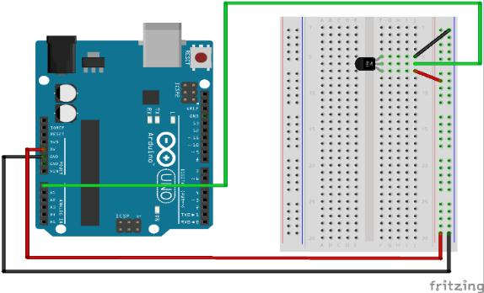
FLOWCHART.
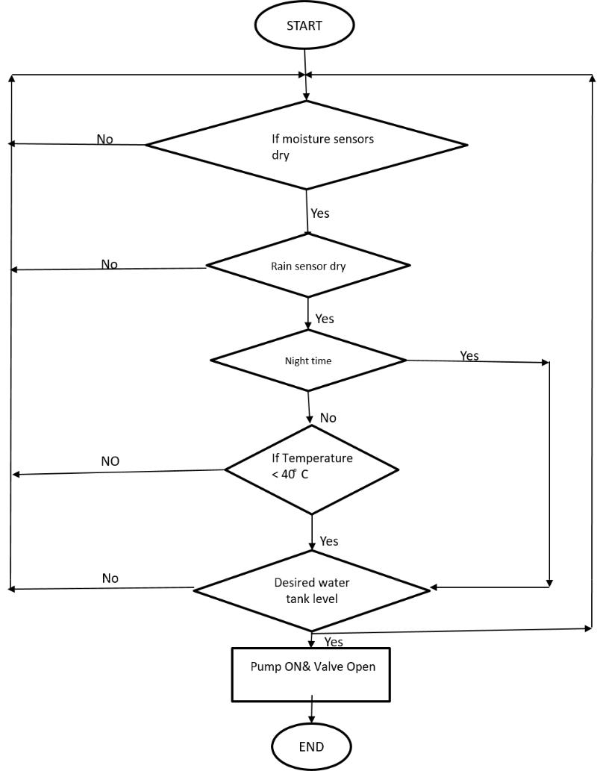

ALGORITHMS.
1.Start
2.Enter password
If password correct
Print “Home Page”
Else
Print”Main Page”
3.Open Home Page
4.Read Temperature of soil
If above 40 degrees
Sprinkler rises
Else
Sprinklers remains node
5.Read Moisture of Soil
If above 400
Sprinkler rises
Else
Sprinklers remain node.

