NAME: SADIKU DAVID JESUFERANMI
MATRIC NO: 18/SCI01/082
Question
a) Given two strings: str1 and str2: str1: “Department of Mathematical and Physical Sciences”; str2: “compUter PROGRAMMINg II”; i. Concatenate not more than n characters (n should be 8) of string 2 into string 1. ii. Convert the second string to uppercase. iii. Find the length of the first string.
SOLUTION
#include<stdio.h>
#include<string.h>
int main() {
char str1[]= "Department of Mathematical and Physical Sciences";
char str2[]= "compUter PROGRAMMINg";
strncat(str1,str2,8);
printf("(i) Concatenation = %s ", str1);
printf("(\n(ii) String 2 in uppercase: %s ", strupr(str2));
printf("\n(iii) Lenght of string str1 1s : %d", strlen(str1));
return 0;
}
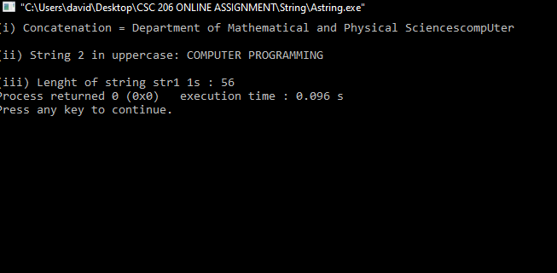

b) Given two strings: str1 and str2: str1:”I am a Member of COSSA”; str2: “I am also a MEMBER of NACOSS”; i. Copy up to n characters of string 1 into string 2. ii. Reverse string 2. iii. Compare string 1 and string 2 lexographically with by a specific character
SOLUTION
#include<stdio.h>
#include<string.h>
int main (){
char str1[]= "I am a Member of COSSA";
char str2[]= "I am also a MEMBER of NACOSS";
strncpy(str2,str1,14);
printf("(i) Copied string is : %s", str2);
strrev(str2);
printf("\n(ii) Reverse of string2 is: %s" ,str2);
if (strcmp(str1,str2)==0)
{
printf("\n(iii) String 1 and String 2 are equal");
}else{
printf("\n(iii) String 1 and String 2 are different");
}
return 0;
}
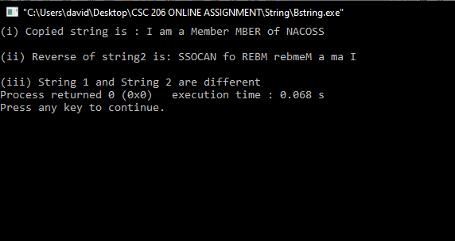

c) Given three strings: str1, str2 and str3: str1:”Do you really WANT to be a gOOd Programmer?”; str2: “Then you must LOVE PROgraMMIng”; str3: “Can you join me to program?”; i. Convert string 1 to lowercase. ii. Compare string1 and string2. iii. Find the first occurrence of ‘m’ in string3.
SOLUTION
#include<stdio.h>
#include<string.h>
int main (){
char str1[]="Do you really WANT to be a gOOd PROgrammer?";
char str2[]="Then you must LOVE PROgraMMing";
char str3[]="Can you join me to program";
strlwr(str1);
printf("(i) Lowercase of String1 is: %s", str1);
if (strcmp(str1,str2)==0)
{
printf("\n(ii) String 1 and String 2 are equal");
}else{
printf("\n(ii) String 1 and String 2 are different");
}
printf("\n(iii) The first occurrence of M in string3 is in: %s",strchr(str3, 'm'));
return 0;
}
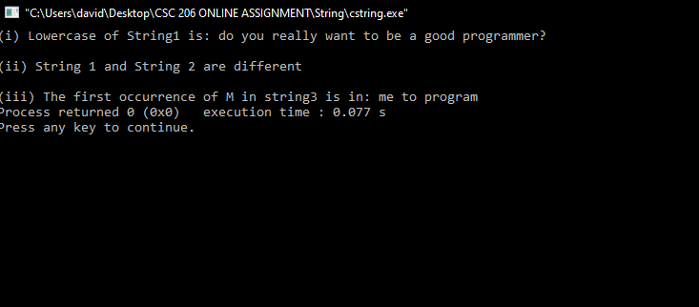

d) Write a C program for these given strings: str1: NIGERIA str2: Nigeria NIGERIA niger. a. Compare the two strings b. Compare at most n characters of the two strings c. Use strnset() to replace specified characters in this string.
SOLUTION
#include<stdio.h>
#include<string.h>
int main (){
char str1[]="NIGERIA";
char str2[]="Nigeria NIGERIA niger";

if (strcmp(str1,str2)==0)
{
printf("(a) String 1 and String 2 are equal");
}else{
printf("(a) String 1 and String 2 are not the same");
}
if (strncmp(str1,str2,1)==0)
{
printf("\n\n(b) String 1 and String 2 are equal");
}else{
printf("\n\n(b) String 1 and String 2 are different");
}
printf( "\n\n (c) Original String2 : %s", str2);
printf("\n\n(cii) Modified String2 : %s", strnset(str2,'*',7));

return 0;
}
