DAVID DAVID LAWRENCE
18/ ENG06/039
MECHANICAL ENGINEERING
200l
ALGORITHM ASSIGNMENT

SOFTWARE DEVELOPMENT PROCESS
The Software Development Process they are steps involved in building an application. There are steps listed below :
1. Conceptualization .
2.Specification.
3 Design .
4.Implementation.
5.Testing & Debugging.
6.Release & Update.

CONCEPTUALIZATION
This process is all about having ideas to solve a problem,
The problem in this case is the Dry season in ABUAD Farm, and as an engineer, we solve problems. To solve this problem, an Application would be required ( Automated Irrigation System). This application will be able to measure the soil temperature, moisture, also be able to control the timer to wet the soil and the plants.

SPECIFICATION.
This involves the Hardware and Software Features,
Hardware Features; Soil temperature Sensor, Soil moisture sensor, sprinkler, tank, pipes, source of water, Arduino, Arduino LCD., Level sensor

Software Features; GUI, Timer, Notification system, Bluetooth system, DBMS.

DESIGN.
The scenario of application start from installing the app on phone then open the application, First of all, the main screen of the app will be loaded when the user will choose which device is connected to Bluetooth. The system will check if the device is connected if it is connected then it notifies the user that the device is connected otherwise notify the user device is not connected. In the main screen, the user can directly switch ON /OFF the entire system. Moreover, If Details Button pressed it loads to details screen. In this Screen user will able to see all details related to whole system For example if he pressed on plant1 button he will be able to see ( amount of water, Soil moisture, Temperature) if there is problem only in this line he can switch ON /OFF line so he is able in this page to control line by line.

IMPLEMENTATION.
Implementation is when the code is written for the application. This is performed by using either a High level language or Low level language.
As it shows in Figure below, the project had divided into 3 fields (Field A, Field B, Field C). However, (Field A) has (valve 1 and flow meter 1), (Field B) has (valve 2 and flow meter 2) and (Field C) has (valve 3 and flow meter 3) and valve 4 with flow meter 4 is the main.
As it shows in the chart, it shows how the system works in one field if only one moisture sensor of Field B active the system will not work also temperature sensor and the light sensor works together. For example, when the temperature is more than 40 C and the light sensor is active then the system will switch OFF because the heat of the sun works to evaporate the water, this system had been configured to stop the process and schedule it. Moreover, the purpose of this system is to work in a smart way, so if there is rain the system will automatically be OFF. Please considered that main water tank will be monitored carefully so that it doesn't go below the level where the level where the pump cannot suck the water. The system will not work if the water level is low. To start the process, two or three moisture sensor of Field B must be activated to move to next step. Next, the rain sensor must be dry to continue the process and the weather temperature sensors should be less than 40 C to enable the process to move to next step. If the water tank level is not below, the pump will run, valve 2 and 4 will open and flow meter of 2 and 4 have the same reading. If two or three moisture sensor of all fields(A, B, C) active at the same time and the rain sensor is dry, the temperature sensor should be less than 40 C and the light sensor is not active then the proceed to next step. If the water level sensor is not below then pump will be ON, valve (1,2,3) and 4 will open and flow meter (1,2,3,4) have the same readings

TESTING AND DEBUGGING
Testing and Debugging, this is checking the performance of the system and checking for errors and removal of errors,
This process would be done after every step in the design and the implementation. After this has being done, the hardware would also be checked and see if it functions properly. After all this a general test would be done.

RELEASE AND UPDATE
The web application is release to the public for use, and there will be an update and development on the application based on the user’s review

HARDWARE AND SOFTWARE FEATURES.
Arduino
Arduino is "an open-source electronics platform based totally on clean-to-use hardware and software". The Arduino control panel programmed by Arduino c and is based on C and C ++
Arduino[ LCD Liquid Crystal Library]
This library permits an Arduino board to control Liquid Crystal Display (LCD) that is on the Hitachi HD44780 chipset, which is on most text-based LCDs.
Moisture Sensor
The soil moisture sensor comprises of two tests that are utilized to the degree the volumetric substance of water. The two tests permit the current to pass through the soil, which gives the resistance esteem to the degree the dampness esteem. When there is water in the soil there will be less resistance and the soil will handle more power. But if the soil is dry it conduct power weekly and needs less power and more resistance
Temperature Sensor
A temperature sensor is sensor to measure the ambient temperature. This sensor has three pins – a positive, a ground, and a flag.
Level Sensor
The water-level pointer is utilized to demonstrate the water level in the tank, by using this sensor we can control the flood of the water as well know the level of the water in the tank , and at any time we can know the water level in the tank, it has a basic circuit.

FLOWCHART.
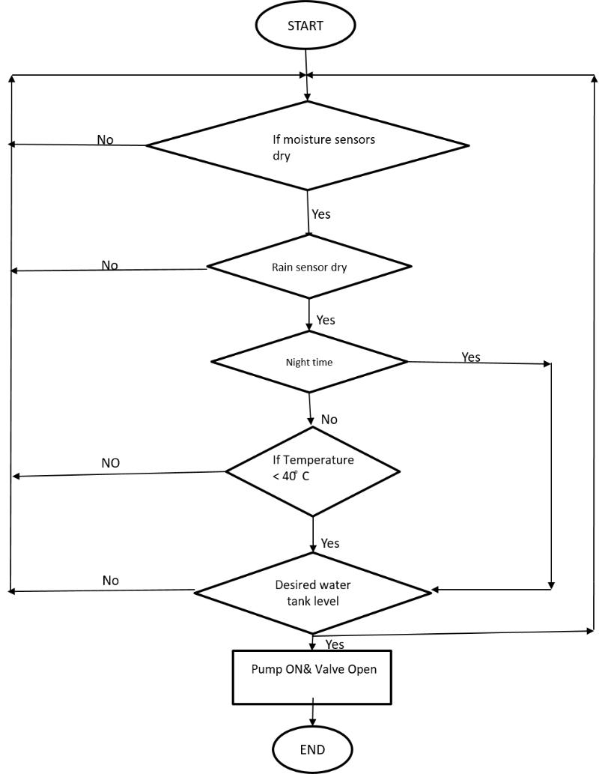

ALGORITHMS.
Step1:Start,
Step2:Enter password,
If password correct,
Print “Home Page”,
Else,
Print”Main Page”,
Step3:Open Home Page,
Step4:Read Temperature of soil
If above 40 degrees
Sprinkler rises,
Else
Sprinklers remains node
Step5:Read Moisture of Soil
If above 400
Sprinkler rises
Else
Sprinklers remain node.

