PEPPLE IBIM OBIEDIMA
16/ENG06/088
MECHANICAL ENGINEERING
MEE 510

DESIGN AND FABRICATION OF A MONOBLOC MACHINE FOR THE PRODUCTION OF GUM FROM CASSAVA STARCH
- Product/ project design
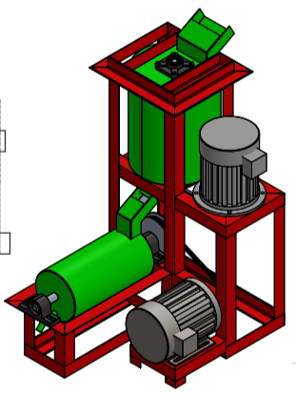
- Materials selection
The materials used was grouped into:
- Materials for fabrication of the machine:
- 3mm mild steel plate
- Electric motor
- Shaft
- Bearing
- Electrical control unit
- 2 inches angle iron
- Materials used for the production of gum from cassava starch:
- Starch
- Dilute Hydrochloric acid (HCl)
- Urea
- Sodium formaldehyde
- Sodium tetraborate decahydrate or borax.
- Factors considered in choosing the material:
- Cost of the materials
- Environmental consideration
- Chemical properties
- Physical properties
- Design specifications:
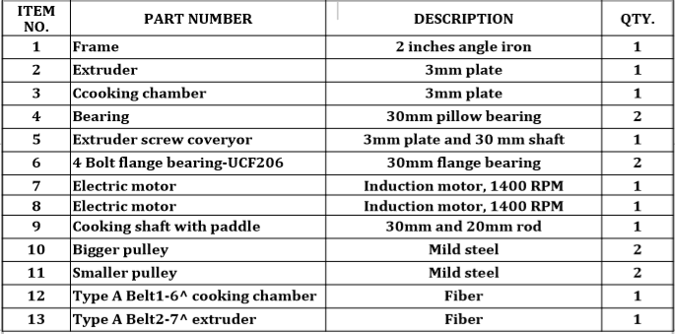
- Details drawing
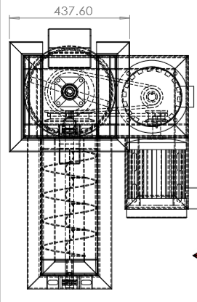

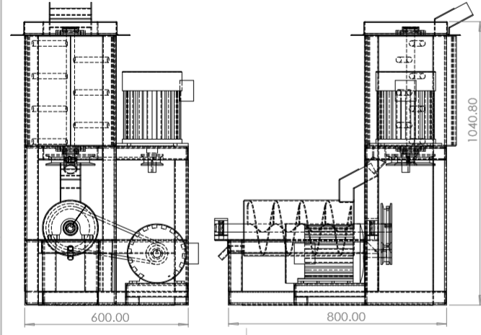
Material | Description | Quantity | Price
3mm plate | Mild steel | 2 | 37,000
Electric motor | Induction motor | 2 | 60,000
2 inches angle iron | Mild steel | 9 | 13,500
Cutting and grinding disc | - | 8 | 8,000
Painting | - | - | 6,000
Shaft | Mild steel | 3 | 15,000
Bearing | 25mm pillow bearing | 4 | 10,000
Control unit | Electrical connections, heating element | - | 40,000
Transport | - | - | 15,000
Logistics | - | - | 15,000
Workmanship | - | - | 30,000
Total |  |  | 249,000
- BEME

- Design calculation
The mono-bloc mixer-extruder concept was adopted and the detailed designs were carried out as follows:
    - Monobloc Machine Parts Design
The machine consists of two sections. The first section has a change-can mixer that incorporates a heating jacket. The design of the mixer comprises several steps as outlined below:
- Selection of a suitable vessel material and size:
an aluminum pot was selected as the mixing vessel. The vessel is well rounded with smooth surfaces.
- Selection of blade materials:
The blade was made of two materials, steel and Perspex. The steel bars were welded to anchor impeller frame while the Perspex bars were bolted to the steel bars. The Perspex bars (since it can be adjusted) ensured maintenance of very small clearances between the vessel surface and the vertical and horizontal pitched blades.
- Selection of mixing speed:
The production of dextrin gum involved heating starch slurry with excess acid until dextrinization was attain. For a controlled process, it was desired that the mixing should take place in the laminar zone, it was necessary to consider the impeller speed with respect to the viscosity of the mixture in the mixer and also on the intended discharge rate.
For fluid mixing, Reynolds Number was defined as (McCabe et al.,2001)
$Re=\frac{nD^{2}ρ}{μ}$ (1)
Where
Re = Reynolds number
n = Revolutions per minute
D = Impeller Diameter
ρ = Density
µ = Viscosity F
The power needed by the impeller is given by the relation as:
$Re=N_{P}n^{3}D^{5}ρ$ (2)
Where N_{p} = power number
For Re<10, flow is in the laminar range and density plays no factor and
$$N_{p}=\frac{K_{L}}{Re}$$
K_{L} = 44.5 for four pitched blade turbine mixer
Hence, $P= K_{L}n^{2}D^{3}μ$ (3)
Where P = Power.

ii) Design of the extruder
Two factors determined the design considerations of the screw extruder and these were the screw size and rotational speed(rpm) of the screw. The choice of screw size depends on the screw diameter, shaft diameter, radial clearance and pitch type of helical flight. The conveying of gummy substances may not be characterized by the presence of lumps and as such the screw size has no limitation of any kind and may depend on the projected throughput. The throughput may thus depend on the size of feed chute and discharge port size. A screw conveyor casting of internal diameter, ‘d’ was selected based on the size of the casing desired of the machine, the conveyor trough is taken to be maximally filled to 30% of its volume.
The cross-sectional area of moving bed of paste (gum) is given as
$A_{x}= \frac{{(d_{x})}^{2}A}{d}$ (4)
Where A_{x} = Cross sectional area of moving bed of paste (gum) at 30% height
A = Cross sectional area of moving bed of paste at 50% height
d and d_{x} are the respective heights for A and A_{x}
$A= \frac{πd^{2}}{2}$
Where
U = Average velocity
λ = Screw pitch
N = Revolutions per minute
Volumetric throughput of the screw conveyor of the screw extruder is given by the relation
$V^{\&}=A_{X}λN$ (5)
Or
$V^{\&}=A_{X}U$
Where V&= Volumetric throughput of screw extruder
A_{x} = Cross sectional area of moving bed of paste (gum) at 30% height
λ = Screw pitch
N = Revolutions per minute
Mass flow rate of gum;
${M^{\&}}_{s}=ρ{V^{\&}}_{s}$ (6)
M&_{s}= Mass flowrate in screw extruder
ρ= Density
V&_{s} = Volumetric flowrate of the screw extruder
For a ribbon flight screw extruder, the capacity factor CF_{f} of the flight (Thompson 1973) is
CF_{f} =1.15 (7)
Hence, the modified mass flowrate is
${M^{\&}}_{g}=\frac{{M^{\&}}_{s}}{{CF}_{f}}$ (8)
M&_{g} = mass flowrate of gum
M&_{s}= mass flowrate in screw extruder
CF_{f} = capacity factor
Power requirement for the extruder motor is given as
$P_{T}=P_{gum}+P_{friction}$
P_{T}= Power required to transport gum
P_{gum} = Power to transport gum freely
P_{friction} = Power to overcome friction during gum transportation
Where, $P_{friction}=50D_{sc}L$
D_{sc} = Screw diameter
L = Screw length
$P_{gum}=F_{S}F_{m}gm_{g}L$
Where, F_{S} = Screw factor =1.7
F_{m} = Material factor =1.8
L = Screw length
g = Acceleration due to gravity
Power required by extruder motor is given as
$P_{motor}=\frac{P_{T}F_{0}}{η}$
Where p = Power required by extruder motor
F =Overload factor
P = Power to transport gum in the extruder
η = Drive efficiency.
- Design process/ manufacturing
- The laboratory experimental design of the gum production:
Some quantity of the cassava starch mass was put into a plastic bath and water added to obtain a ratio 2:1 of starch to water. 0.3M HCl was then added to the suspension formed to obtain slurry made up of starch suspension/acid ratio of 1:1, by volume. The slurry was then stirred thoroughly to form a uniform slurry, and sodium tetraborate decahydrate i.e. borax (10% by weight of the starch present) added.
After dextrinization has been completed, the sample mixture was allowed to cool to room temperature (with progressive mixing). Gum adjuncts such as urea (3% by volume of mixture) and sodium formaldehyde (10% by volume of mixture) were added to increase water resistance and shelf life respectively. After sufficient mixing at room temperature, the gum was discharged manually through a swing gate valve into a ribbon screw extruder where additional mixing was done prior to actual extrusion of the gum into small plastic bottles. Thereafter, each sample was inspected for quality.
- The fabrication of the machine:
The machine was fabricated in the workshop with the materials that have also been listed above
The frame was fabricated first with the allocated measurements using the 2 inches angle iron, the cooking chamber and mixer was fabricated with the 3mm plate, then the electric motor and other components were welded. The electrical component was then connected (i.e. control element) and also the heating element. The machine was then painted for a beautiful finishing, then the efficiency of the machine was tested.

