ALGORITHMS ASSIGNMENT

NAME:
DEPARTMENT:
MATRIC NO:

SOFTWARE DEVELOPMENT PROCESS
The Software Development Process they are steps involved in building an application. There are six steps involved in the software development Process of the application ;
CONCEPTUALIZATION
SPECIFICATION
DESIGN
IMPLEMENTATION
TESTING & DEBUGGING
RELEASE & UPDATE

CONCEPTUALIZATION
This procedure is tied in with having thoughts to take care of an issue,

The issue for this situation is the Dry season in ABUAD Farm, and as a designer, we take care of issues. To take care of this issue, an Application would be required ( Automated Irrigation System). This application will have the option to gauge the dirt temperature, dampness, likewise have the option to control the clock to wet the dirt and the plants.
SPECIFICATION.
This involves the Hardware and Software Features,
Hardware Features; Soil temperature Sensor, Soil moisture sensor, sprinkler, tank, pipes, source of water, Arduino, Arduino LCD., Level sensor

Software Features; GUI, Timer, Notification system, Bluetooth system, DBMS.

DESIGN.
The situation of use start from introducing the application on telephone at that point open the application, First of all, the primary screen of the application will be stacked when the client will pick which gadget is associated with Bluetooth. The framework will check on the off chance that the gadget is associated in the event that it is associated, at that point it tells the client that the gadget is associated in any case advise the client gadget isn't associated. In the principle screen, the client can straightforwardly turn ON/OFF the whole framework. In addition, If Details Button squeezed it burdens to subtleties screen. In this Screen client will ready to see all subtleties identified with entire framework For instance in the event that he went ahead plant1 button he will have the option to see ( measure of water, Soil dampness, Temperature) if there is issue just in this line he can turn ON/OFF line so he is capable in this page to control line by line.
IMPLEMENTATION.
Implementation is when the code is written for the application. This is performed by using either a High level language or Low level language.
As it shows in Figure below, the project had divided into 3 fields (Field A, Field B, Field C). However, (Field A) has (valve 1 and flow meter 1), (Field B) has (valve 2 and flow meter 2) and (Field C) has (valve 3 and flow meter 3) and valve 4 with flow meter 4 is the main.
As it shows in the chart, it shows how the system works in one field if only one moisture sensor of Field B active the system will not work also temperature sensor and the light sensor works together. For example, when the temperature is more than 40 C and the light sensor is active then the system will switch OFF because the heat of the sun works to evaporate the water, this system had been configured to stop the process and schedule it. Moreover, the purpose of this system is to work in a smart way, so if there is rain the system will automatically be OFF. Please considered that main water tank will be monitored carefully so that it doesn't go below the level where the level where the pump cannot suck the water. The system will not work if the water level is low. To start the process, two or three moisture sensor of Field B must be activated to move to next step. Next, the rain sensor must be dry to continue the process and the weather temperature sensors should be less than 40 C to enable the process to move to next step. If the water tank level is not below, the pump will run, valve 2 and 4 will open and flow meter of 2 and 4 have the same reading. If two or three moisture sensor of all fields(A, B, C) active at the same time and the rain sensor is dry, the temperature sensor should be less than 40 C and the light sensor is not active then the proceed to next step. If the water level sensor is not below then pump will be ON, valve (1,2,3) and 4 will open and flow meter (1,2,3,4) have the same readings.
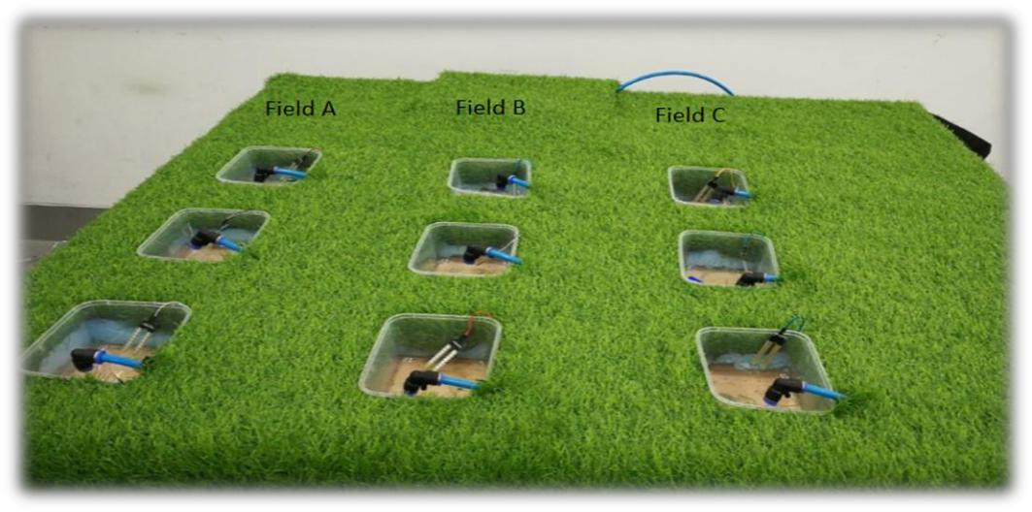

TESTING AND DEBUGGING
Testing and Debugging, this is checking the presentation of the framework and checking for blunders and expulsion of mistakes,

This procedure would be done after each progression in the plan and the execution. After this has being done, the equipment would likewise be checked and check whether it works appropriately. After this a general test would be finished.
RELEASE AND UPDATE
The web application is release to the general public for use, and there may be an update and development at the application primarily based on the user’s review

HARDWARE AND SOFTWARE FEATURES.
• Arduino
Arduino is "an open-source gadgets stage dependent on clean-to-utilize equipment and programming". The Arduino control board modified by Arduino c and depends on C and C ++
• Arduino[ LCD Liquid Crystal Library]
This library permits an Arduino board to manipulate Liquid Crystal Display (LCD) this is on the Hitachi HD44780 chipset, that's on maximum text-primarily based LCDs.

• Moisture Sensor
The soil wetness sensing element contains of 2 tests that are used to the degree the volumetrical substance of water. the 2 tests allow this to suffer the soil, which supplies the resistance esteem to the degree the moistness esteem. once there's water within the soil can|there'll} be less resistance and therefore the soil will handle additional power. however if the soil is dry it conduct power weekly and desires less power and additional resistance.

• Temperature Sensor
A temperature sensor will be sensor to gauge the surrounding temperature. This sensor has three pins – a positive, a ground, and a fan

• Level Sensor
The water-stage pointer is utilized to demonstrate the water level within the tank, by the usage of this sensor we will manipulate the flood of the water as nicely recognize the extent of the water in the tank , and at any time we will recognize the water level within the tank, it has a primary circuit

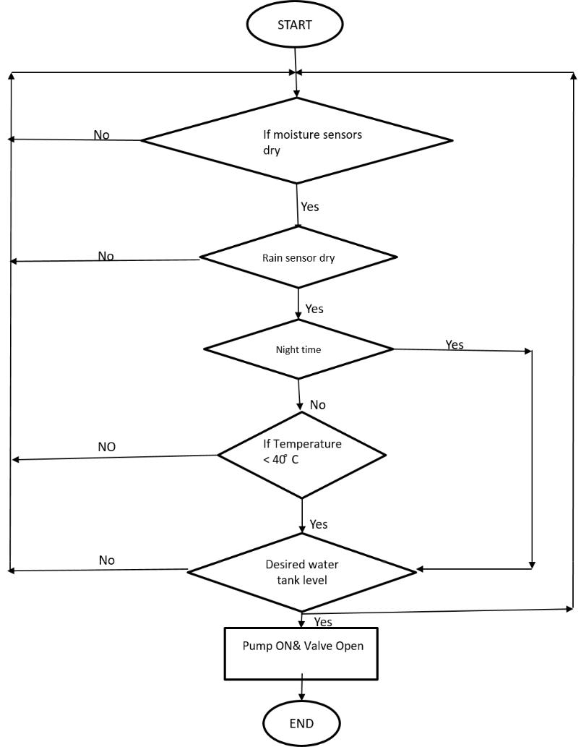
FLOWCHART.

ALGORITHMS.
1.Start
2.Enter password
If password correct
Print “Home Page”
Else
Print”Main Page”
3.Open Home Page
4.Read Temperature of soil
If above 40 degrees
Sprinkler rises
Else
Sprinklers remains node
5.Read Moisture of Soil
If above 400
Sprinkler rises
Else
Sprinklers remain node.

