19/mhs11/068
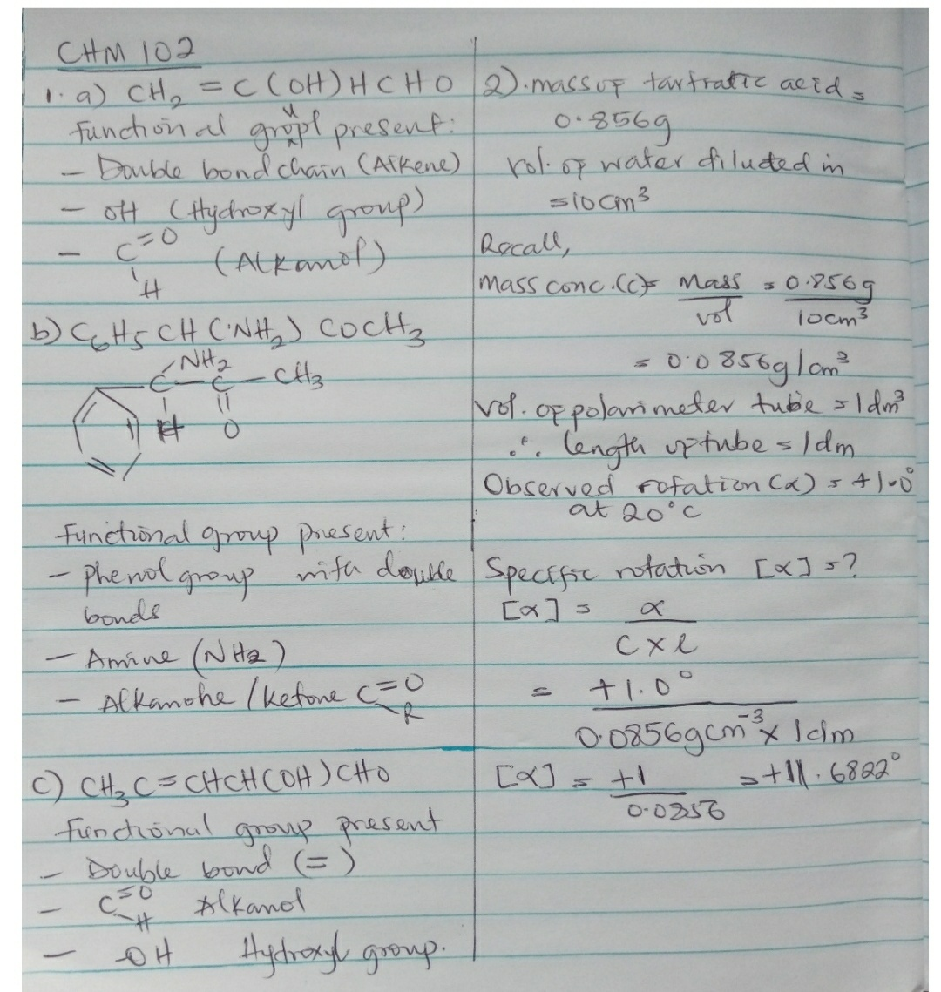
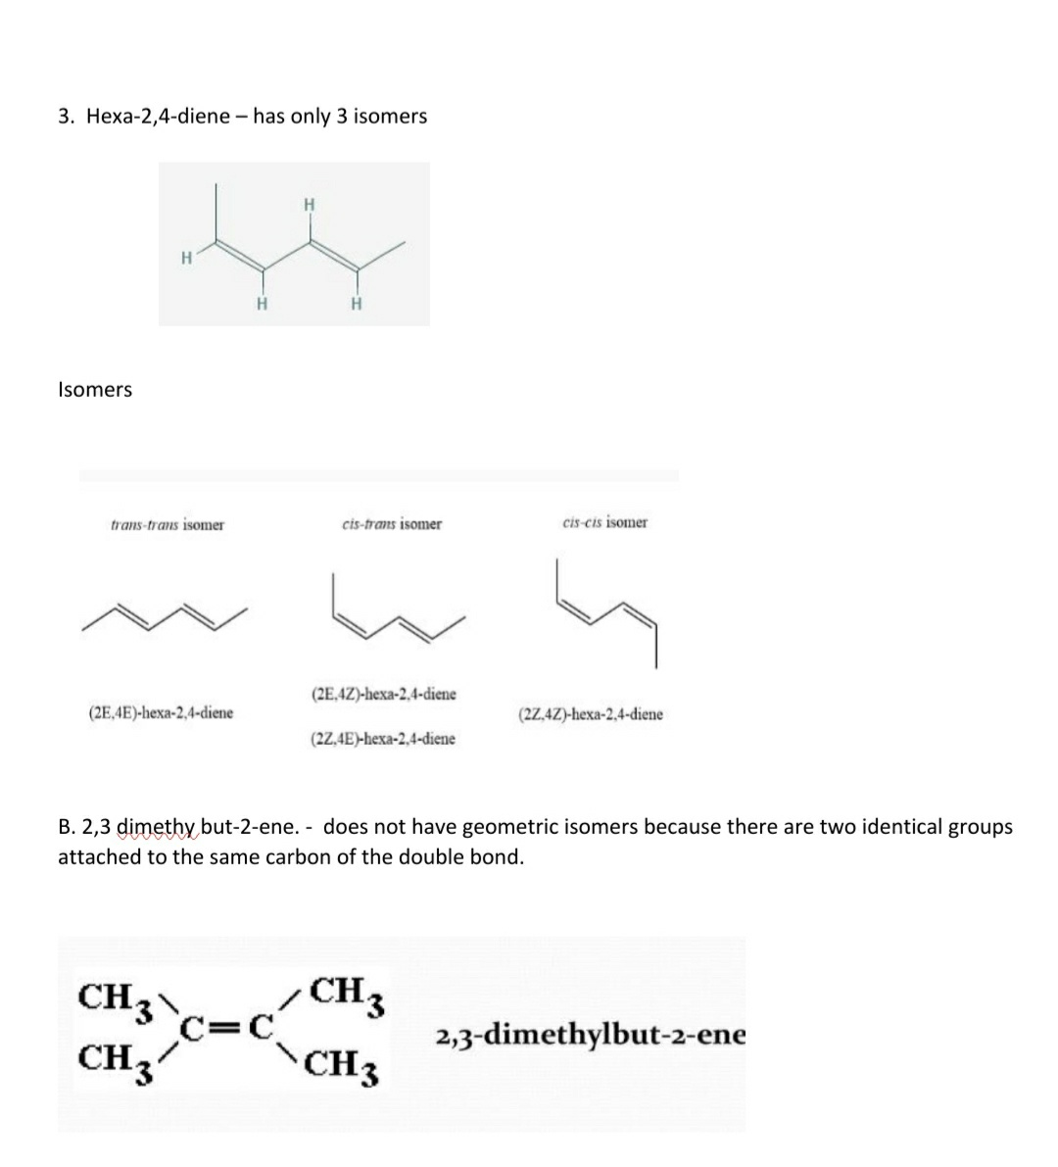
Ifeanyichukwu tonia
pharmacy
19/mhs11/068
17 May 2020

