ONWUMA CHIBUOGWU OBI
18/MHS06/042
Describe the mechanism of aerobic respiration

Aerobic Respiration:
Aerobic respiration is an enzymatically controlled release of energy in a stepwise catabolic process of complete oxidation of organic food into carbon dioxide and water with oxygen acting as terminal oxidant. The common mechanism of aerobic respiration is also called common pathway because its first step, called glycolysis, is common to both aerobic and anaerobic modes of respiration. The common aerobic respiration consists of three steps—glycolysis, Krebs cycle and terminal oxidation.

Glycolysis:
It is also called EMP pathway because it was discovered by three German scientists Embden, Meyerhof and Parnas. Glycolysis is the process of breakdown of glucose or similar hexose sugar to molecules of pyruvic acid through a series of enzyme mediated reactions releasing some energy (as ATP) and reducing power (as NADH₂). It occurs in the cytoplasm. It takes place in the following sub steps.

1. Phosphorylation:
Glucose is phosphorylated to glucose-6-phosphate by ATP in the presence of enzyme hexokinase or glucokinase (e.g., liver) and Mg²⁺.
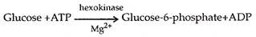

2. Isomerization:
Glucose-6-phosphate is changed to its isomer fructose-6-phosphate with the help of enzyme phosphohexose isomerase.
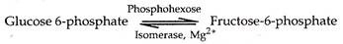

Fructose-6-phosphate can also be produced directly by phosphorylation of fructose with the help of enzyme fructokinase.
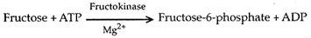

3. Phosphorylation:
Fructose-6-phosphate is further phosphorylated by means of ATP in presence of enzyme phosphofructo-kinase and Mg²⁺. The product is Fructose-1, 6 diphosphate.

4. Splitting:
Fructose-1, 6-diphosphate splits up enzymatically to form one molecule each of 3- carbon compounds, glyceraldehyde 3-phosphate (= GAP or 3-phosphoglyceraldehyde = PGAL) and dihydroxy acetone 3-phosphate (DIHAP). The latter is further changed to glyceraldehyde 3-phosphate by enzyme triose phosphate isomerase (= phosphotriose isomerase).
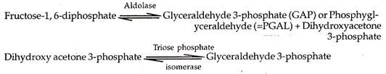

5. Dehydrogenation and Phosphorylation:
In the presence of enzyme glyceraldehyde phosphate dehydrogenase, glyceraldehyde 3-phosphate loses hydrogen to NAD to form NADH₂ and accepts inorganic phosphate to form 1, 3-diphosphoglyceric acid.

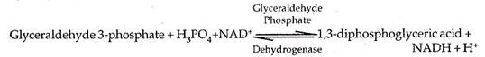

6. Formation of ATP:
One of the two phosphates of diphosphoglyeerie acid in linked by high energy bond. It can synthesise ATP and form 3-phosphoglyceric acid. The enzyme is phosphoglyceryl inase. The direct synthesis of ATP from metabolites is called substrate level phosphorylation.

7. Isomerization:
3-phosphoglyceric acid is changed to its isomer 2-phosphoglyceric acid by zyme phosphoglyceromutase.

8. Dehydration:
Through the agency of enzyme enolase, 2-phosphoglyceric acid is converted to phosphoenol pyruvate (PEP). A molecule of water is removed in the process. Mg²⁺ is required.
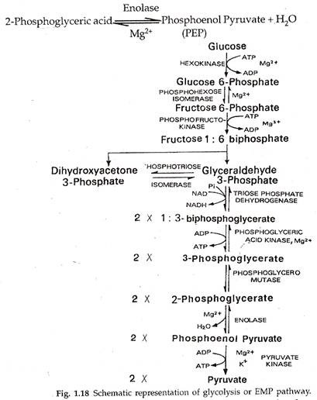

9. Formation of ATP:
During formation of phosphoenol pyruvate the phosphate radical picks up energy. It helps in the production of ATP by substrate level phosphorylation. The enzyme is pyruvic kinase. It produces pyruvate from phosphoenol pyruvate.
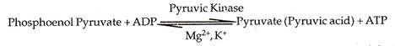

Krebs Cycle:
The cycle was discovered by Hans Krebs . It occurs inside mitochondria. The cycle is also named as citric acid cycle or tricarboxylic acid (TCA) cycle after the initial product. Krebs cycle is stepwise oxidative and cyclic degradation of activated acetate derived from pyruvate.

Oxidation of Pyruvate to Acetyl-CoA:
Pyruvate enters mitochondria. It is decarboxylated oxidatively to produce CO₂ and NADH. The product combines with sulphur containing coenzyme A to form acetyl CoA or activated acetate. The reaction occurs in the presence of an enzyme complex pyruvate dehydrogenase (made up of a decarboxylase, lipoic acid, TPP, transacetylase and Mg²⁺).

