NAME:UMUNNAH CHINEDU
DEPARTMENT:MECHANICAL ENGINEERING
MATRIC NO:18/ENG06/070

PROCESSES FOR SOFTWARE DEVELOPMENT
The Software Development Process they are steps involved in building an application. There are six steps involved in the software development Process of the application ;
CONCEPTUALIZATION
SPECIFICATION
DESIGN
IMPLEMENTATION
TESTING & DEBUGGING
RELEASE & UPDATE

CONCEPTUALIZATION
The problem in this case is the Dry season in ABUAD Farm, and as an engineer, we solve problems. To solve this problem, an Application would be required ( Automated Irrigation System). This application will be able to measure the soil temperature, moisture, also be able to control the timer to wet the soil and the plants.

SPECIFICATION.
This involves the Hardware and Software Features,
Hardware Features; Soil moisture sensor, sprinkler, tank, pipes, source of water, Arduino, Soil moisture sensor,Arduino LCD., Level sensor,Soil temperature Sensor,

Software Features; DBMS,Notification system, GUI, Timer, Bluetooth system.

DESIGN.
The scenario of application start from installing the app on phone then open the application, First of all, the main screen of the app will be loaded when the user will choose which device is connected to Bluetooth. The system will check if the device is connected if it is connected then it notifies the user that the device is connected otherwise notify the user device is not connected. In the main screen, the user can directly switch ON /OFF the entire system.

IMPLEMENTATION.
Implementation is when the code is written for the application. This is performed by using either a High level language or Low level language.
As it shows in Figure below, the project had divided into 3 fields (Field A, Field B, Field C). However, (Field A) has (valve 1 and flow meter 1), (Field B) has (valve 2 and flow meter 2) and (Field C) has (valve 3 and flow meter 3) and valve 4 with flow meter 4 is the main.
meter of 2 and 4 have the same reading. If two or three moisture sensor of all fields(A, B, C) active at the same time and the rain sensor is dry, the temperature sensor should be less than 40 C and the light sensor is not active then the proceed to next step. If the water level sensor is not below then pump will be ON, valve (1,2,3) and 4 will open and flow meter (1,2,3,4) have the same readings.

TESTING AND DEBUGGING
Testing and Debugging, this is checking the performance of the system and checking for errors and removal of errors,
This process would be done after every step in the design and the implementation. After this has being done, the hardware would also be checked and see if it functions properly. After all this a general test would be done.
RELEASE AND UPDATE
The web application is release to the public for use, and there will be an update and development on the application based on the user’s review

HARDWARE AND SOFTWARE FEATURES.

• Moisture Sensor
The soil moisture sensor comprises of two tests that are utilized to the degree the volumetric substance of water. The two tests permit the current to pass through the soil, which gives the resistance esteem to the degree the dampness esteem. When there is water in the soil there will be less resistance and the soil will handle more power. But if the soil is dry it conduct power weekly and needs less power and more resistance.

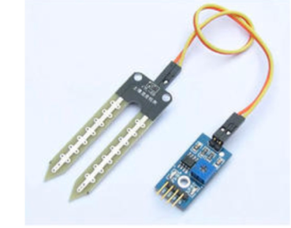

• Temperature Sensor
A temperature sensor is sensor to measure the ambient temperature. This sensor has three pins – a positive, a ground, and a flag
• Arduino
Arduino is "an open-source electronics platform based totally on clean-to-use hardware and software". The Arduino control panel programmed by Arduino c and is based on C and C ++
• Level Sensor
The water-level pointer is utilized to demonstrate the water level in the tank, by using this sensor we can control the flood of the water as well know the level of the water in the tank , and at any time we can know the water level in the tank, it has a basic circuit

• Arduino[ LCD Liquid Crystal Library]
This library permits an Arduino board to control Liquid Crystal Display (LCD) that is on the Hitachi HD44780 chipset, which is on most text-based LCDs.

FLOWCHART.
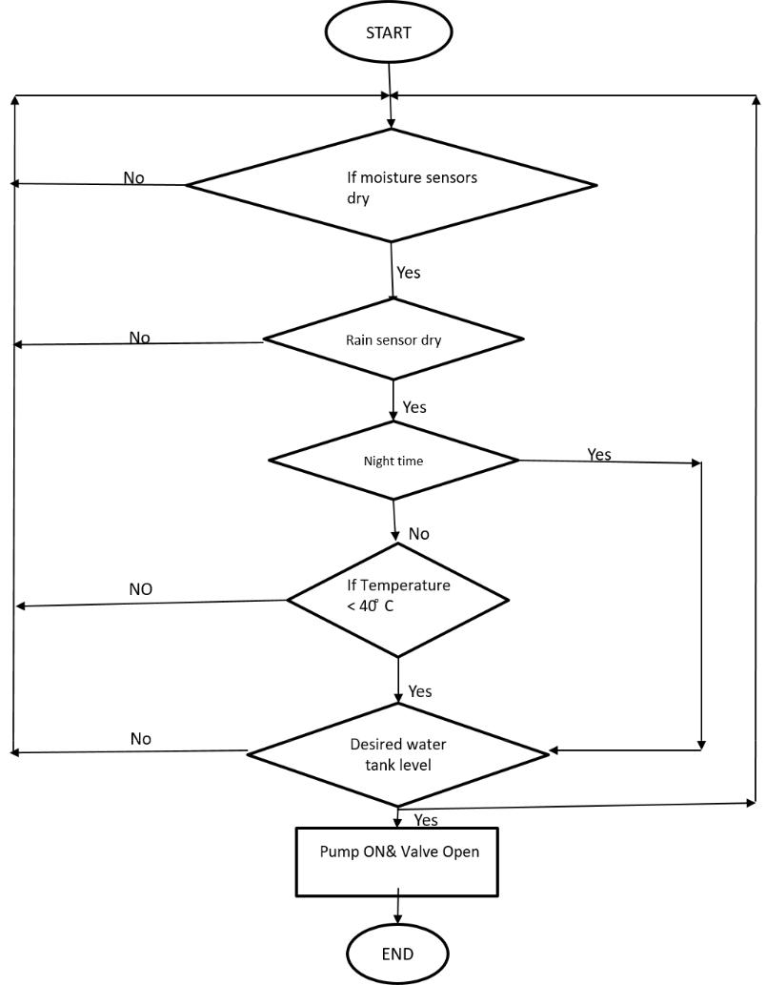

ALGORITHMS.
1.Start
2.Enter Encryption
If Encryption is correct
Print “Home Page”
Else
Print”Main Page”
3.Open Home Page
4.Read Temperature of soil
If above 40 degrees
Sprinkler rises
Else
Sprinklers remains node
5.Read Moisture of Soil
If above 400
Sprinkler rises
Else
Sprinklers remain..

