NAME: ADEMOROTI HELEN ADEDOLAPO
MATRIC NO: 18/MHS01/019
LEVEL: 200L MEDICINE AND SURGERY
LECTURER: DR. OGEDENGBE OLUWATOSIN OLALEKAN
COUSE NAME: ANATOMY (EMBRYOLOGY)
DATE: May 15, 2020

DISCUSS THE SECOND WEEK OF DEVELOPMENT
The second week of embryonic development involves the following events:
- The completion of the implantation of the blastocyst
- Formation of the Bi-laminar embryonic disc (epiblast and hypoblast)
- Development of the extra-embryonic structures (amniotic cavity, amnion, umbilical vesicle, connecting stalk, and chorionic sac)

DAY 8
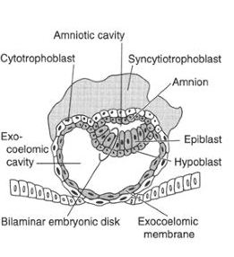
- The blastocyst is partially (slowly) embedded in the endometrium.
- The syncytiotrophoblast continues to erode in the region of the endometrium (invading the capillaries, blood vessels, and endometrial glands
- The cells of the cytotrophoblast divide and migrate into the syncytiotrophoblast, where they fuse and lose their individual cell membrane.
- The embryoblast will differentiate into two layers:
  - The cuboidal cells called the hypoblast layer, which is adjacent to the blastocyst cavity.
  - The columinar cells called the epiblast layer, which is adjacent to the amniotic cavity
- However, the cells of the epiblast that adjacent to the cytotrophoblast are called amnioblasts or the amnion
- Amnioblasts and the rest of the epiblast surrounds the amniotic cavity
- The epiblast and the hypoblast form the bilaminar germ disc
- The endometrium adjacent to the implantation site is edematous and highly vascular.

DAY 9
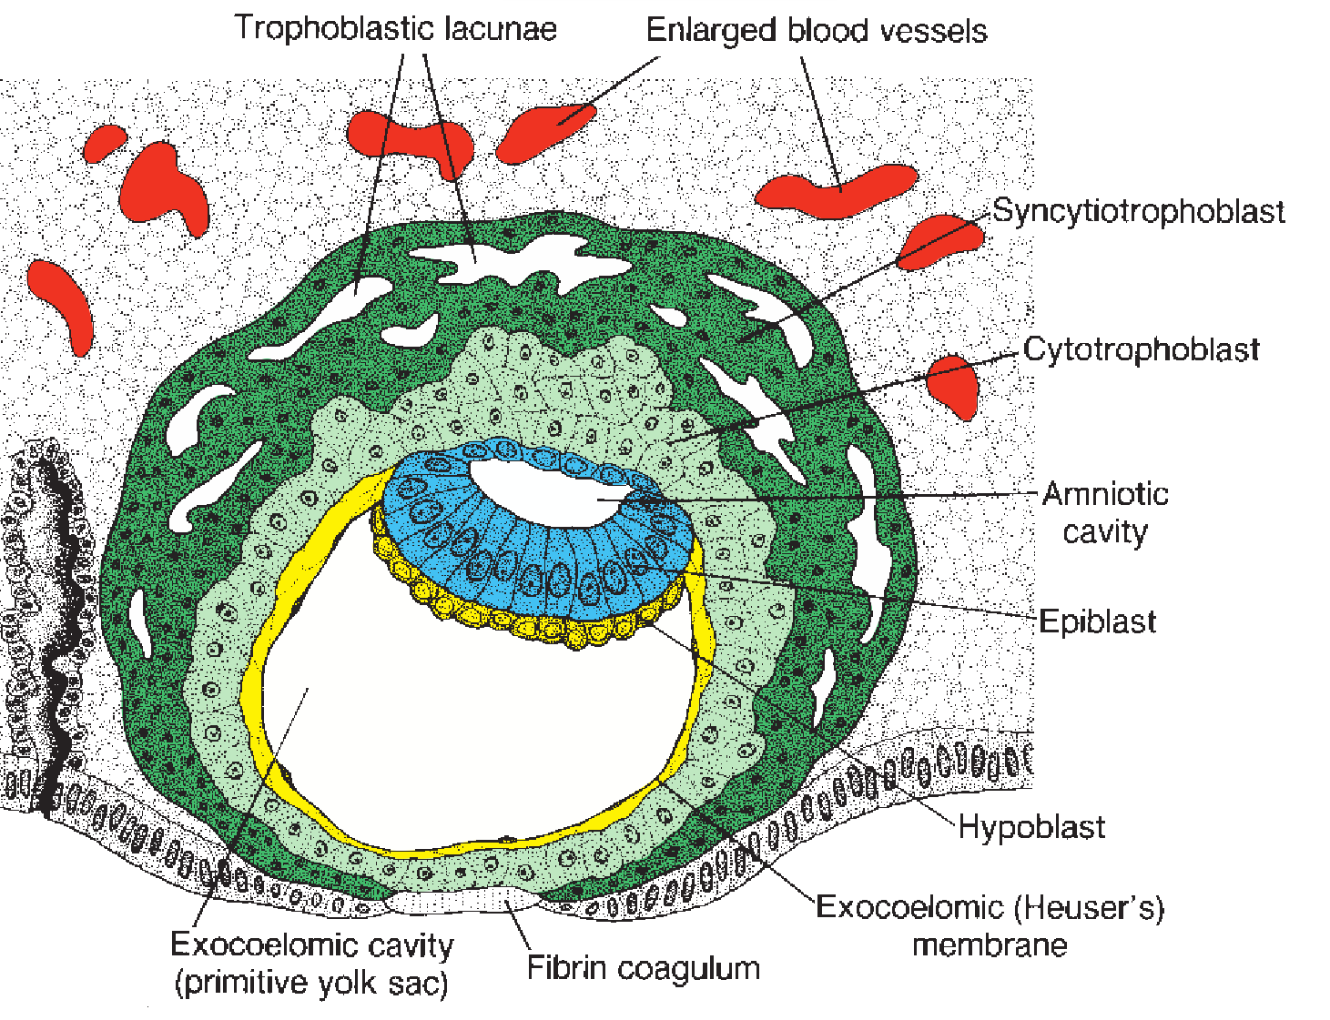
- The blastocyst is more deeply embedded in the endometrium. The penetration defect in the surface epithelium is closed by a fibrin coagulum.
- The syncytiotrophoblast continues to erode in the endometrium and cytotrophoblast continues to divide.
- The vesicles develop in the region of the syncytiotrophoblast and they fuse to form larger lacunae called trophoblastic lacunae. This phase of trophoblast development is known as the lacunar stage.
- Another membrane develops adjacent to the hypoblast which is called the exocoelomic (Heuser’s) membrane; which surrounds the primary yolk sac or primary umbilical vesicle or exocoelomic cavity.

DAY 11-12
- The blastocyst is completely embedded in the endometrium.
- The syncytiotrophoblast continues to erode in the endometrium and cytotrophoblast continues to divide.
- The syncytiotrophoblast ruptures some of the capillaries as it erodes the endometrium. The ruptured endometrial capillaries are called sinusoids
- The rupture sinusoids communicates with the trophoblastic lacunae which helps in transporting nutrients and oxygen to the embryo. At this stage, a primordial uteroplacental circulation is established.
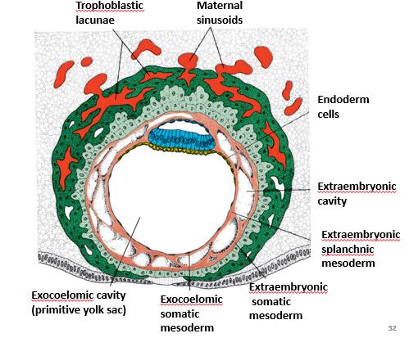

- A space of mesoderm develops between the exocoelomic membrane and cytotrophoblast, and between the cytotrophoblast and the amnioblast. The space of the mesoderm is called extra embryonic mesoderm except for the connecting stalk.
- Cavities develop at the region of the extraembryonic mesoderm called extraembryonic cavity or coelum
- This coelum divides the mesoderm into two parts
  - The extraembryonic mesoderm lining the cytotrophoblast and amnion is called the extraembryonic somatic mesoderm
  - The extraembryonic mesoderm lines the amnioblast, the exocoelomic cavity, and the hypoblast and epiblast is known as the extraembryonic splanchnic mesoderm.
- As the development atkke place, a reaction takes place called decidual reaction. The cells of the endometrium wells because of the accumulation of the glycogen and lipid in their cytoplasm and they are known as decidual cells.
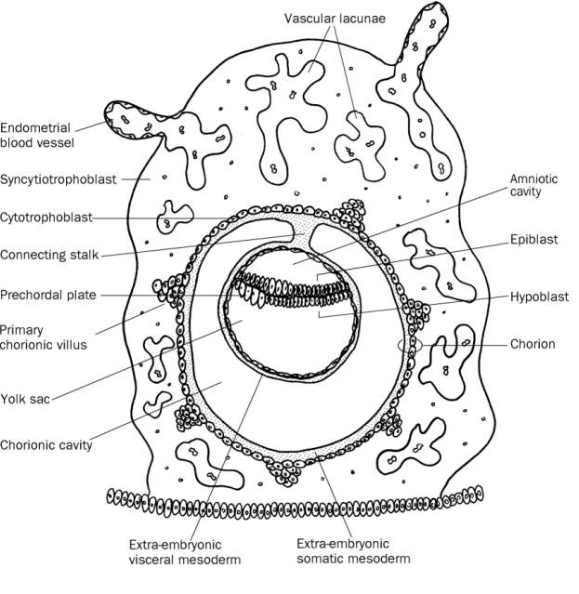

DAY 13
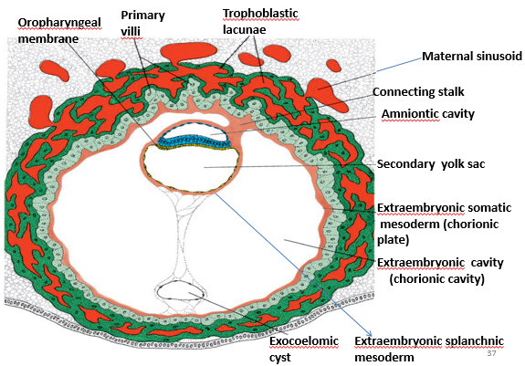
- The surface defect in the endometrium has been completely covered by the surface epithelium
- Occasionally bleeding occurs at the implantation site as a result of increased blood flow into the lacunar spaces
- At this stage, the cells of the cytotrophoblast acquire a syncytium which gives us a shape of villi (cellular columns) and it is called a primary villi
- And the extraembryonic cavity/ coelom becomes enlarge and becomes the chorionic cavity
- The primary yolk sac becomes reduced in size and is known as the secondary yolk sac or definitive yolk sac or the secondary umbilical vesicle
- A part of the yolk sac is pinched off to form a cyst called exocoelomic cysts.
- The cyst is found in the extraembryonic cavity or chorionic cavity or extraembryonic coelom.
- The extraembryonic coelom expands and forms a large cavity called the chorionic cavity
- The extraembryonic mesoderm lining the inside of the cytotrophoblast is then known as the chorionic plate
- The only place where extraembryonic mesoderm traverses the chorionic cavity is in the connecting stalk
- With development of blood vessels, the connecting stalk becomes the umbilical cord

CLINICAL SIGNIFICANCE
- The syncytiotrophoblast produces a hormone called the human chorionic gonadotrophin (hCG), which enters the maternal blood via lacunae and keeps the corpus luteum secreting estrogens and progesterone. The hCG maintains the hormonal acivity of the corpus luteum in the ovary during pregnancy. It can be detected in the maternal blood or urine as early as day 10 of pregnancy and is the basis for pregnancy tests because enough hCG is produced at the end of the second week, even when the lady is not aware that she is pregnant.
- Extrauterine implantation: is when the blastocyst implants outside the uterus and this could result into etopic pregnancy. However, 95% to 98% of etopic implantations occur in the uterin tubes and most often in the ampulla and isthmus.

