NAME: OGUNNIKE IYANUOLUWA.O
MATRIC NO: 18/MHS05/011
COURSE: ANA 206
DEPARTMENT: PHYSIOLOGY
COLLEGE: MHS

QUESTION
Discuss the rotation of the intestine

The intestines are formed while fetuses are in the womb, during the tenth week of gestation. As the intestines develop, they normally move from base of the umbilical cord back to the abdominal cavity. There are three stages that take place:

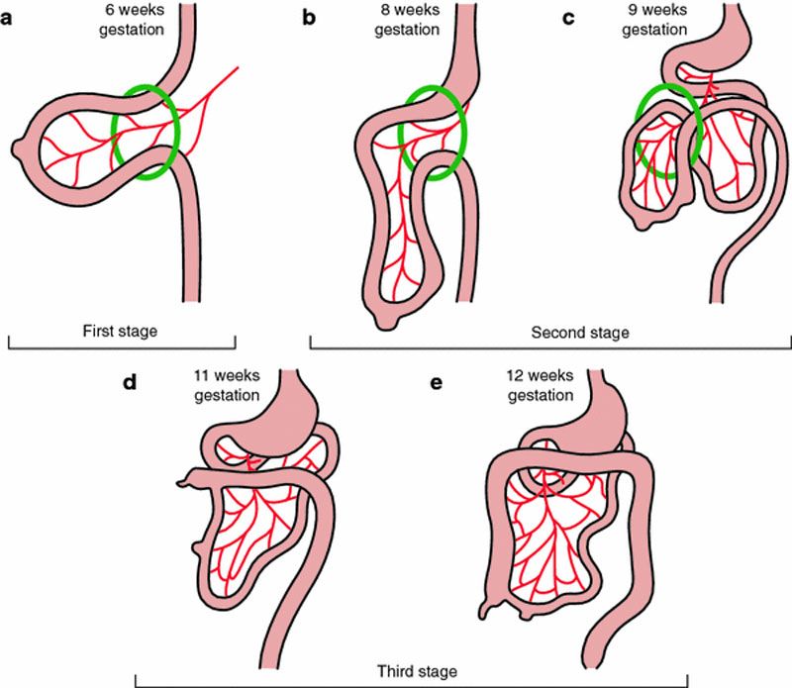

- The first stage; occurs between the fifth and tenth week of fetal development. The bowel herniated rotates 90 counterclockwise around the mesentery causing proximal portion of the loop to migrate from the superior portion to the right side and distal portion of the loop to migrate from the inferior position to the left.

- The second stage; occurs at week ten, the bowel retracts back into the abdominal cavity where it rotates 180 more counterclockwise. The cecum is now in the right upper quadrant of the abdominal cavity.

- The third stage; lasts from 11 weeks till term, enlargement of the large intestine pushes the cecum down into its final position in the right lower quadrants.

