OTOKO JEMIMAH AWAJINOMBEEK
MATRIC NO: 15/ENG03/028
SUBMITTED IN PARTIAL FULFILMENT
OF THE REQUIREMENT FOR THE AWARD OF THE
BACHELOR OF ENGINEEERING (B.ENG) DEGREE IN CIVIL ENGINEERING
TO
DR WASIU JOHN,
DEPARTMENT OF CIVIL ENGINEERING, COLLEGE OF ENGINEERING, AFE BABALOLA UNIVERSITY, ADO-EKITI,
NIGERIA
MAY, 2020

Contents
1a Flexural Strength 2
1b Design of Pile cap 2
2a Stability of retaining wall 9
2b1 Reasons for the enlargement of bored piles at the base 9
2b2 Reason for reinforcing and designing precast piles to resist bending moment 9
3a 9
3b 9
4a Differences between HA and HB loading system 9
4b Mathematical expressions for active and passive pressure on a retaining wall 12
4c Pile Load distribution 16

1a Flexural Strength
“Flexural strength, also known as modulus of rupture, or bend strength, or transverse rupture strength is a material property, defined as the stress in a material just before it yields in a flexure test; The flexural strength represents the highest stress experienced within the material at its moment of yield” (wikipedia, 2020).
“Flexural strength is a measure of the tensile strength of concrete beams or slabs; Flexural strength identifies the amount of stress and force an unreinforced concrete slab, beam or other structure can withstand such that it resists any bending failures; Flexural strength is also known as bend strength or modulus of rupture or fracture strength” (corrosionpedia, 2018).

1b Design of Pile cap
Data:
- Pile diameter ɸ = 500 mm
- Number of piles = 4
- Design Load = 4000 kN
- Pile Spacing = 1350mm c-c
- F_{cu} = 30Nmm⁻²; F_{y} = 410 Nmm⁻²
- Rectangular Column dimension on pile cap = 450 mm × 450 mm
Design Procedure
- Dimensions of Pile Cap (Surface dimension)
Considering 150mm offset from the pile
Pile diameter = 500 mm
Pile Spacing = 1350mm c-c
Width = Length = (1350 mm) + (500 mm/2) + (150 mm) + (500 mm/2) + (150 mm)
= 2150 mm

- Dimensions of Pile Cap (depth/Thickness)
A guide line to calculate depth of a pile cap is given by (Reynolds & Steedman, 1999: pg. 421) is as follows:
For Pile diameter > 550 mm; Pile cap depth (H_{p}) = (2 ɸ_{p} + 100) mm (1)
For Pile diameter ≥ 550 mm; H_{p} = ⅓ × (8 ɸ_{p} + 600) mm (2)

Pile diameter ɸ_{p} = 500 mm
H_{p} = (2 × 500) + 100
= 1100 mm
- Design for reinforcement
$A_{s}= \frac{T}{0.87 × f_{y}}$ (3) (Reynolds & Steedman, 1999) pg. 421
$T = \frac{Nl}{8d}$ (4 Piles) (4) (Reynolds & Steedman, 1999) pg. 421
A_{s} = Cross sectional area of Main bar reinforcement
T = Tensile force to be resisted by reinforcement Neglecting size of column
N = Design Load = 4000 kN
l = Distance between pile centre
d = Effective depth of pile cap
Effective Depth of pile (h_{p}) = H_{p} – Cover - ɸ_{s} (5)
Assuming a concrete cover of 100 mm and diameter of reinforcement ɸ_{s} = 25mm
h_{p} = 1100 mm – 100 mm – 25 mm
h_{p} = d = 975 mm
l = 1350 mm
$T = \frac{\left(4000 kN\right)×(1350 mm)}{8 ×(975 mm)}$
T = 692.3 kN = 692.3 × 10³ N

$A_{s}= \frac{692.3 kN }{0.87 × 410 N{mm}^{-2}}$
A_{s} = 1940.8466mm²
ɸ_{s design} = 24.8553
$∴$ Provide y25 @ 250 mm c-c for the Main Bar Reinforcement
- Design for shear stress
The design shear stress v at any cross-section:
$v = \frac{V}{bd}$ (6) BS: 8110-1:1997, 3.5.5.2
$v≤0.8\sqrt{f_{cu}} or 5N{mm}^{-2}$ (7) BS: 8110-1:1997, 3.5.5.2

v = Design shear stress
V= Design ultimate value of a concentrated load = 4000 kN
b = Breadth of slab (pile cap) under consideration = 2150 mm (See figure 1)
d = Effective depth = 975 mm
$v = \frac{4000 × {10}^{3}}{2150 mm ×975 mm}$
v = 1.91 Nmm⁻²

$v≤0.8\sqrt{f_{cu}}$
$1.91 {Nmm}^{-2}≤0.8\sqrt{30 {Nmm}^{-2}}$
1.91 Nmm⁻²$≤$ 4.38 Nmm^{-2;} Depth of Pile cap is sufficient

- Design for Shear reinforcement
Looking at section 3.5.5.3, Table 3.8 and Table 3.16 in BS: 8110-1:1997.
- From Table 3.8, Values of design concrete shear stress v_{c}; assuming $\frac{100 A_{s}}{b_{v}d}=3$, for effective depths $≥$ 400 mm, $v_{c}$= 0.91 Nmm⁻²
- From Table 3.16; for v_{c} < v < (0.4 + v_{c}) i.e. 0.91 < 1.17 < (0.4 + 0.91 =1.31), Area of shear reinforcement (A_{sv}) to be provided:

$A_{sv} = \frac{(0.4bs_{v})}{(0.95f_{yv})}$ (8) BS: 8110-1:1997, Table 3.16
b = Breadth of slab (pile cap) under consideration = 2150 mm (See figure 1)
s_{v} = Spacing of links along the member
The spacing of links in the direction of the span should not exceed 0.75d, At right-angles to the span, the horizontal spacing should be such that no longitudinal tension bar is more than 150 mm from a vertical leg; this spacing should in any case not exceed d. (BS: 8110-1:1997, 3.4.5.5); Assume s_{v} = 300 mm
f_{yv} = Characteristic strength of links ($≤$460 N/mm2) [BS: 8110-1:1997, 3.4.5.1]
f_{yv} = 410Nmm⁻²

$A_{sv} = \frac{(0.4bs_{v})}{(0.95f_{yv})}$

$A_{sv} = \frac{(0.4 ×2150 mm ×300 mm)}{(0.95 × {410 Nmm}^{-2})}$
A_{sv} = 662.3876 Nmm⁻²
ɸ_{sv} = 14.52 mm
$∴$ Provide y15 @ 300 mm c-c for Shear Reinforcement (Links)
- Design for Punching shear
The maximum design shear stress v_{max} should not exceed $0.8\sqrt{f_{cu}} or 5N{mm}^{-2}$ . The value of v_{max} is given by the equation:

$v_{max} = \frac{V}{u_{0}d}$ (9) BS: 8110-1:1997, 3.7.7.2

V= Design ultimate value of a concentrated load = 4000 kN
$u_{0}$ = Effective length of perimeter which touches the loaded area (Perimeter of rectangular column = 4 × 450 mm = 1800 mm)
d = Effective depth = 975 mm

$v_{max} = \frac{4000 × {10}^{3}}{1800 mm ×975 mm}$
$v_{max}$ = 2.28
$v_{max}≤0.8\sqrt{f_{cu}}$
$2.28 {Nmm}^{-2}≤0.8\sqrt{30 {Nmm}^{-2}}$
2.28 Nmm⁻² $≤$ 4.38 Nmm^{-2;} Depth of Pile cap is sufficient

The nominal design shear stress v appropriate to a particular perimeter is calculated from the following equation:
$v = \frac{V}{ud}$ (10) BS: 8110-1:1997, 3.7.7.3

V= Design ultimate value of a concentrated load = 4000 kN
u = effective length of the outer perimeter of the zone
Critical sections for the shear should be assumed to be located 20 % (1/5) of the diameter of the pile inside the face of the pile (BS: 8110-1:1997, 3.11.4.3). Perimeter of the critical section/zone = 4 ×1050 mm = 4200 mm (See figure 1).
d = Effective depth = 975 mm

$v = \frac{4000 × {10}^{3}}{4200 mm ×975 mm}$
v = 0.98 Nmm⁻²
v > v_{c} i.e. 0.98 Nmm⁻² > 0.91 Nmm⁻²; Shear reinforcement is required for punching shear within the critical section

- Design for shear reinforcement (Punching shear)

If v_{c} < v < 2v_{c} (i.e. 0.91< 0.98 < (2 × 0.91), shear reinforcement in the form of links may be provided in accordance with the equation:
$$\sum{A_{sv}sin∝ = \frac{\left(v-v_{c}\right)ud}{0.95 f_{yv}}}$$

$f_{yv}$ = characteristic strength of shear reinforcement (in Nmm-²)
$\sum{A_{sv}}$ = area of shear reinforcement (in mm²)
$∝ =$ angle between the shear reinforcement and the plane of the slab.
u = effective length of the outer perimeter of the zone
Critical sections for the shear should be assumed to be located 20 % (1/5) of the diameter of the pile inside the face of the pile (BS: 8110-1:1997, 3.11.4.3). Perimeter of the critical section/zone = 4 ×1050 mm = 4200 mm (See figure 1).
d = Effective depth = 975 mm

$\sum{A_{sv}sin∝ = \frac{\left(0.98-0.91\right) {Nmm}^{-2}4200mm ×975mm}{0.95 ×410 mm}}$

$\sum{A_{sv}sin∝ = \frac{\left(0.98-0.91\right) {Nmm}^{-2}4200mm ×975mm}{0.95 ×410 mm}}$
$\sum{A_{sv}sin∝ = }$735.9435 mm²
Assuming $∝$ = 45⁰
$\sum{A_{sv} = }$ 864.896 mm²
ɸ_{sv} = 17mm²
$∴$ Provide y20 @ 300 mm c-c for Shear Reinforcement within the critical zone (Links)

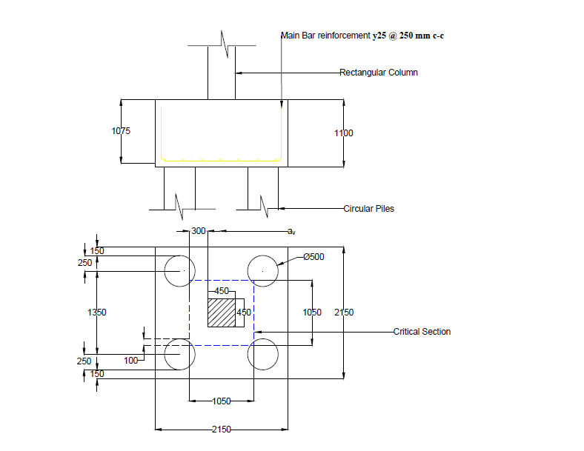
Figure 1: Designed pile cap

2a Stability of retaining wall

2b1 Reasons for the enlargement of bored piles at the base
Bored piles with an enlarged base are called belled piles or under reamed piles.
“Belled piles (otherwise known as under reamed piles) have mechanically formed enlarged bases in the form of an inverted cone, and can only be formed in stable soil conditions. They are a useful method for increasing the bearing capacity in deep foundations, and allow a greater bearing capacity than a straight-shaft pile. These piles are appropriate for wide ranging soils which are often subjected to seasonal moisture differences, filled up ground and detached or soft strata, as well as being used in common ground conditions where economics are favourable due to the reduced pile shaft diameter (requiring less concrete)” (Red Deer Piling, 2015).

2b2 Reason for reinforcing and designing precast piles to resist bending moment
“Reinforcement should be provided in all precast concrete piles to take up the stresses caused in handling, pitching and driving and this greatly exceeds what is needed once the pile is in the ground” (Salman, et al., 2010)

3a

3b

4a Differences between HA and HB loading system
The following are extracts from (Childs, 2020) explaining the HA loading system
- HA loading is the normal design loading for Great Britain and adequately covers the effects of all permitted normal vehicles other than those used for abnormal indivisible loads.
- Normal vehicles are governed by the Road Vehicles (Authorised Weight) Regulations 1998, referred to as the AW Vehicles and cover vehicles up to 44 tonne gross vehicle weight.
- Loads from these AW vehicles are represented by a Uniformly Distributed Load and a Knife Edge Load. The loading has been enhanced to cover:
- impact load (caused when wheels 'bounce' i.e. when striking potholes or uneven expansion joints).
- overloading
- Lateral bunching (more than one vehicle occupying the width of a lane).
- The magnitude of the Uniformly Distributed Load is dependent on the loaded length as determined from the influence line for the member under consideration.
- For simply supported single span decks this usually relates to the span of the deck.
- The UDL (W kN/m) is multiplied by a lane factor β to obtain the value to be applied to each notional lane. If the UDL is required in kN/m² then W will need to be divided by the notional lane width bL.
- The knife edge load (KEL) is also multiplied by the lane factor β. The KEL may be positioned anywhere along the loaded length in order to obtain the worst effect in the member being considered.
- A single wheel load of 100 kN also needs to be considered as an alternative to the UDL and KEL as part of the HA loading design. The wheel load can produce more severe effects than the UDL+KEL on short span members.
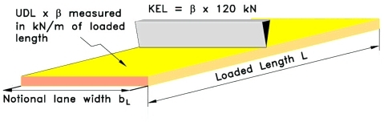
Figure 2: HA UDL+KEL loading on one notional lane (Childs, 2020)

The following are extracts from (Childs, 2020) explaining the HB loading system
- Type HB loading requirements derive from the nature of exceptional industrial loads (e.g. electrical transformers, generators, pressure vessels, machine presses, etc.) likely to use the roads in the area.
- The vehicle load is represented by a four-axle vehicle with four wheels equally spaced on each axle. The load on each axle is defined by a number of units which is dependent on the class of road and is specified follows:
- Motorways and trunk roads require 45 units, Principal roads require 37.5 units and other public roads require 30 units.
- One unit of HB is equal to 10kN per axle.
- There are five HB vehicles to check although most vehicles can be discounted by inspection. The spacing between the inner two axles of the vehicle has five different values which produces the range of HB vehicle to consider.
- Only one HB vehicle is considered to load any one superstructure. The vehicle is positioned within one notional lane or straddles two notional lanes in order to obtain the worst effect on the member.
- HA loading is placed in any remaining lane not occupied by the HB vehicle.
- Also, if the deck is long enough, the HA UDL only is placed in the lanes occupied by the HB vehicle, but is omitted from the length of lane within 25m from the front and back of the HB vehicle.
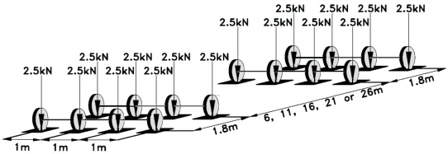
Figure 3: 1 unit of HB loading (Childs, 2020)

4b Mathematical expressions for active and passive pressure on a retaining wall
According to (Rankine, 1856), the following are mathematical expressions for lateral earth pressures on retaining walls
Coefficient of active earth pressure:
$Ka =\tan^{2} \left(45- \frac{∅^{'}}{2}\right)$ = $\frac{1-\sin{(∅^{'})}}{1+ \sin{(∅^{'})}}$ (11)
Coefficient of passive earth pressure:
$Kp =\tan^{2} \left(45+ \frac{∅^{'}}{2}\right)$ = $\frac{1+ \sin{(∅^{'})}}{1-\sin{(∅^{'})}}$ (12)

NOTE: Total lateral earth pressure (Active or Passive) = Area of the pressure diagram

Dry Cohesionless Backfill:
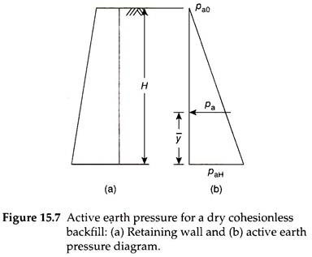
$P_{a}= \frac{K_{a}γH^{2}}{2}$ (13)
$P_{p}= \frac{K_{p}γH^{2}}{2}$ (14)
Cohesionless Backfill with Surcharge:
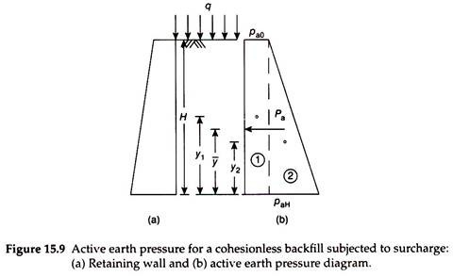
$P_{a}= K_{a}qH+ \frac{K_{a}γH^{2}}{2}$ (15)
$P_{P}= K_{P}qH+ \frac{K_{P}γH^{2}}{2}$ (16)

Fully Submerged Cohesionless Backfill:
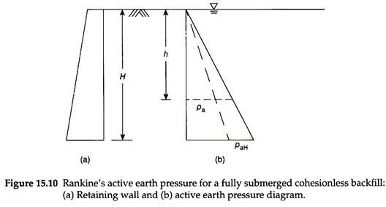
$P_{a}= \frac{K_{a}γ^{'}H^{2}}{2}+ \frac{K_{a}γH^{2}}{2}$ (17)
$P_{p}= \frac{K_{p}γ^{'}H^{2}}{2}+ \frac{K_{p}γH^{2}}{2}$ (18)

Partially Submerged Cohesionless Backfill:
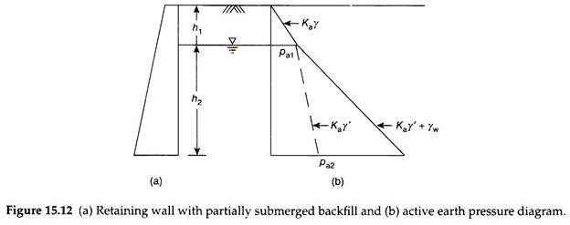
$P_{a}= \left[\frac{1}{2}P_{a1} × h_{1}\right]+ \left[P_{a2} × h_{2}\right]+ \left[\frac{1}{2} × \left(P_{a2}- P_{a1}\right) × h_{2}\right]$ (19)
$P_{p}= \left[\frac{1}{2}P_{p1} × h_{1}\right]+ \left[P_{p2} × h_{2}\right]+ \left[\frac{1}{2} × \left(P_{p2}- P_{p1}\right) × h_{2}\right]$ (20)

Cohesionless Backfill with Sloping Surface:
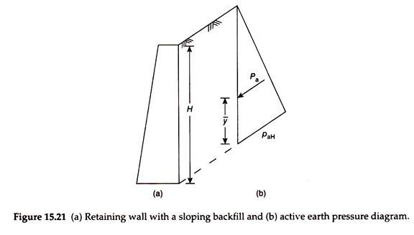
$P_{a}= \frac{K_{a}γH^{2}}{2}$ (21)
$P_{p}= \frac{K_{p}γH^{2}}{2}$ (22)

Cohesive backfill:
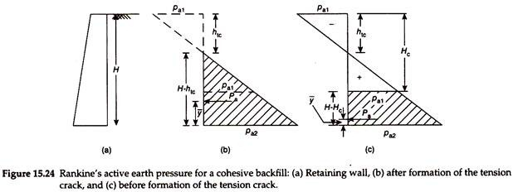
- When tension crack Is developed:
$P_{a}= \frac{1}{2} × \left(K_{a}γH-2c\sqrt{K_{a}}\right) × \left(H- h_{tc}\right)$ (23)
$P_{p}= \frac{1}{2} × \left(K_{p}γH-2c\sqrt{K_{p}}\right) × \left(H- h_{tc}\right)$ (24)
Cohesive backfill when tension crack is not developed:
$P_{a}= \frac{1}{2} × \left(K_{a}γH-2c\sqrt{K_{a}}\right) × \left(H- H_{c}\right)$ (25)
$P_{p}= \frac{1}{2} × \left(K_{p}γH-2c\sqrt{K_{p}}\right) × (H- H_{c})$ (26)

4c Pile Load distribution

PILE | Xn | Yn | X² | Y² | Pn
1 | +5.5 | -1.5 | 30.25 | 2.25
2 | -5.5 | -4.9 | 30.25 | 24.01
3 | -2 | -8.1 | 4 | 65.61
4 | -2 | +8.1 | 4 | 65.61
5 | -5.5 | +4.9 | 30.25 | 24.01
6 | -5.5 | +1.5 | 30.25 | 2.25
7 | +2 | +4.7 | 4 | 22.09
8 | +2 | -4.7 | 4 | 22.09
 | 30 | 38.4 | 137 | 227.92

$$PN=\frac{N}{n}±\frac{Nexx.Yn}{Ixx}±\frac{Neyy.Xn}{Iyy}$$

$$N=300KN$$
$$n=8$$
$$\frac{N}{n}=375$$
$$Ixx=∑x^{2}=137m^{2}$$
$$Iyy=∑y^{2}=227.92m^{2}$$
$$y‾ =\frac{/∑y/}{n} =\frac{38.4}{8}=4.8m$$
$$x‾ =\frac{/∑x/}{n} =\frac{30}{8}=3.75m$$

$$exx=\left(3.5+2\right)-x‾$$
$$=5.5-3.75$$
$$=1.75m$$

$$exx=\left(3.2+3.2\right)-y‾$$
$$=6.4-4.8$$
$$=1.75m$$

$$\frac{Nexx}{Ixx}=\frac{3000*1.75}{137}=38.3212$$
$$\frac{Neyy}{Iyy}=\frac{3000*1.6}{227.92}=21.0600$$
$$pn=375±\left(38.3212\right)Yn ±\left(21.0600\right)Xn$$
$$p1=375-\left(38.3212\right)\left(1.5\right)+\left(21.0600\right)\left(5.5\right)=433.3462KN$$
$p2=375-\left(38.3212\right)\left(4.9\right)-\left(21.0600\right)(5.5)=$71.39612KN
$$p3=375-\left(38.3212\right)\left(8.1\right)-\left(21.0600\right)(2) =22.48828KN$$
$p4=375+\left(38.3212\right)\left(8.1\right)-\left(21.0600\right)(2) =$643.28172KN
$$p5=375+\left(38.3212\right)\left(4.9\right)-\left(21.0600\right)(5.5) =446.94386KN$$
$$p6=375+\left(38.3212\right)\left(1.5\right)+\left(21.0600\right)(5.5) =548.3111KN$$
$p7=375+\left(38.3212\right)\left(4.7\right)+\left(21.0600\right)(2) =$597.22969KN
$$p8= 375-\left(38.3212\right)\left(4.7\right)+\left(21.0600\right)(2) =237.01036KN$$
3000KN

References
abuildersengineer, 2013. Example: Pile cap design.. [Online]
Available at: http://www.abuildersengineer.com/2013/02/example-pile-cap-design.html
[Accessed 22 April 2020].
Childs, D., 2020. HA and HB Type Loading. [Online]
Available at: http://bridgedesign.org.uk/tutorial/ha-hb-loading.php
[Accessed 28 April 2020].
corrosionpedia, 2018. Flexural Strength. [Online]
Available at: https://www.corrosionpedia.com/definition/5061/flexural-strength
[Accessed 22 April 2020].
Rankine, W., 1856. On the stability of loose earth.. Philosophical Transactions of the Royal Society of London, Volume 147.
Red Deer Piling, 2015. Belled Piles (Under Reamed Piles). [Online]
Available at: http://www.reddeerpiling.com/belled-piles-under-reamed-piles/
[Accessed 23 April 2020].
Reynolds, C. E. & Steedman, J. C., 1999. Foundations: Pile Cap Desin . In: Reinforced concrete desiger's handbook. s.l.:Gopsons Papers Ltd., p. 194.
Salman, F. A., Mohammed, M. M., Shirazi, S. M. & Jameel, M., 2010. Reinforcement in concrete piles embedded in sand. International Journal of the Physical Sciences, 5(15), pp. 2259-2271.
wikipedia, 2020. Flexural strength. [Online]
Available at: https://en.wikipedia.org/wiki/Flexural_strength
[Accessed 22 April 2020].

