ABDULLAHI USMAN

19/SMS11/008

I.T.S(INTELLIGENCE AND SECURITY STUDIES

SMS( SOCIAL AND MANAGEMENT SCIENCE)

(Earth surface)

The solar system consists of the Sun; the eight official planets, at least three “dwarf planets”, more than 130 satellites of the planets, a large number of small bodies (the comets and asteroids), and the interplanetary medium. (There are probably also many more planetary satellites that have not yet been discovered.)
Orbits
The solar system consists of the Sun; the eight official planets, at least three “dwarf planets”, more than 130 satellites of the planets, a large number of small bodies (the comets and asteroids), and the interplanetary medium. (There are probably also many more planetary satellites that have not yet been discovered.)
The inner solar system contains the Sun, Mercury, Venus, Earth and Mars:
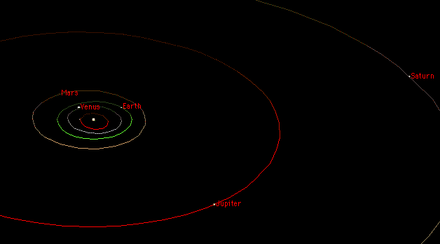

The main asteroid belt (not shown) lies between the orbits of Mars and Jupiter. The planets of the outer solar system are Jupiter, Saturn, Uranus, and Neptune (Pluto is now classified as a dwarf planet):
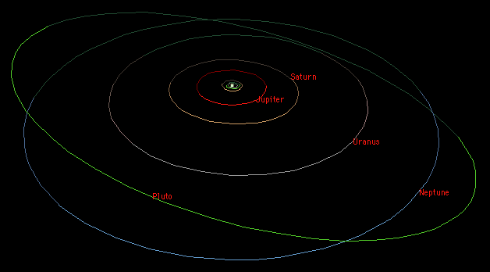
The first thing to notice is that the solar system is mostly empty space. The planets are very small compared to the space between them. Even the dots on the diagrams above are too big to be in proper scale with respect to the sizes of the orbits.
The orbits of the planets are ellipses with the Sun at one focus, though all except Mercury are very nearly circular. The orbits of the planets are all more or less in the same plane (called the ecliptic and defined by the plane of the Earth’s orbit). The ecliptic is inclined only 7 degrees from the plane of the Sun’s equator. The above diagrams show the relative sizes of the orbits of the eight planets (plus Pluto) from a perspective somewhat above the ecliptic (hence their non-circular appearance). They all orbit in the same direction (counter-clockwise looking down from above the Sun’s north pole); all but Venus, Uranus and Pluto also rotate in that same sense.

The classification of planets are as follows;

- by composition:
  - terrestrial or rocky planets: Mercury, Venus, Earth, and Mars:
    - The terrestrial planets are composed primarily of rock and metal and have relatively high densities, slow rotation, solid surfaces, no rings and few satellites.
  - jovian or gas planets: Jupiter, Saturn, Uranus, and Neptune:
    - The gas planets are composed primarily of hydrogen and helium and generally have low densities, rapid rotation, deep atmospheres, rings and lots of satellites.
- by size:
  - small planets: Mercury, Venus, Earth, Mars.
    - The small planets have diameters less than 13000 km.
  - giant planets: Jupiter, Saturn, Uranus and Neptune.
    - The giant planets have diameters greater than 48000 km.
  - The giant planets are sometimes also referred to as gas giants.
- by position relative to the Sun:
  - inner planets: Mercury, Venus, Earth and Mars.
  - outer planets: Jupiter, Saturn, Uranus, Neptune.
  - The asteroid belt between Mars and Jupiter forms the boundary between the inner solar system and the outer solar system.
- by position relative to Earth:
  - inferior planets: Mercury and Venus.
    - closer to the Sun than Earth.
    - The inferior planets show phases like the Moon’s when viewed from Earth.
  - Earth.
  - superior planets: Mars thru Neptune.
    - farther from the Sun than Earth.
    - The superior planets always appear full or nearly so.
- by history:
  - classical planets: Mercury, Venus, Mars, Jupiter, and Saturn.
    - known since prehistorical times
    - visible to the unaided eye
    - in ancient times this term also refered to the Sun and the Moon; the order was usually specificied as: Saturn, Jupiter, Mars, Sun, Venus, Mercury and Moon, based on the time for them to go “all the way round” the sphere of the “fixed” stars).
  - modern planets: Uranus, Neptune.
    - discovered in modern times
    - visible only with optical aid
  - Earth.
  - The IAU decided that “classical” should refer to all eight planets (Mercury thru Neptune, including Earth but not Pluto). This is contrary to historical usage but makes some sense from a 21st century perspective.

