RENAL PHYSIOLOGY
AMOO OLUWANIFEMI MICHAEL
18/MHS01/379
MEDICINE AND SURGERY (MBBS)
Assignment Questions
Q1. Discuss the role of kidney in glucose homeostasis?
Q2. Discuss the process of micturition?
Q3. Explain juxtaglomerular apparatus?
Q4. Discuss the role of kidney in regulation of blood pressure?
Q5. Discuss the role of Kidney in Calcium homeostasis?

Q1. Discuss the role of kidney in glucose homeostasis?
The kidneys contributions to maintaining glucose homeostasis are significant and include such functions as release of glucose into the circulation via gluconeogenesis, uptake of glucose from the circulation to satisfy their energy needs, and reabsorption of glucose at the level of the proximal tubule. Renal release of glucose into the circulation is the result of glycogenolysis and gluconeogenesis, respectively involving the breaking down and formation of glucose-6-phosphate from precursors (e.g. lactate, glycerol, amino acids). With regard to renal reabsorption of glucose, the kidneys normally retrieve as much glucose as possible, rendering the urine virtually glucose free. The glomeruli filter from plasma approximately 180 grams of D-glucose per day, all of which is reabsorbed through glucose transporter proteins that are present in cell membranes within the proximal tubules. If the capacity of these transporters is exceeded, glucose appears in the urine. The process of renal glucose reabsorption is mediated by active (sodium-coupled glucose cotransporters SGLTs) and passive (glucose transporters GLUTs) transporters.
The transport of glucose into and across cells is dependent on specialized carrier proteins in 2 gene families: the facilitated glucose transporters (GLUTs) and the sodium-coupled glucose cotransporters (SGLTs). These transporters control glucose transport and reabsorption in several tissue types, including the proximal renal tubule, small intestine, blood-brain barrier, and peripheral tissues. GLUTs are involved in the passive transport of glucose across cell membranes, facilitating its downhill movement as it equilibrates across a membrane. SGLTs, on the other hand, mediate active transport of glucose against a concentration gradient by means of cotransport with sodium. Of the various SGLT proteins expressed in the kidneys, SGLT2 is considered most important; based on animal studies, it is responsible for reabsorbing 90% of the glucose filtered at the glomerulus. SGLT1 contributes to the other 10% of glucose reabsorbed in the proximal tubule. This predominant role of SGLT2 in renal reabsorption of glucose raises the prospect of therapeutically blocking this protein in patients with diabetes. Of the various GLUT proteins expressed in the kidneys, GLUT2 is the major transporter, releasing into circulation the glucose reabsorbed by SGLTs in the proximal tubular cells.
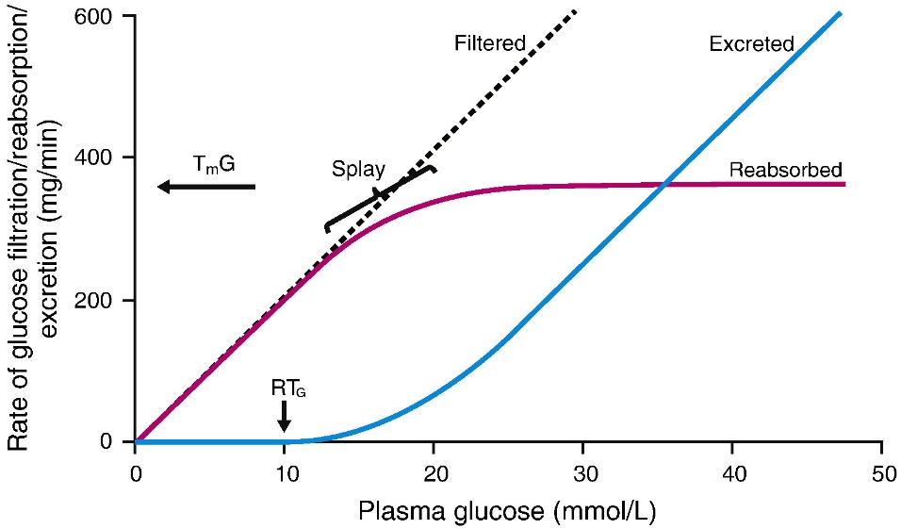
The relationship between plasma glucose concentration and renal glucose reabsorption in normoglycemic individuals

Q2. Discuss the process of micturition?
Micturition or urination is the process of expelling urine from the bladder. This act is also known as voiding of the bladder. The excretory system in humans includes a pair of kidneys, two ureters, a urinary bladder and a urethra. The kidneys filter the urine and it is transported to the urinary bladder via the ureters where it is stored till its expulsion. The process of micturition is regulated by the nervous system and the muscles of the bladder and urethra. The urinary bladder can store around 350-400ml of urine before it expels it out.

Stages of Micturition
The urinary bladder has two distinct stages or phases:
- Resting or filling stage
- Voiding stage

Resting or Filling Stage
It is in this phase of the bladder that the urine is transported from the kidneys via the ureters into the bladder. The ureters are thin muscular tubes that arise from each of the kidneys and extend downwards where they enter the bladder obliquely. The oblique placement of the ureters in the bladder wall serves a very important function. The opening of the ureter into the urinary bladder is not guarded by any sphincter or muscle. Therefore, this oblique nature of opening prevents the urine from re-entering the ureters. At the same time, the main muscle of the urinary bladder, the detrusor muscle, is relaxing allowing the bladder to distend and accommodate more urine.

Voiding Stage
During this stage, both the urinary bladder and the urethra come into play together. The detrusor muscle of the urinary bladder which was relaxing so far starts to contract once the bladder’s storage capacity is reached. The urethra is controlled by two sets of muscles: The internal and external urethral sphincters. The internal sphincter is a smooth muscle whereas the external one is skeletal. Both these sphincters are in a contracted state during the filling stage.
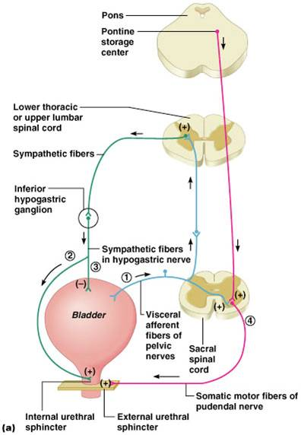

Micturition is governed by both the nervous and muscular systems. Within the nervous system, the process is governed by the autonomous nervous system and the somatic system. Once the urinary bladder reaches its maximum capacity, the stretch receptors in the walls of the bladder send an impulse via the pelvic nerve to the brain via the spinal cord.
The micturition reflex is ultimately generated from the level of the spinal cord after it receives reflexes from the pontine region in the brain. Once the bladder and the urethra receive the signals to empty the bladder, the two sphincters relax and the detrusor muscle causes the contractions of the bladder. Along with these muscles, the muscles of the abdomen also play a role by putting pressure on the bladder wall. This leads to complete emptying of the bladder.

Q3. Explain juxtaglomerular apparatus?
The juxtaglomerular apparatus is a structure in the kidney that regulates the function of each nephron (the functional units of the kidney). The juxtaglomerular cells come together with the macula densa to form the juxtaglomerular apparatus. The juxtaglomerular apparatus is named because it is next to the glomerulus.
The juxtaglomerular apparatus consists of three types of cells:
- The macula densa
- Juxtaglomerular cells
- Extraglomerular mesangial cells
Juxtaglomerular cells
Renin is produced by juxtaglomerular cells. These cells are similar to epithelium and are located in the tunica media of the afferent arterioles as they enter the glomeruli. The juxtaglomerular cells secrete renin in response to:
- Stimulation of the beta-1 adrenergic receptor
- Decrease in renal perfusion pressure (detected directly by the granular cells)
- Decrease in NaCl concentration at the macula densa, often due to a decrease in glomerular filtration rate
Extraglomerular mesangial cells
Extraglomerular mesangial cells are located in the junction between the afferent and efferent arterioles. These cells have a contractile property similar to vascular smooth muscles and thus play a role in “regulating GFR” by altering the vessel diameter. Renin is also found in these cells.
Macula densa
At the point where the afferent arterioles enter the glomerulus and the efferent arteriole leaves it, the tubule of the nephron touches the arterioles of the glomerulus from which it rose. At this location, the distal convoluted tubule, there is a modified region of tubular epithelium called the macula densa. Cells in the macula densa respond to changes in the sodium chloride levels in the distal tubule of the nephron via the tubuloglomerular feedback (TGF) loop.

Q4. Discuss the role of kidney in regulation of blood pressure?
The system that regulates blood pressure in the kidney is called the renin-angiotensin-aldosterone system. The renin–angiotensin system (RAS), or renin–angiotensin–aldosterone system (RAAS), is a hormone system that regulates blood pressure and fluid and electrolyte balance, as well as systemic vascular resistance. When renal blood flow is reduced, juxtaglomerular cells in the kidneys convert the precursor pro-renin (already present in the blood) into renin and secrete it directly into circulation. Plasma renin then carries out the conversion of angiotensinogen, released by the liver, to angiotensin I. Angiotensin I is subsequently converted to angiotensin II by the angiotensin-converting enzyme (ACE) found on the surface of vascular endothelial cells, predominantly those of the lungs. Angiotensin II is a potent vasoconstrictive peptide that causes blood vessels to narrow, resulting in increased blood pressure. Angiotensin II also stimulates the secretion of the hormone aldosterone from the adrenal cortex. Aldosterone causes the renal tubules to increase the reabsorption of sodium which in consequence causes the reabsorption of water into the blood, while at the same time causing the excretion of potassium (to maintain electrolyte balance). This increases the volume of extracellular fluid in the body, which also increases blood pressure.
If the RAS is abnormally active, blood pressure will be too high. There are many drugs that interrupt different steps in this system to lower blood pressure. These drugs are one of the primary ways to control high blood pressure, heart failure, kidney failure, and harmful effects of diabetes. Renin activates the renin–angiotensin system by cleaving angiotensinogen, produced by the liver, to yield angiotensin I, which is further converted into angiotensin II by ACE, the angiotensin–converting enzyme primarily within the capillaries of the lungs.
Angiotensin-2 also stimulates the adrenal gland to secrete a hormone called aldosterone. Aldosterone stimulates more Na reabsorption in the distal tubule, and water gets reabsorbed along with the Na. The increased Na and water reabsorption from the distal tubule reduces urine output and increases the circulating blood volume. The increased blood volume helps stretch the heart muscle and causes it to generate more pressure with each beat, thereby increasing the blood pressure.
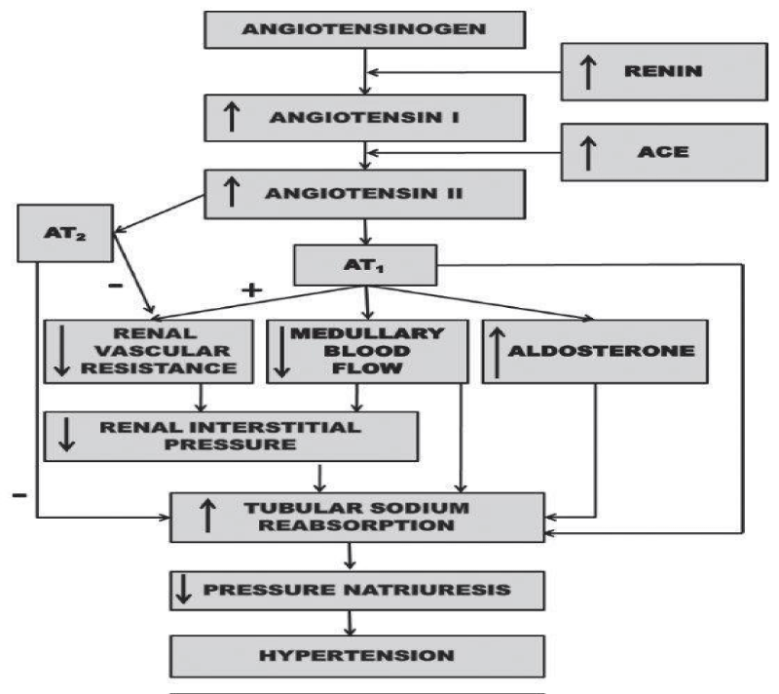

Q5. Discuss the role of Kidney in Calcium homeostasis?
The kidney is critically important in calcium homeostasis. Under normal blood calcium concentrations, almost all of the calcium that enters glomerular filtrate is reabsorbed from the tubular system back into blood, which preserves blood calcium levels. If tubular reabsorption of calcium decreases, calcium is lost by excretion into urine.
About 50% of plasma calcium is freely filtered through the renal glomerulus, and 99% of the filtered calcium is actually reabsorbed along renal tubules. The excreted calcium in the final urine is about 200 mg per day in an adult person with an average diet. Several factors are involved in the regulation of calcium in renal tubules. PTH and activated vitamin D enhance calcium reabsorption in the thick ascending limb, distal convoluted tubule and connecting tubule, oestrogen promotes calcium absorption in the distal convoluted tubule and connecting tubule. Acidosis contributes to hypercalcaemia by reducing calcium reabsorption in the proximal tubule and distal convoluted tubule and alkalosis vice versa. Plasma calcium itself also controls renal calcium absorption through altered PTH secretion as well as via binding to the calcium sensing receptor (CaSR) in the thick ascending loop. To facilitate Ca2+ reabsorption along renal tubules;
- Voltage difference between the lumen and blood compartment should be favourable for Ca2+ passage, i.e., a positive voltage in the lumen;
- Concentration difference should be favourable for Ca2+ passage with a higher Ca2+ concentration in the lumen;
- An active transporter should exist if the voltage or concentration difference is not favourable for Ca2+ reabsorption.
Each renal tubular segment has a different Ca2+ concentration difference or voltage environment for its unique mechanism for calcium reabsorption.

