Green Grace Igbogi

18/mhs07/021

Pharmacology

Phs 206 assignment
Antimicrobial resistance

Question
List and explain 4 mechanism of antimicrobial resistance Note. Benjamin s (course rep) send me your contact

Mechanism of antimicrobial resistance include
The three fundamental mechanisms of antimicrobial resistance are
(1) enzymatic degradation of antibacterial drugs,
(2) alteration of bacterial proteins that are antimicrobial targets, and
(3) changes in membrane permeability to antibiotics.
(4) drug removal from the cell.

Antibiotic resistance can be either plasmid mediated or maintained on the bacterial chromosome. The most important mechanism of resistance to the penicillins and cephalosporins is antibiotic hydrolysis mediated by the bacterial enzyme beta-lactamase. The expression of chromosomal beta-lactamase can either be induced or stably depressed by exposure to beta-lactam drugs. Methods to overcome resistance to beta-lactam antibiotics include the development of new antibiotics that are stable to beta-lactamase attack and the coadministration of beta-lactamase inhibitors with beta-lactam drugs. Resistance to methicillin, which is stable to gram-positive beta-lactamase, occurs through the alteration of an antibiotic target protein, penicillin-binding protein 2. Production of antibiotic-modifying enzymes and synthesis of antibiotic-insensitive bacterial targets are the primary resistance mechanisms for the other classes of antibiotics, including trimethoprim, the sulfonamides, the aminoglycosides, chloramphenicol, and the quinolone drugs. Reduced antibiotic penetration is also a resistance mechanism for several classes of antibiotics, including the beta-lactam drugs, the aminoglycosides, chloramphenicol, and the quinolones.

(1) Changing the drug
Many bacteria code for enzymes that can modify antibiotics. The result is that often they can no longer bind to their target site. Beta-lactam antibiotics for example are degraded by a class of enzymes called beta-lactamases, which cleave the characteristic lactam ring of the drug rendering them inactive.
Genes encoding these elements can be acquired horizontally, but many bacteria encode these elements intrinsically. Mutations in these genes, or the promoter regions of these genes have been well characterised as a leading cause of clinical levels of resistance through increased gene expression.
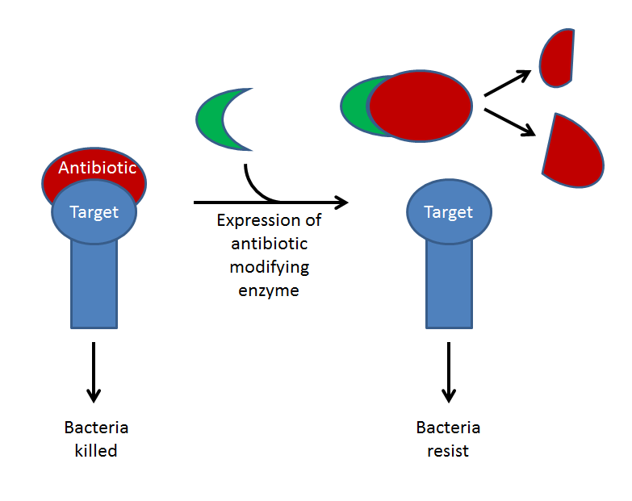
Above- this diagram depicts how expression of antibiotic-modifying enzymes can lead to drug resistance. In addition to enzymatic cleavage, some of these enzymes inactivate antibiotics by covalently linking them with other molecules, for example the aminoglycoside acetyl-transferases.
(2) Changing the target
In addition to drug modification, bacteria can become resistant by changing the shape of an antibiotic's target. These mutations often change the shape of the target, lowering the affinity to antibiotics, but not impairing their native function. Furthermore, bacteria can horizontally acquire decoy proteins with high affinities to antibiotic, meaning the drug will bind to these instead of their cellular target.
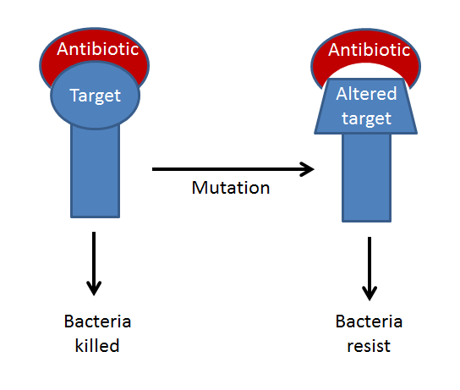
Above- this diagram shows mutation altering the structure of an antibiotic target. This is a common mechanism of resistance to quinolone antibiotics (such as ciprofloxacin). Quinlones target bacterial DNA gyrases and other type IV topoisomerases. Mutations in specific regions of the genes encoding these proteins (Quinolone Resistance Determining Region) have been shown to confer resistance.
(3) Active efflux
Finally, the mechanism most commonly associated with resistance to multiple classes of antibiotics (multi-drug resistance) are the action of efflux pumps. These multi-protein complexes can be very selective in their targets, or very broad. They continually pump antibiotics out of the cell, lowering intercellular concentrations of the drug, leading to resistance. Efflux pumps are often intrinsically present in susceptible strains implying a more general biological function. Mutations leading to overexpression of efflux pumps are a common feature in bacteria resistant to several classes of clinical antibiotics.
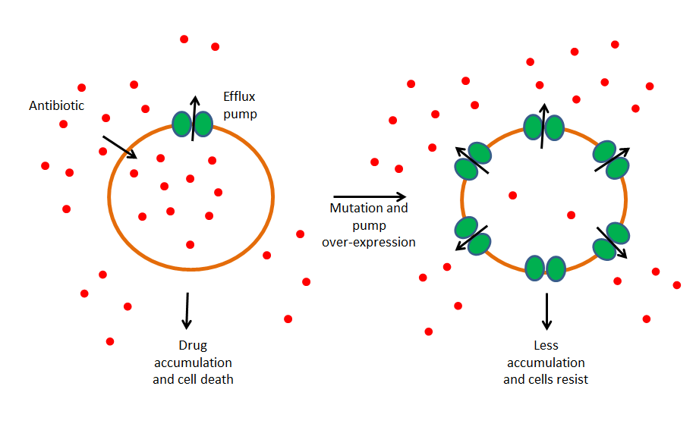
Above- The presence of efflux pumps in susceptible strains indicates that they have a function in the essential biology of the cell. Over expression of these pumps are what results in clinical levels of resistance.

4. drug removal from the cell.
Reduced drug uptake is the third major mechanism responsible for β-lactam resistance in gram-negative bacteria, where β-lactams need to enter the periplasmic space to bind the PBP targets located in the cytoplasmic membrane. In fact, in gram-negative bacteria, the activity of β-lactams against the bacterial cell depends on the complex interplay of a number of factors (Figure 138-1), including:
•
the concentration of the antibiotic in the environment;
•
the rate of antibiotic entry through the outer membrane;
•
the amount of β-lactamase produced;
•
the catalytic efficiency of the β-lactamase for the antibiotic; and
•
the affinity of the PBPs for the antibiotic.
Reduced drug uptake can be due either to a reduction or alteration in the porin channels used by β-lactams to cross the outer membrane, or to the presence of efflux pumps that can actively extrude β-lactams from the periplasmic space.
Reduced uptake is often encountered as a β-lactam resistance mechanism in Pseudomonas aeruginosa, but also in Acinetobacter baumannii and Enterobacteriaceae. In Pseudomonas aeruginosa, mutational loss or alterations of the OprD2 porin, which is the entry channel for carbapenems, is one of the most common mechanisms of acquired resistance to these drugs, while upregulation of the resident RND-type MexAB multidrug efflux pump can contribute to acquired resistance to several β-lactams which are effluxed by the pump from the periplasmic space, including meropenem, and anti-pseudomonas cephalosporins and penicillins.15
In Enterobacteriaceae, reduced uptake by mutational loss or alteration of some porins, in combination with the overproduction of ESBLs or AmpC-type β-lactamases, can be responsible for a low-level carbapenem resistance phenotype that can be selected during carbapenem treatment.

