NAME: SMOOTH SIMON
MATRIC NO: 15/ENG03/030
COURSE: CVE504
QUESTION ONE
- Define flexural strength
Answer:
The flexural strength of a material is defined as the maximum bending stress that can be applied to that material before it yields.
- A group of four piles supports a 450 x 450 mm rectangular column which transmits an ultimate axial load of 4000 kN. If the pile diameter is 500 mm spaced at 1350 mm Centre - Centre, design the pile cap using f_{cu} =30N/mm², f_{y}=410N/mm².
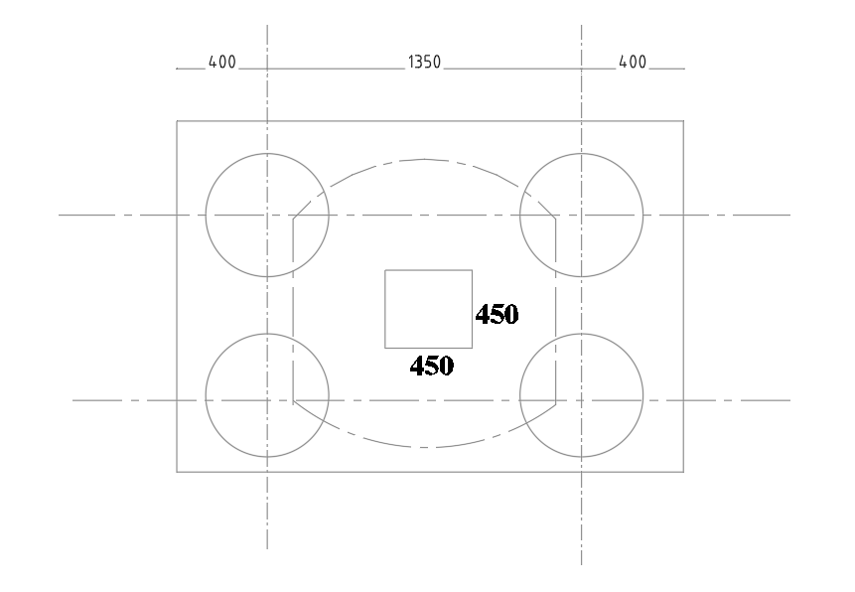
$$500÷2=250+150=400(edge distance of pile edge of the pile cap)$$
$$solution$$
$$pile diameter ∅=500mm$$
$$depth f pile h=1100mm$$
$$effective d=h-cover-∅$$
$$depth=1100-100-25=975mm$$
$$span l=\frac{1}{2}×spacing=\frac{1}{2}×1350=675mm$$
$$critical section=\frac{1}{5}∅=\frac{1}{5}×500=100mm$$
$$a_{v}=\frac{1375-450}{2}=450-100=350mm$$
$$a^{i}=250-100=150mm$$
Design for reinforcement
$$As=\frac{NL}{4d×0.87×Fyk}=\frac{4000×{10}^{3}×675}{4×975×0.87×410}=1941{mm}^{2}$$
$$Total area, 2As=3882{mm}^{2}$$
$$provide Y25 @250\frac{c}{c}$$
Shear check
$$shear along critical section, v=\frac{p}{2}=\frac{4000}{2}=2000KN$$
$$Ved=V×\frac{a_{v}}{2d}=\frac{2000×350}{2×975}=359KN$$
$$Vrd.c=0.12K{(100P Fck)}^{\frac{1}{2}}≥\left({0.035K}^{1.5}{Fck}^{0.5}\right);k=1+\sqrt{\frac{200}{d}}=1+\sqrt{\frac{200}{975}}=1.45$$
$$Vrd.c=0.12×1.43{\left(100×0.0026×30\right)}^{\frac{1}{3}}≥\left(0.035×{1.43}^{1.5}×{30}^{0.5}\right)$$
$$=0.35≥0.33(o.k)$$
$$Vrd.c=\frac{0.35×2150×975}{1000×1000}=0.73>vrd.c$$

QUESTION TWO
- A cantilever retaining wall has angle of friction 45⁰ and supports a granular material of saturated density of 1820kg/m³. Check the stability of the wall and determine the overturning and restrained moments. Assume 30-410N/mm³ grade of concrete.
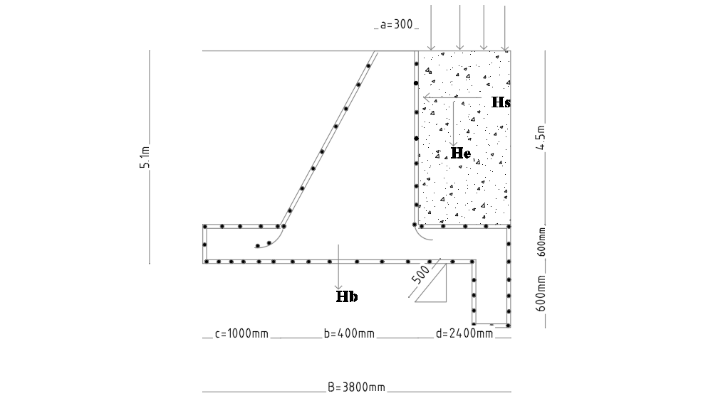

- Checking for stability
$$Ka=\frac{1-\sin{45}}{1+\sin{45}}=0.17$$
$$Kp=\frac{1}{0.17}=5.88$$
$$P_{a}=K_{a}pgH$$
$$P_{a}=K_{a}pgH=0.17×1820×10×{5.1×10}^{-3}=15.78KN/m²$$
Load due to surcharge
$$Ps=KaSl=0.17×12=2.04KN/m²$$
$$horizontal force, Hk=\frac{1}{2}P_{a}H=\frac{1}{2}×15.78×5.1=40.24KN$$
$$Horizontal force due to surcharge, Hs= P_{s}H=2.04×5.1=10.4KN$$
Vertical load
$$Hw:wall: \frac{1}{2}\left(a+b\right)h=\frac{1}{2}\left(0.3+0.4\right)×4.5×24=37.8KN$$
$$He:earth: \frac{1}{2}\left(a+b\right)h=\frac{1}{2}\left(2.4+2.5\right)×4.5×1820×10×{10}^{-3}=200.7KN$$
$$He:base: Aρ_{conc}=3.8×0.6×24=54.7KN$$
Variable loads
$$V_{l}=d×S_{L}=2.4×12=28.8KN$$
$$Overturning moment Mo=γ_{F}H_{K}\frac{H}{3}+γ_{F}H_{S}\frac{H}{2}$$
$$Mo=\left(1.1×40.24×\frac{5.1}{3}+1.5×10.4×\frac{5.1}{2}\right)=114.95KNM$$
$$Restraint moment Mr=\left[Hw\left(C+\frac{b}{2}\right)+\left(Hb×\frac{b}{2}\right)+He\left(d+b-a\right)\right]γ_{F}$$
$$Mr=[37.8\left(1.2\right)+\left(54.7×1.9\right)+\left(200.7×\left(2.4+0.4-0.3\right)\right]×0.9=585.9KNM$$

- Give reasons for the following; (a) Bored piles are enlarged at base (b) Precast piles must be reinforced and design to resist bending moment.
Answer
- Bored piles are enlarged at base because it may be a cost-effective option to the barrette shaped piles, considering the reduction of the cross section of the deep foundation elements, yet maintaining a high bearing capacity.
- Reinforcement must be provided in the precast concrete pile to withstand the bending and tensile stresses which occur during handling and driving. Once the pile is in the ground, and if mainly compressive loads are carried, the majority of this steel is redundant

QUESTION THREE
- Write a well detailed explanation of the construction procedure including materials used, tests on soil bearing capacity, pile length e.t.c during the construction of Fajuyi Park Bridge, Ado-Ekiti.
Answer:
The technical study of execution:
This is the first and most important step in the construction of a bridge because the enormous loads applied on this structure during the construction site and after its commissioning must be well quantified and studied in a really sufficient time with the consideration the aesthetic aspect that plays a very important role in bridges.

The infrastructure:
- The foundations are the base of the bridge which transmit all the loads of the superstructure to the ground, this ground which is variable one matter of resistance because there are clay soils that cannot mympa support the feet of a pedestrian for this case it is very difficult to implement a work of such characteristics that requires a high technicality.
- The superficial foundations (soles) (between 0-5m).
- the semi-deep foundations (improved the soil by the big concrete and the sole will be implanted on this improved ground) (between 5-10 m).
- the deep foundations (improved the ground by piles anchored in the good ground and the sole will be implanted on the piles) (between 10-100 meters).
Realization of the piles:
- This is a step that requires a lot of technique and difficulty as well as specific means (drilling, lining) and qualified human resources (drilling specialists)
- the stages of realization of the piles are as follows
- Implantation of the axes of piles
- Drilling of piles
- Drilling of bored piles
- Preparation of the reinforcement cage
- Implementation of the reinforcement in the jacketed tube.
- Concreting piles.
- Remove the shirts.

Realization of the soles:
- After the implementation of the piles, it is necessary to proceed to the opening of the excavation for the sole that will distribute the loads from the superstructure on the piles and piles on the ground.
- In general, the piles realized before require the coppicing to demolish the heads of the piles to reach the low level of the sole this operation is called the coppicing of the piles.
- After the coppicing and the preparation of the excavation of the footing according to the dimensions opted in study the laying of a layer of clean concrete with a thickness of 10 to 15 cm for a good concreting and facility of carrying out the reinforcement.
- Following the reinforcement operation of the semmelle according to the plans civil engineering and then the formwork and finally the concreting of the sole.
Realization of the supports (piles and abutment):
- The pile and is intermediate vertical element to support the deck of the bridge and transmits to the foundation and the abutment is a vertical element located at the end of the bridge support shore so each bridge has two abutments a number of piles of (0 -Infinity)
Realization of the apron:
- The deck of a bridge is a very important element that require a whole subject of discussion technically there are several types of aprons according to the types of the bridges and according to the method of realization thus the means in disposition that will be treated in the next subject in detail.
- If a Bridge structure is to be located within Afe Babalola University, suggest a likely location and justify your assertion.
Answer
A bridge structure should be built at Ureje river because there is a flow of water passing through that area.
QUESTION FOUR
- Differentiate between HA and HB loading system
Answer
HA loads are represented by a uniformly distributed load with a knife edge load.
WHILE
HB loading is an abnormal vehicle unit loading.
- Give a mathematical definition of active and passive pressure acting on a retaining wall.
$$Pa=Ka w h$$
Where
$$Ka=\frac{{Cos β-(\cos^{2}β-\cos^{2}∅)}^{1/2}}{{Cos β+(\cos^{2}β-\cos^{2}∅)}^{1/2}}×Cos β$$
And
$$Ka=Coefficient of active pressure$$
$$w=weight density os soil$$
$$h=depth of the section\left(below top soil\right)where the pressure is being evaluated$$
$$β=angle that the top surface of soil makes the horizontal$$
$$∅=angle of internal friction of soil$$
The expression of passive pressure is:
$$Pa=Kp w h$$
Where
$$Kp=\frac{{Cos β+\left(\cos^{2}β-\cos^{2}∅\right)}^{1/2}}{{Cos β-\left(\cos^{2}β-\cos^{2}∅\right)}^{1/2}}×Cos β$$
$$or in the case of β=0, then the two coefficients are inversely proportional such that$$
$$Kp=\frac{1}{Ka}$$

