IFEOLUWA PROMISE
19/ENG02/021
COMPUTER ENGINEERING
CHM 102
1&2.
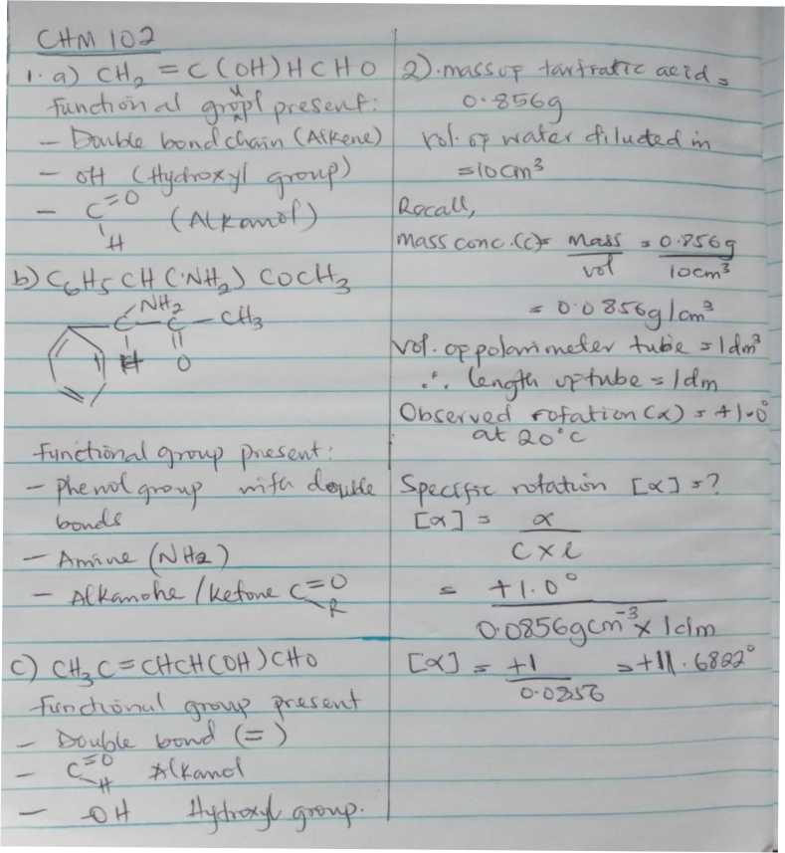
3. Hexa-2,4-diene - has only 3 isomers
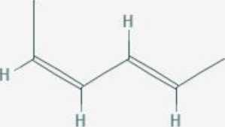

Isomers
trans trans isomer
(2E,4E)-hexa-2.4-dieiie
cis-trans isomer (2E.4Z)-hexa-2.4-dicnc (2Z.4E>hexa-2.4-<iiene
cis-cis isomer
(2Z.4Z)-hexa-2.4-dieue

B. 2,3 dimethy but-2-ene. - does not have geometric isomers because there are two identical groups attached to the same carbon of the double bond.

ch₃
2,3-dimethylbut-2-ene

