19/MHS01/067
CHEMISTRY ASSIGNMENT
- Classification of alcohols is based on :
  - the number of hydrogen atoms s attached to carbon atom containing the hydroxyl group. If the numbers of hydrogen atoms attached to the carbon atom bearing the hydroxyl group are three or two, it is called a primary alcohol, if it is one hydrogen atom it is called secondary alcohol and if no hydrogen atom is attached to the carbon atom bearing the hydroxyl group, it is called a tertiary alcohol.
Example of primary alcohol is CH₃ OH Methanol
Example of secondary alcohol is CH₃ CH(OH) CH₃
Example of tertiary alcohol is (CH₃)₃ C-OH 2- Methylpropan-2-ol

- The number of hydroxyl group they possess. Monohydric alcohols have one hydroxyl group present in the alcohol structure. Dihydric alcohols are also called glycol, the have two hydroxyl groupsnpresemt in the alcohol structure while trihydric alcohols or triols have three hydroxyl groups present in the alcohol structure. Polyhydric alcohols or polyols have more than three hydroxyl groups.
Example of monohydric alcohol is Propanol
Example of dihydric alcohol is Ethane -1,2- diol Dihydric alcohol
Example of trihydric alcohol is Propane-1,2,3-triol Trihydric alcohol

2 . Solubility of alcohol in water
Alcohols are soluble in water. This is due to the hydroxyl group in the alcohol which is able to form hydrogen bonds with water molecules . Alcohols with a smaller hydrocarbon chain are very soluble, as the length of the chain increases the solubility in water decrease. With four carbons in the hydrocarbon chain and higher, the decrease in solubility becomes visible as the mixture forms two immiscible layers of liquid. The reason why the solubility decreases as the length of hydrocarbo chain increases is because it requires more energy to overcome the hydrogen bonds between the alcohol molecules as the molecules are more tightly packed together as the size and mass increase.

- Manufacture of ethanol
Carbohydrates such as starch can be made to yield ethanol by the biological process of fermentation. The biological catalyst, enzymes found in yeast break down the carbohydrate molecules into ethanol to give a yield of 95% . The starch containing materials include molasses, potatoes, cereals, rice and on on warming with malt to 60°C for a specific period of time are converted into Maltese by the enzymes distaste contained in the malt.
2(C₆ H10 O₅)_{n} + _{n}H₂ O 60°C/ diatase nC12H22O11
Carbohydrate maltose

The Maltese is broken down into glucose on addition of yeast which contains the enzymes Maltase at a temperature of 15°C

C12H22O11 2C₆ H12 O₆

The glucose at constant temperature of 15°C is then converted into alcohol by The enzymes Zymase contained also in yeast .

C₆ H12 O₆ 2CH₃ CH₂ OH +2CO₂
Glucose 15°C/Zymase Ethanol.
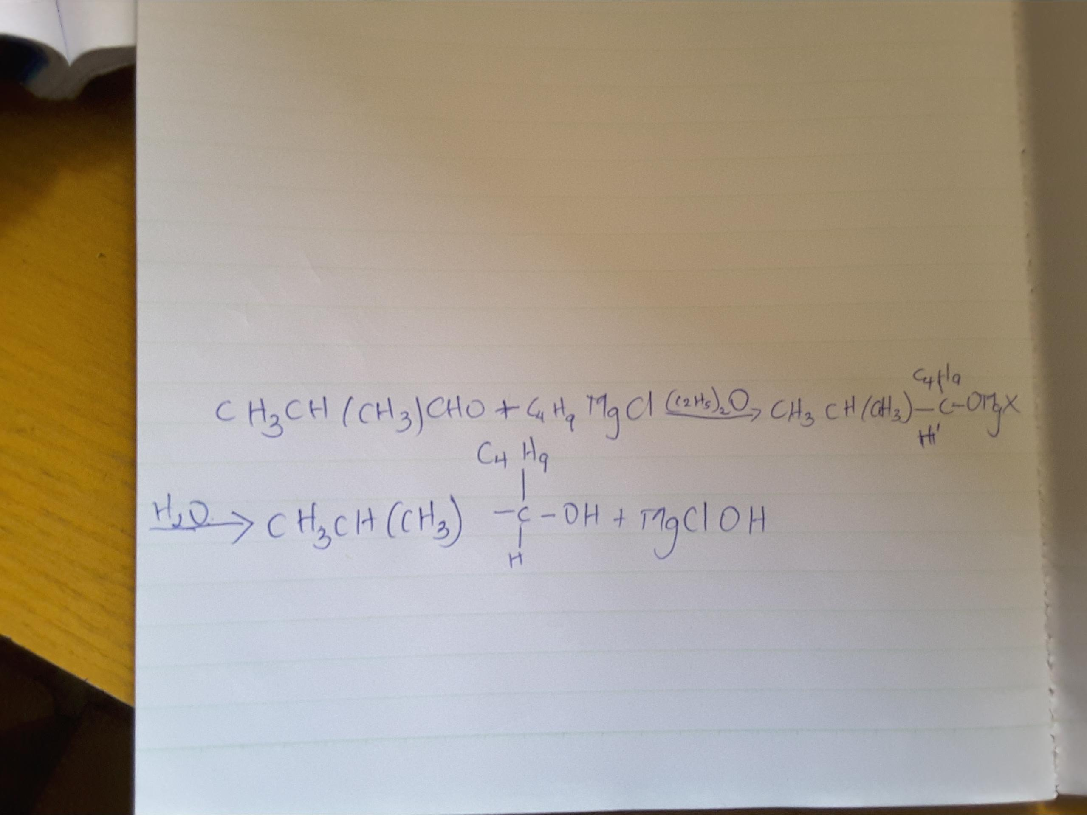
- RR'C=O + RMgX 》》RR'R''C-OMgX》》RR'R''C-OH + Mg(OH)X

5.
