NDAH CHRIS CHIMENEM
18/MHS03/007
ANATOMY
ANA 204

QUESTION 1: CRITICALLY EXAMINE THE RENAL FUNCTION OF DESERT DWELLERS AND THE ANATOMICAL BASIS OF THEIR UNIQUE ADAPTATION.

Since water is not readily available in the arid environment, animals have acquired a unique adaptation to excrete very little amount of water. The nephrons in desert animals are equipped with well developed Henle’s loop and the number of juxtamendullary nephrons in the kidney is very high unlike that of humans.
From the diagram below we can see that the Henle’s loop of the juxtamedullary nephron goes very deep into the medulla. 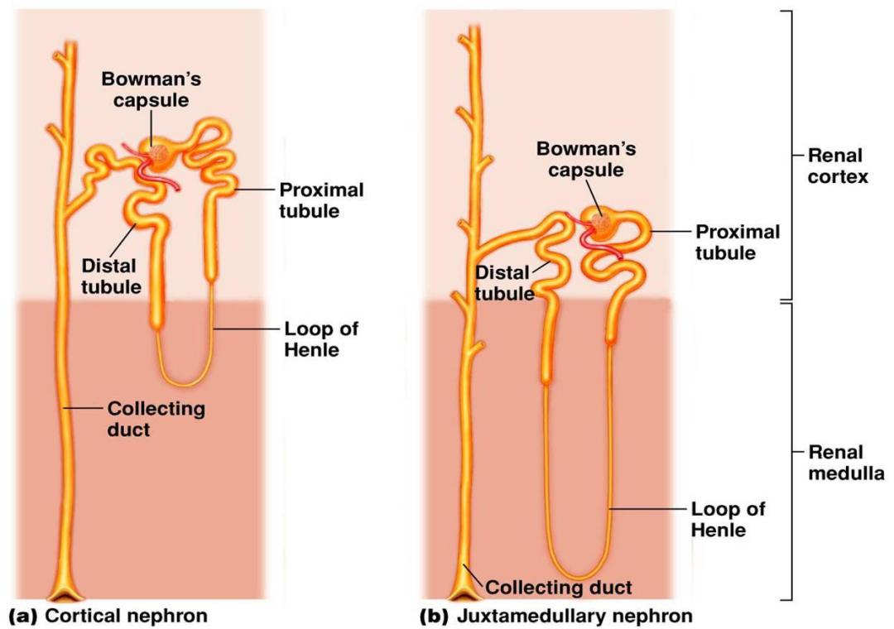
This is why the medulla of a camels kidney is thicker than that of other mammals. The Henle’s loops of juxtamedullary nephrons along with counter flowing blood vessels called vasa recta help in conservation of water. The longer the Henle’s loop more amount of solute will be reabsorbed and hence more amount of water could be removed from filtrate. The juxtaglomerular apparatus components are topographically intimate for effective tubuloglomerular autoregulation of renal blood flow.

QUESTION 2: WRITE EXTENSIVELY ON THE CLINICAL IMPORTANCE OF THE GLOMERULAR FILTRATION BARRIER

The glomerular filtration barrier is a highly irrigated structure that performs selective filtration of the plasma. Inside the bowmans capsule it functions as a highly organized, semipermeable membrane preventing the passage of the majority of proteins into the urine. The glomerular filtration barrier consists of the fenestrated endothelium, the glomerular basement membrane, and the podocyte foot processes, which are connected by a slit-diaphragm. The filtration barrier normally acts to retain protein inside the lumen of the capillaries separate from the urinary space; however, defects in the podocytes affecting the feet, tight junction (podocin, nephrin), and the slit diaphragm signalling, actin cytoskeleton, and cell matrix interactions have been identified in causing a breakdown of this barrier.
If the barrier is affected it can lead to various conditions such as diabetes mellitus and hypertension which are well recognized as important risk factors for developing chronic kidney disease.

