NAME: IKECHUKWU JOY NMESOMA
DEPARTMENT: PHYSIOLOGY
MATRIC NO: 18/MHS05/008
DATE18/05/2020
ANA 204 ASSIGNMENT

QUESTION 1: Critically examine the renal function of desert dwellers and the anatomical basis of their unique adaptation.
The nephrons in desert mammal Camel
The nephrons in desert mammal Camel are equipped with well developed Henle's loop and number of juxtamedullary nephrons in kidneys is very high, about 35% (in man this number is about 15%).
Desert mammals do not readily find water; hence they must excrete very less amount of water. They are able to produce highly concentrated urine.
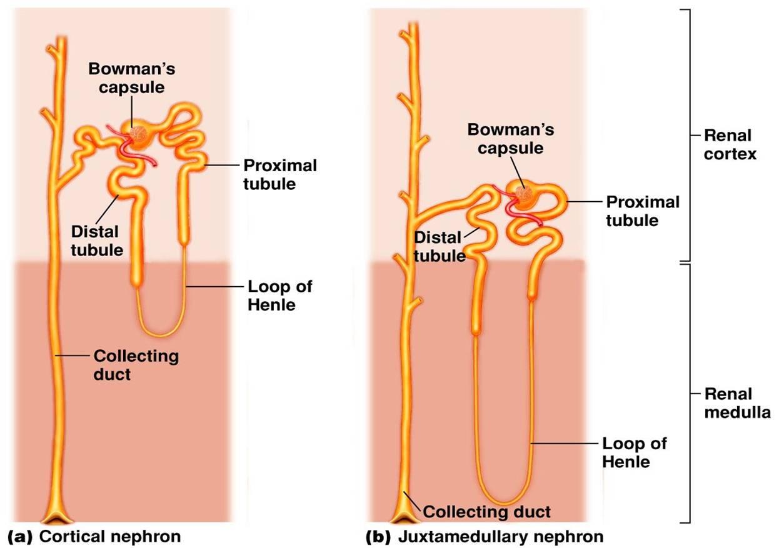
From the accompanying diagram you would be able to see that the Henle's loop of juxtamedullary
(adjacent to medulla of kidney) nephron goes deep down into the medulla. This is why medulla of camel's kidney is thicker than that of other mammals, but it is most well developed in another desert mammal, the kangaroo rats.
The Henle's loops of juxtamedullary nephrons along with counter flowing blood vessels, called vasa recta, help in conservation of water.
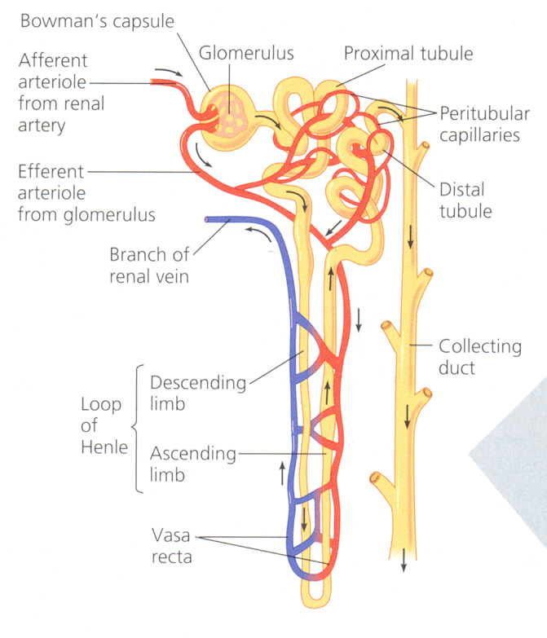
Blood first flows along ascending limb of Henle, which is impermeable to water. Solutes can leave the filtrate and enter the blood along this stretch. When this blood flows along descending limb, water is reabsorbed from filtrate but not the solutes. Longer the Henle's loop, more amount of solute will be reabsorbed and hence more amount of water could be removed from filtrate.

QUESTION 2: Write extensively on the clinical importance of the glomerular filtration barrier.

Glomerular Filtration Barrier

Pathophysiology/Pathogenesis
The glomerular filtration barrier functions as a highly organized, semipermeable membrane preventing the passage of the majority of proteins into the urine. The glomerular filtration barrier consists of the fenestrated endothelium, the glomerular basement membrane, and the podocyte foot processes, which are connected by a slit-diaphragm. The filtration barrier normally acts to retain protein inside the lumen of the capillaries separate from the urinary space; however, defects in the podocytes affecting the feet, tight junction (podocin, nephrin), and the slit diaphragm signalling, actin cytoskeleton, and cell matrix interactions have been identified in causing a breakdown of this barrier.
The glomerular filtration barrier has several layers.
The first is a glycocalyx made up of proteoglycans and an adsorbed layer of plasma proteins that is located between the endothelial cells and the capillary lumen.
Fenestrated endothelial cells form the next layer. Next is the thick glomerular basement membrane (GBM), which is synthesized by podocytes and endothelial cells and has an inner layer composed of collagen type IV and laminin sandwiched between layers of heparin sulphate. Podocyte foot processes line the epithelial side of the GBM; the intercellular junctions between adjacent foot processes are closed by the slit diaphragm, a specialized intercellular junction that acts as a molecular sieve and the final component of the filtration barrier. The slit diaphragm comprises several proteins, including nephrin, CD-associated protein (CD2AP), podocin, the tight junction protein ZO-1 (zonula occludens 1), P-cadherin, catenins, and the calcium channel TRPC6 (transient receptor potential cation channel, subfamily C, member 6), each of which is required for slit diaphragm integrity. Slit diaphragm proteins are supported by the highly dynamic podocyte actin cytoskeleton that in turn is anchored to an integrin complex that fastens each podocyte foot process to the GBM.

GLOMERULAR FILTRATION AND REMAN BLOOD FLOW

Determinants of Ultra Filtrate Composition
The glomerular filtration barrier determines the composition of the plasma ultra filtrate. It restricts the filtration of molecules primarily on the basis of size. In general, molecules with a radius smaller than 20 Å are filtered freely, molecules larger than 42 Å are not filtered, and molecules between 20 and 42 Å are filtered to various degrees. For example, serum albumin, an anionic protein that has an effective molecular radius of 35.5 Å, is filtered poorly. Because the filtered albumin and other small proteins normally are reabsorbed avidly by the proximal tubule, almost no protein appears in the urine of persons with normal renal function.

