NAME: UDO DAVID ANIEFIOK.
MATRIC NO: 16/MHS07/035

- Importance of fungi to mankind:
Biological Insecticides:
As animal pathogens, fungi help to control the population of damaging pests. These fungi are very specific to the insects they attack; they do not infect animals or plants. Fungi are currently under investigation as potential microbial insecticides, with several already on the market. For example, the fungus Beauveria bassiana is a pesticide being tested as a possible biological control agent for the recent spread of emerald ash borer.
Farming:
The mycorrhizal relationship between fungi and plant roots is essential for the productivity of farm land. Without the fungal partner in root systems, 80–90 percent of trees and grasses would not survive. Mycorrhizal fungal inoculants are available as soil additives from gardening supply stores and are promoted by supporters of organic agriculture.
Food:
Fungi figure prominently in the human diet. Morels, shiitake mushrooms, chanterelles, and truffles are considered delicacies. The meadow mushroom, Agaricus campestris, appears in many dishes. Moulds of the genus Penicillium ripen many cheeses. They originate in the natural environment such as the caves of Roquefort, France, where wheels of sheep milk cheese are stacked to capture the moulds responsible for the blue veins and pungent taste of the cheese.

- 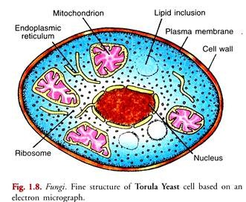

- Sexual reproduction in filamentous fungi consists of three sequential stages: plasmogamy, karyogamy, and meiosis. The diploid chromosomes are pulled apart into two daughter cells, each containing a single set of chromosomes (a haploid state). Plasmogamy, the fusion of two protoplasts (the contents of the two cells), brings together two compatible haploid nuclei. At this point, two nuclear types are present in the same cell, but the nuclei have not yet fused. Karyogamy results in the fusion of these haploid nuclei and the formation of a diploid nucleus (i.e., a nucleus containing two sets of chromosomes, one from each parent). The cell formed by karyogamy is called the zygote.

- Adaptations of Bryophytes (to a land existence):
Spores are dispersed by the wind. Two other adaptations help made the move from water to land possible for Bryophytes: a waxy cuticle and gametangia. The waxy cuticle helped to protect the plants tissue from drying out and the gametangia provided further protection against drying out specifically for the plant’s gametes.

- Eusteles:
The typical vascular cylinder of a dicotyledonous plant or a gymnosperm, consisting of a ring of collateral bundles of xylem, cambium, and phloem.
Atactostele:
A type of eustele, found in monocots, in which the vascular tissue in the stem exists as scattered bundles.
Siphonostele:
A type of vascular system consisting of a ring of vascular bundles surrounding a central pith.
Dictyostele:
A type of siphonostele, in which the vascular tissue in the stem forms a central cylinder around a pith, but with closely spaced leaf gaps.

- 