EDIDIONG IME- ESSIEN
CSC310
17/SCI01/041

Question
•Explain the following Interconnection networks:
1.Torus
2.Hypercube Interconnection Network

Answers
A torus interconnect is a switch-less network topology for connecting processing nodes in a parallel computer system. Specifically, it cares about aspects of an object that stay the same as it is stretched or squished, as long as there is no tearing. In the topological world, a torus is a two-dimensional space, or surface, with one hole.
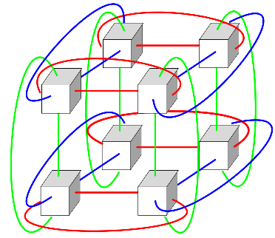

2. Hypercube are a type of network topology used to connect multiple processors with memory modules and accurately route data. Hypercube networks consist of 2 nodes. These nodes form the vertices of squares to create an internetwork connection. A hypercube is basically a multidimensional mesh network with two nodes in each dimension. Due to similarity, such topologies are usually grouped into a k-ary d-dimensional mesh topology family where d represents the number of dimensions and k represents the number of nodes in each dimension.

