Name: OTENE VICTOR.A.
Matric no: 17/sci01/072

Torus interconnection network
A torus interconnection is a switchless network topology for connecting processing nodes in a parallel computer system.
A torus interconnection can be seen as a mesh interconnection with nodes arranged in a rectilinear array of N = 2,3, or more dimensions, with processors connected to the nearest neighbors, and corresponding processors on opposite edges of the array connected. In this lattice, each node has 2N connections. This topology got the name from the fact that the lattice formed in this way is topologically homogeneous to N-dimensional torus.
Advantages
- Higher speed, lower latency (Higher path diversity)
- Better fairness
- Lower energy consumption
Disadvantages
- Complexity of wiring
- Cost
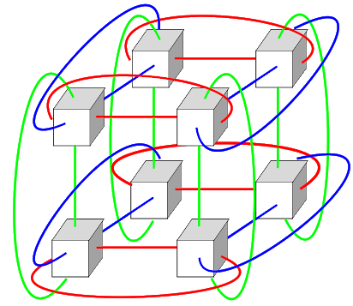

Hypercube interconnection
Hypercube networks are a type of network topology used to connect multiple processors with memory modules and accurately route data. Hyper cube consists of 2^{m} node. These nodes form the vertices of squares to create an interconnection network.
Hypercube (or binary n-cube multiprocessor) structure represents a loosely coupled system made up of N=2n processors interconnected in an n-dimensional binary cube. Each processor makes a made of the cube. Each processor makes a node of the cube. Therefore, it is customary to refer to each node as containing a processor, in effect it has not only a CPU but also local memory and I/O interface. Each processor has direct communication paths to n other neighbor processors. These paths correspond to the cube edges.
There are 2 distinct n-bit binary addresses which can be assigned to the processors. Each processor address differs from that of each of its n neighbors by exactly one-bit position
Advantages
- Increased performance
- Reliability
Disadvantage
- Higher node complexity

