NAME: OGUNNIKE IYANUOLUWA. O
MATRIC NO: 18/MHS05/011
COURSE: ANA 204
DEPARTMENT: PHYSIOLOGY
COLLEGE: MHS

QUESTIONS
- Critically examine the renal function of desert dwellers and the anatomical basis of their unique adaptation.
- Write extensively on the clinical importance of the glomerular filtration barrier.

Desert mammals do not readily find water which makes them excrete very little amount of highly concentrated urine. The henle’s loop of juxtamedullary nephrons with the vasa recta are responsible for the conservation of the little water they take in whenever they get. The renin-angiostensin-aldosterone system is very active, retaining sodium ion with water. The urine is concentrated at the expense of other electrolytes. Both the renal blood and urinary flow rates are lower than in species that have access to unlimited water supply. The renal medulla is responsible for maintenance of water balance. The nephrons and vessels interact with each other, exchanging water and solutes among many compartments in an arranged manner in order to produce urine that is concentrated in solutes.

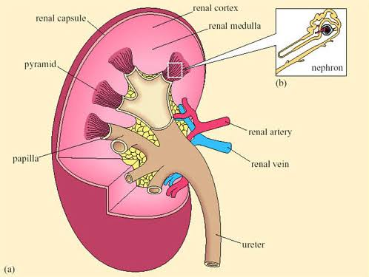

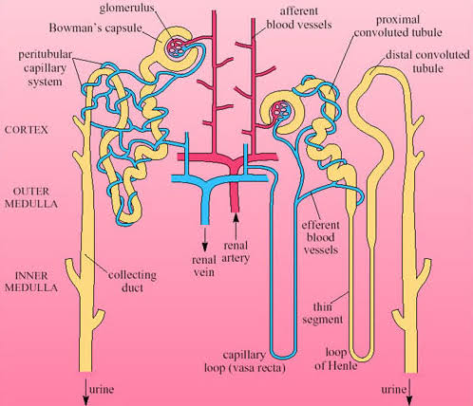

Desert animals can retain water by avoiding the sun and extreme heat. This makes them avoid drinking water and avoid water loss through the body. Water is often used up in the cooling process, hence making them dehydrated. Nocturnal desert animals keep cool by being active at night, while others get away from the sun’s heat by digging underground burrows.
The henle’s loop is usually longer in desert animals because they need to conserve water for survival so they want to pass out urine once in a while and in very small quantities.

The glomerular filtration barrier is a highly specialized blood filtration interface that displays a high conductance to small solutes in plasma but retains relative impermeability to macromolecules. It consists of three layered components:
- The fenestrated capillary endothelium
- The glomerular basement membrane
- Filtration slit diaphragms between pedicels.

The clinical importance of the glomerular filtration barrier is the prevention of the passage of the majority of proteins into the urine.
