Name: Ajibade Opeyemi Melody
Matric no: 18/MHS01/047
Department: Anatomy
Course: Ana 204
Assignment
- Firstly, the nephrons in desert mammal Camel are equipped with well developed Henle's loop and number of juxtamedullary nephrons in kidneys is very high, about 35%. Desert mammals do not readily find water, hence they must excrete very less amount of water. They are able to produce highly concentrated urine.
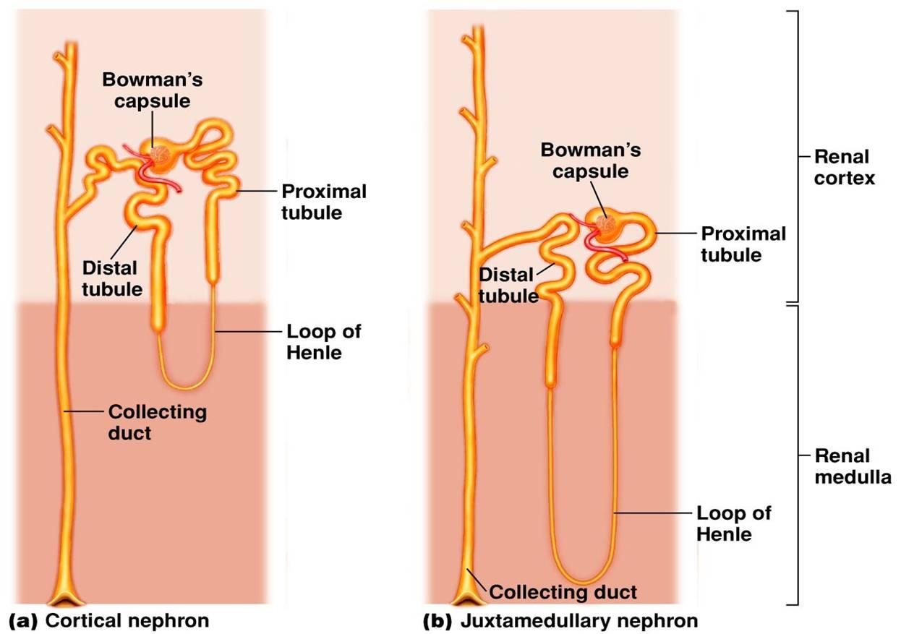

From the diagram you would be able to see that the Henle's loop of juxtamedullary nephron goes deep down into the medulla. This is why medulla of camel's kidney is thicker than that of other mammals, but it is most well developed in another desert mammal, the kangaroo rats. The Henle's loops of juxtamedullary nephrons along with counter flowing blood vessels, called vasa recta, help in conservation of water.

- In health, the glomerular filtration barrier functions as a highly organized, semipermeable membrane preventing the passage of the majority of proteins into the urine. The glomerular filtration barrier is a main component for the filtration of the plasma and formation of primary urine. It is composed of specialized cells and non- cellular structures that, together, can avoid the loss of important plasma components but permit the passage of water and undesirable molecules. For this functionality, this barrier has a specific morphology with a fenestrated endothelium covered with glycocalyx, a basement membrane, and a set of slit diaphragms formed by the foot processes of podocytes. Urine formation begins at the glomerular filtration barrier. The glomerular filter through which the ultrafiltrate has to pass consists of three layers: the fenestrated endothelium, the intervening glomerular basement membrane, and the podocyte slit diaphragm. This complex “membrane” is freely permeable to water and small dissolved solutes, but retains most of the proteins and other larger molecules, as well as all blood particles. Proper functioning of the podocyte is critical for maintaining the integrity and selectivity of the glomerular filtration barrier. Podocyte dysfunction causes increased protein excretion in the urine and a condition called nephrotic syndrome. The podocyte is a terminally differentiated cell, with little capacity for division or cell repair. Injury to the podocyte is increasingly recognized as a key mechanism in many chronic kidney diseases.

