NAME- OKON SEUBONG-ABASI
MATRIC NO. 17/MHS01/245
RENAL PHYSIOLOGY ASSIGNMENT
- Discuss the role of the kidney in glucose homeostasis
In addition, the kidneys contribute to glucose homeostasis by filtering and absorbing glucose. Under normal conditions, the kidneys retrieve as much glucose as possible, rendering the urine virtually glucose free.
The kidneys contribute to maintaining glucose homeostasis are significant and include such functions as release of glucose into circulation via glucogenesis, uptake of glucose from circulation and reabsorption of glucose at the level of the proximal tubule.
Renal release of glucose into circulation is the result of glycogenolysis and gluconeogenesis. With regard to renal reabsorption of glucose, the kidneys normally retrieve as much glucose as possible.
The glomeruli filter from plasma approximately 180g of D-glucose per day all of which are reabsorbed through glucose transporter proteins in the cell membranes within the proximal tubules. If the capacity of these transporters is exceeded, glucose appears in the urine. The process of renal glucose reabsorption is mediated by active (sodium-coupled glucose co-transporters) and passive (glucose transporters) transporters

- Discuss the process of micturition
Micturition also known as urination is the release of urine from the urinary bladder reaches about 250ml, stretch receptors in the bladder walls are stimulated and excite sensory parasympathetic fibers which relay information to the sacral area of the spine. The information is then relayed to two different sites
- Parasympathetic motor neurons are excited and act to contract the detrusor muscles in the bladder so that bladder pressure increases and the internal sphincter opens
- At the same time, somatic motor neurons supplying the external sphincter via the pudendal nerve are inhibited, allowing the external sphincter to open and the urine to flow out, assisted by gravity
There is the presence of the following receptors:
- M3 (muscarinic) receptors and the β-adrenergic receptors on the detrusor muscle
- α₁ receptor on the internal sphincter
- nicotinic receptor in external sphincter
Signals from central nervous system will be sent to the urinary tract through 3 important efferent fibres: -
- Sacral region of the spinal cord. The pelvic nerve is a parasympathetic nerve. It releases acetylcholine which binds to M3 receptor on the detrusor muscle causing contraction of the detrusor muscle.
- Pudendal nerve which is a somatic nerve also releases acetylcholine and acts on nicotinic receptor found on the external sphincter causing it contract.
- From the thoracic, lumbar region and synapses with a ganglion. It secretes neurotransmitters and pass information to a post sympathetic fiber known as hypogastric nerve. Because it is a post sympathetic nerve, it secretes the neurotransmitter, noradrenaline.
When the noradrenaline binds to the β3 receptors on the detrusor muscle, it causes relaxation of the detrusor muscle
When noradrenaline binds to the α₁ receptor on the internal sphincter. A sensory nerve fiber, an afferent pelvic nerve’s response is stimulated when the bladder is stretched.
- When the bladder is full, there is a lot of stretching in the bladder
- This will send the pelvic nerve to increase firing and send out fast signals to the sacral region.
- When the fast signals are sent, it then causes the neurons to bypass the thoracic lumbar region and goes to stimulate the neurons in the pontine micturition centre
- This causes an inhibition of hypogastric nerve which will lead to the contraction of the detrusor muscle and the relaxation of internal sphincter.
- Neurons coming from the pontine micturition centre will
- Stimulate the pelvic efferent nerves causing contraction of the detrusor muscle
- Inhibit the pudendal nerve causing relaxation of the external sphincter
- Urine is then able to go out of the body through the urethra

- Explain juxtaglomerular apparatus
Introduction
The juxtaglomerular apparatus is a specialized structure formed by the distal convoluted tubule and the glomerular afferent arteriole. It is located near the vascular pole of the glomerulus and its main function is to regulate blood pressure and the filtration rate of the glomerulus.
- Macula densa: - it is a collection of specialized epithelial cells in the distal convoluted tubule. In response to elevated sodium, the macula densa cells trigger contraction of the afferent arteriole, reducing blood flow to the glomerulus and the glomerular filtration rate.
- Juxtaglomerular cells: - these are derived from smooth muscle cells, of the afferent arteriole secrete renin when blood pressure in the arteriole falls. Renin increases blood pressure via the renin- angiotensin-aldosterone system.
- Extramesengial cells: - Also known as Lacis cells are flat, elongated cells located near the macula densa. They secrete prostaglandin, a vasodilator and also control glomerular filtration.
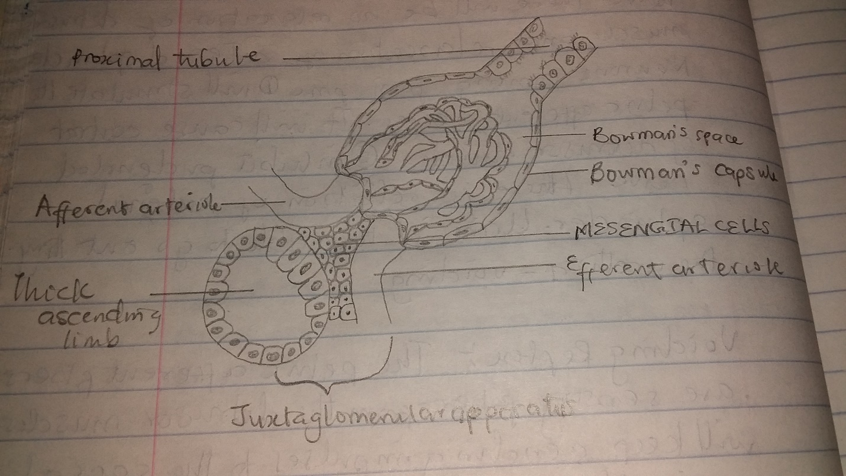

- Discuss the role of the kidney in blood pressure regulation
The kidneys ensure that the make-up and volume of the fluids in the body is correct. They help control the chemical balance of the blood and regulate the body’s level of sodium, potassium and calcium. The kidneys remove waste products and excess water from the body and so help to regulate blood pressure. One of the ways it does this is through the renin angiotensin aldosterone mechanism
RENIN ANGIOTENSIN ALDOSTERONE MECHANISM
- When blood pressure reduces, the kidney senses it through the macula densa causing activation of the juxtaglomerular apparatus.
- Juxtaglomerular cells would then be activated to secrete renin.
- Renin converts the proprotein angiotensinogen to angiotensin I
- Angiotensin converting enzyme then converts the angiotensin I to angiotensin II
- Angiotensin II then performs the following functions
- It is a potent vasoconstrictor. It constricts the blood vessels leading to increase in blood pressure
- Stimulates sympathetic discharge directly
- It will act on the adrenal cortex which will secrete aldosterone. Aldosterone will cause tubular reabsorption of sodium and chloride ions this will then cause an increased water retention
- It will also act on the posterior pituitary lobe causing ADH secretion and cause water reabsorption by the collecting ducts of the kidney
- It stimulates thirst
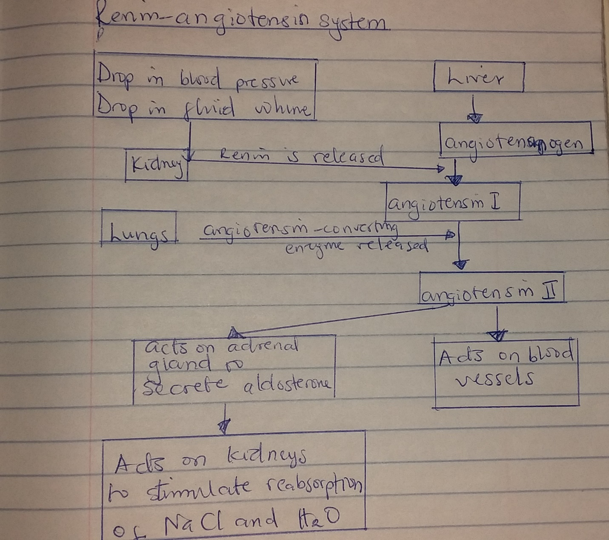

- Discuss the role of the kidney in calcium homeostasis
The kidney is critically important in calcium homeostasis. Under normal blood calcium concentrations, almost all of the calcium that enters glomerular filtrate is reabsorbed from the tubular system back into blood which preserves blood calcium levels. If tubular reabsorption of calcium decreases, calcium is lost by excretion into urine.
