Name : Festus-Ifode Ewomaoghene Chidera
Department : Anatomy
Matric Number: 18/MHS01/163
Course Code: Ana 204

Question
1. Critically examine the renal function of desert dwellers and the anatomical basis of their unique adaptation

2. Write extensively on the clinical importance of the glomerular filtration barrier.

Answers
1.) Animals found in the desert biome do not easily have access to water, as a result they have a very developed excretory that maximizes the ability to reabsorb water. This reason is why they excrete very little water and highly concentrated urine. In order for them to achieve this the kidneys and intestines of a camel are very efficient at reabsorbing water. Camels' kidneys have a 1:4 cortex to medulla ratio. Secondly, the renal corpuscles have a smaller diameter, which reduces surface area for filtration.Thirdly, they have a well-developed and very long henle’s loop that helps them reabsorb water more effectively than other animals.
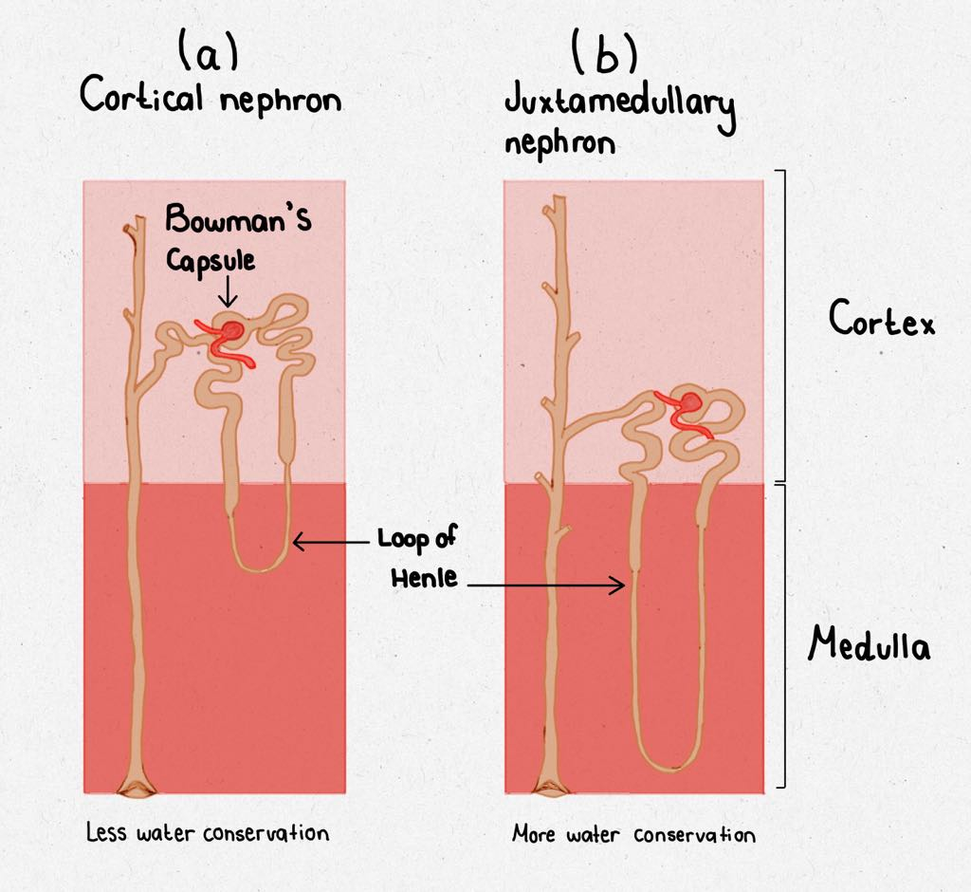
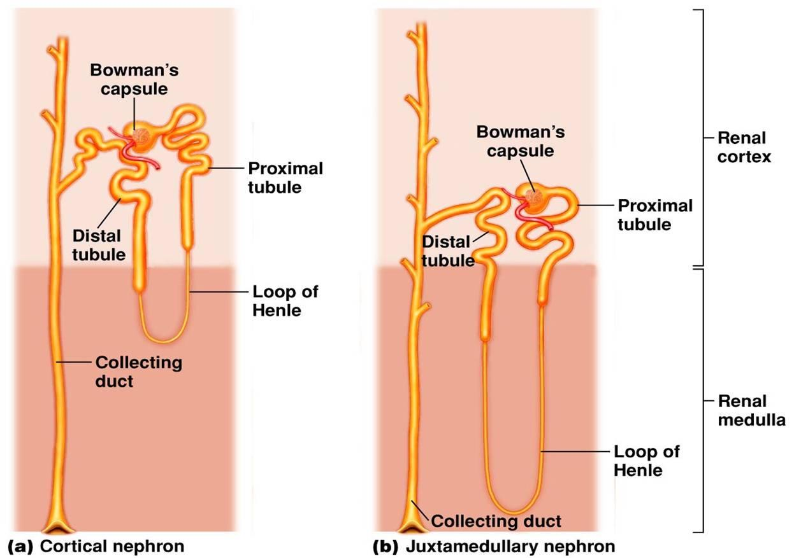

2.) Glomerular filtration is a physiological function of kidney nephrons. The ultrafiltrate, which appears in the lumen of the proximal convoluted tubule, is composed of water and solutes that can pass through the filtering membrane of the capillaries. Under physiological conditions, the large molecular weight proteins and blood cells do not pass through the capillary wall and hence do not appear in the luminal fluid. Therefore, glomerular filtration is relatively nonselective. The benefits of the filtration process are that it disposes of excess fluid, solutes, and metabolism byproducts and that it serves to detoxify the system by disposing of chemicals identified as foreign. Notably, pharmacotherapy with diuretics, such as the thiazides and loop diuretics, is based on the principle of detoxification. In general, the glomerular filtration rate (GFR) is relatively stable. Water content and ingredients are maintained by varying the amount of water and solute reabsorbed by the different segments of the nephron beyond the glomerulus. The physiological process of filtration plays a crucial role in the pharmacological actions of diuretics. For the most part, the diuretics must undergo glomerular filtration to exert their action on this specialized reabsorption process.

