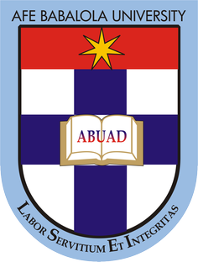

ASITA OBONISO

17/ENG06/014

SUBMITTED TO
ENGR. DR.OYEBODE

AFE BABALOLA UNIVERSITY, ADO-EKITI, EKITI STATE.

IN PARTIAL COMPLETION OF THE CONTINUOUS ASSESSMENT (C.A) FOR THE ENGINEERING LAW AND MANAGERIAL ECONOMICS (ENG 384) COURSE. MAY 21, 2020

CLASS TEST
- You have been invited by the current president of Nigeria, General Muhammadu Buhari to make an argument for the optimization of engineering resources in the country. As an aspiring Engineer, briefly discuss your view on this and make viable recommendations that will facilitate timely completion of engineering projects within the allocated budget without jeopardizing economic and legal regulations of NigeriaYou have been invited by the current president of Nigeria, General Muhammadu Buhari to make an argument for the optimization of engineering resources in the country. As an aspiring Engineer, briefly discuss your view on this and make viable recommendations that will facilitate timely completion of engineering projects within the allocated budget without jeopardizing economic and legal regulations of NigeriaYou have been invited by the current president of Nigeria, General Muhammadu Buhari to make an argument for the optimization of engineering resources in the country. As an aspiring Engineer, briefly discuss your view on this and make viable recommendations that will facilitate timely completion of engineering projects within the allocated budget without jeopardizing economic and legal regulations of Nigeria

