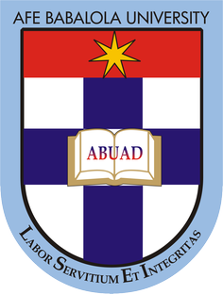

OKOLI WALTER

SHORT TEST
You have been invited by the current president of Nigeria, General Muhammadu Buhari to make an argument for the optimization of engineering resources in the country. As an aspiring Engineer, briefly discuss your view on this and make viable recommendations that will facilitate timely completion of engineering projects within the allocated budget without jeopardizing economic and legal regulations of Nigeria.

SOLUTION
Engineering resources in the country can be optimized by having a transparent contractor-worker relationship. Contracts are awarded to engineering firms, ie rehabilitation of an express way. Such contracts should have a human resources manager, an engineering supervisor, an economist. Likewise an ecological expert should be on board.
Human resource managers look out for the input of labourers both skilled and unskilled and likewise should compared to their output.
The engineering supervisor should ensure tht the job done by these worker meet all engineering requirements and specification. This must be done without bias.
The economist here must work hand in hand with both the human resource manager and the supervisor as he controls their funding. However, this power shouldn’t be abused. He must correlate with the supervisor to know how the material chosen, the engineering approach taken and a few other factors affect the funding. Likewise he should seek to support human management as some or more workers may have troubles either individually or collectively.
The ecologist literally plays a behind the scenes role and only steps in when any step taken into the project seeks to harm the environment.
With all these put into place, the office of the presidency should give their best shot at ensuring no corrupted individuals are a part of the project. This enables smooth flow of funds from the presidency to the mere workers and this boosts communication.

