NAME: EHIE GREAT CHIMSOM
MATRIC NUMBER: 17/SCI03/003
DEPARTMENT: BIOCHEMISTRY
COURSE CODE: BCH 302
- BIOSYNTHESIS OF PASMALOGENS

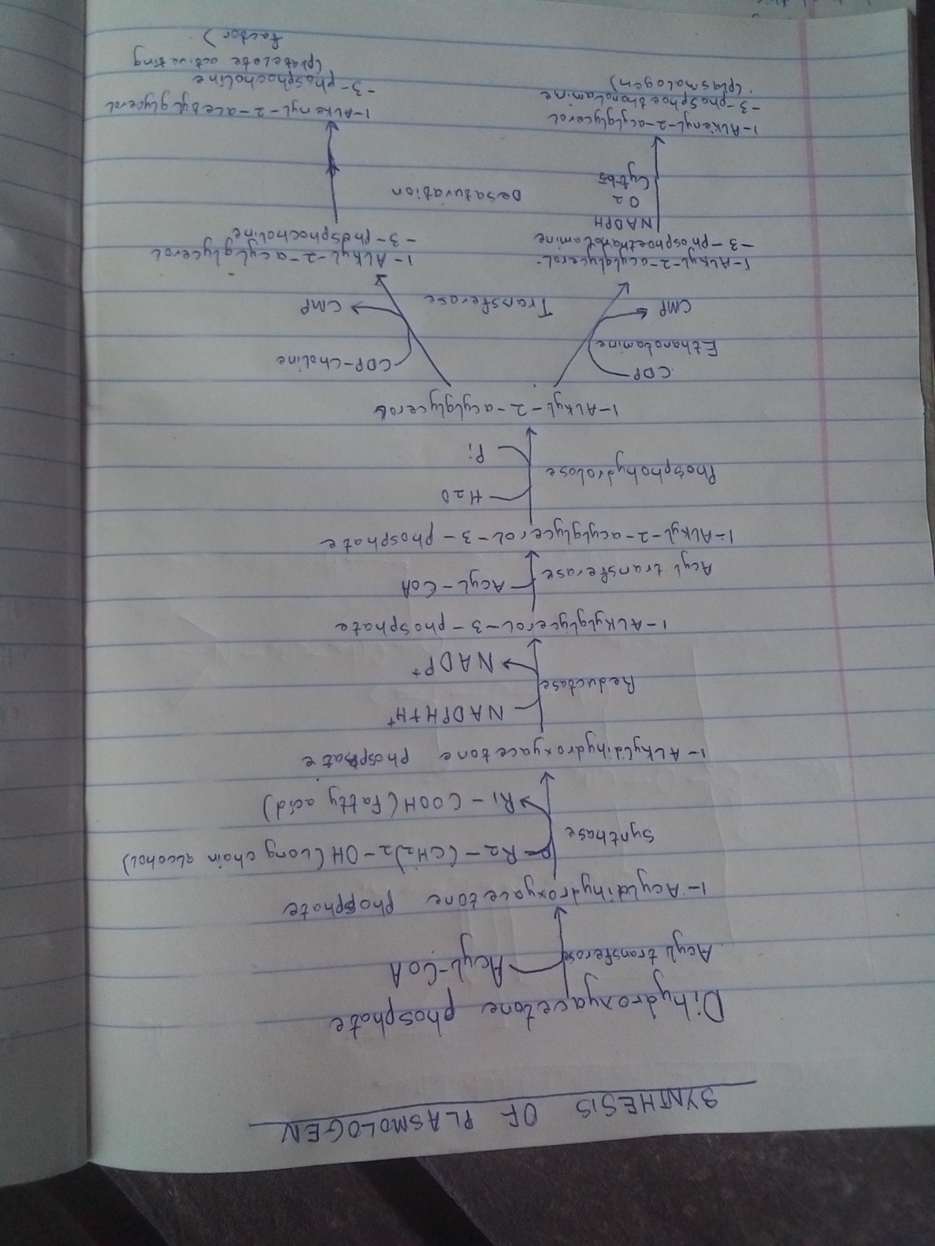
- SITE OF DEGREDATION OF 5 PHOSPHOLIPASE
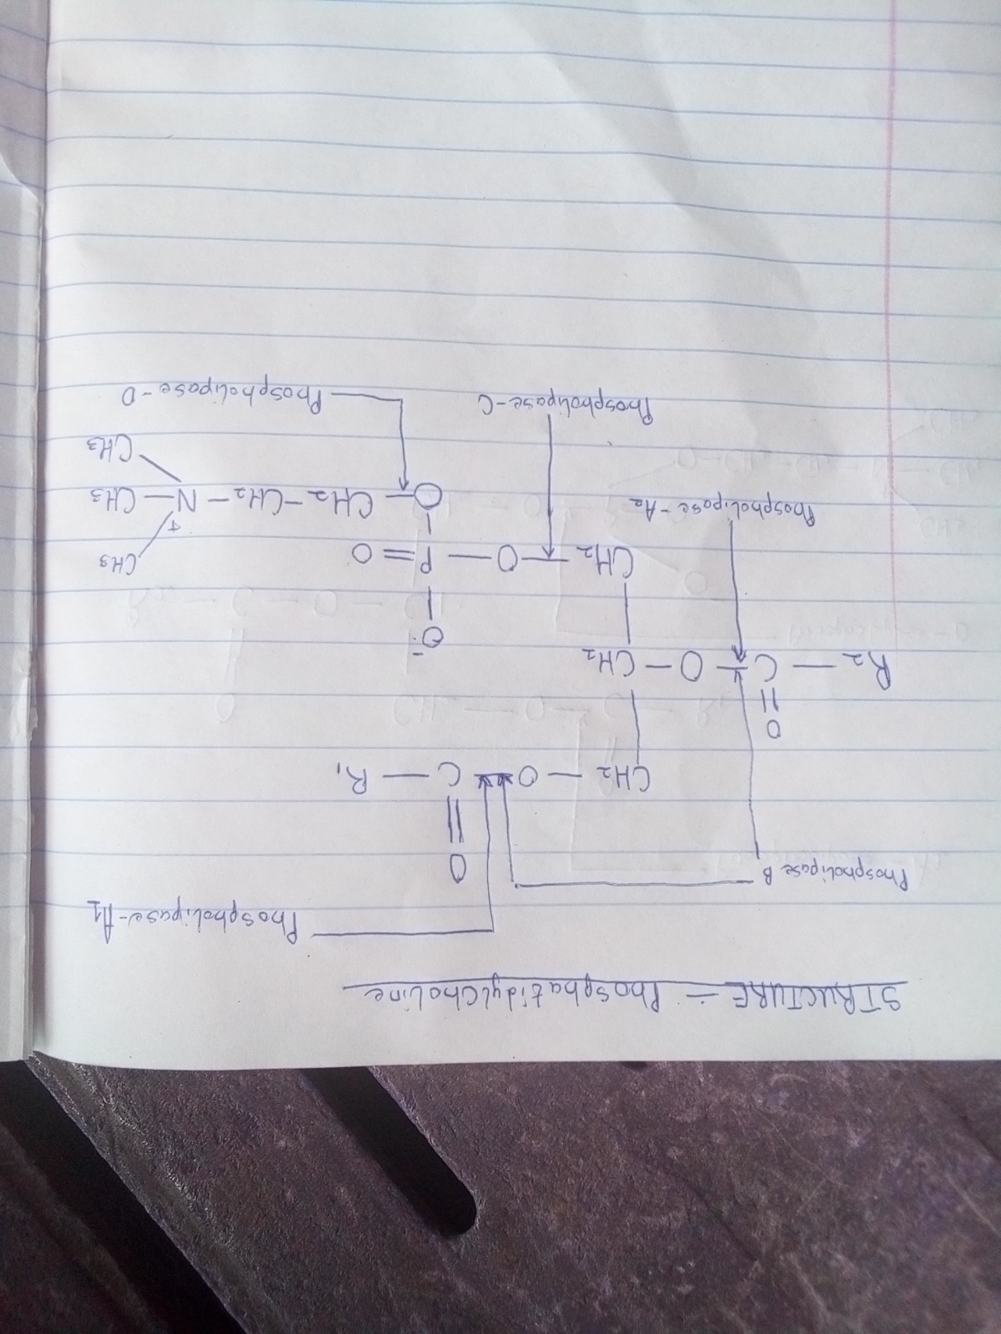

- Phospholipase-A1: Remove the fatty acyl group on C1 of the glycerol moiety.
- Phospholipase-A2: Catalyzes the hydrolysis of the ester bond of glycerophospholipids to form a free fatty acid and lysophospholipid, which is attacked by lysophospholipase by removing the remaining 1-acyl group.
- Phospholipase-B: Hydrolyzes both acyl groups on C1 and C2.
- Phospholipase-C: Cleaves the bond, between phosphate and glycerol of phospholipids.
- Phospholipase-D: Cleaves the bond between the phosphate and the Nitrogen base.

3a. Biosynthesis of Glycolipids
Cerebroside is the simples glycosphingolipids. In a cerebroside, glucose or galactose is linked to the terminal hydroxyl group of ceramide to form glucocerebroside or galactocerebroside.
Galactocerebroside is is a major lipid of myelin, wherease glucocerebroside is the major glycolipid of extraneural tissues and a precursor of most of the more complex glycolipids.
- Ceramide reacts with UDP-glucose or UDP-galactose to form glucocerebroside or galactocerebroside respectively.
- Ganglosides are the major complex glycolipids, contain a branched chain oligosaccharides of as many as seven sugar residues
- Ganglosidses are produced from ceramide by the stepwise addition of activated sugar, eg. UDP-glucose, UDP-galactose and sialic acid usually N-acetylneuraminic acid (NANA).

3b. Degradation of Glycolipids
- The glucocerebrosides and galactocerebrosides are hydrolyzed by lysosomal enzymes beta-glucoserebrosidase and beta-galactocerebrosidase respectively to ceramide and hexose residues. The ceramide so formed is further cleaved by another lysosomal enzyme ceramidase to sphingosine and free fatty acid.
- The different gangliosides are degraded by a set of lysosomal enzymes, beta-glucosidase, beta-hexasominidase, beta-galactosidase, neuramidase.

